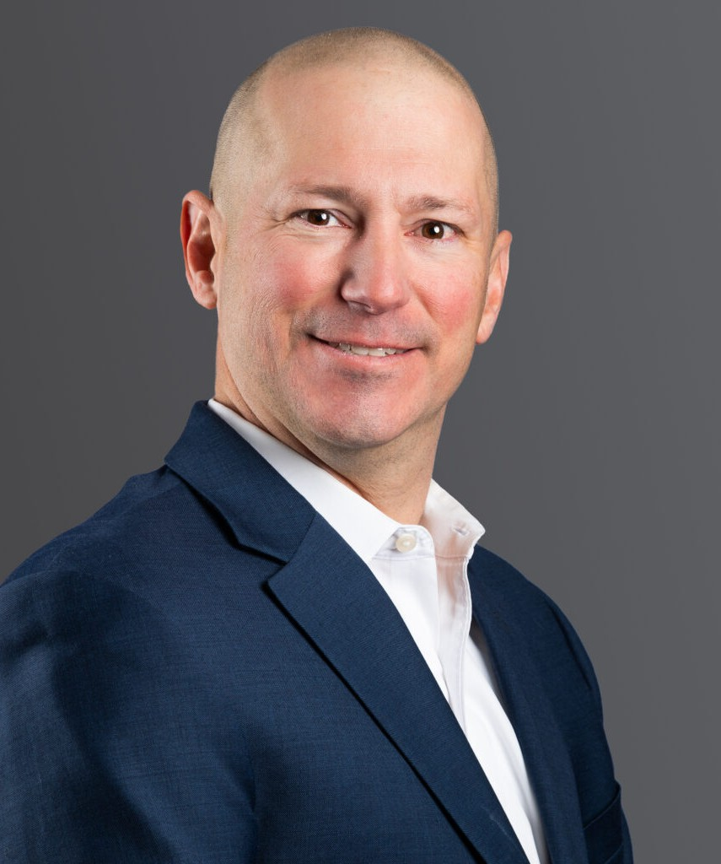

ARTHUR K. GRIFFIN

Director

[Real Estate](https://www.fennemorelaw.com/services/real-estate/)

[Denver](https://www.fennemorelaw.com/contact-us/denver-2/)

P: 303.813.3824 F: 303.291.3201

[Basalt](https://www.fennemorelaw.com/contact-us/basalt/)

P: 970.431.9060 F: 303.291.3201

[agriffin@fennemorelaw.com](mailto:agriffin@fennemorelaw.com)

# ARTHUR K. GRIFFIN

Arthur represents commercial real estate and advanced energy clients with development, acquisitions and dispositions, lending, and land use matters, and has extensive experience in the industrial, hospitality, retail, energy, and office industries. With a background in corporate and

tax law in addition to his real estate experience, Arthur is able to dissect all aspects of a deal and see the business perspectives, allowing him to provide sophisticated representation to his clients in both routine and complex matters. He advises his advanced energy clients in real

estate, land use, and tax matters, including the large scale implementation of solar photovoltaic systems on real estate developments, solar leasing, power purchase agreements, electronic vehicle charging stations, and other related energy development projects. He has also advised alcohol manufacturers, distributors, and retailers, including major casinos and nightclub

operators, regarding federal and state regulatory alcohol laws and liquor licensing matters, including licensing and regulatory compliance matters with the Alcohol and Tobacco Tax and Trade Bureau, the Colorado Department of Revenue – Liquor and Tobacco Enforcement

Division, and various Colorado municipalities.

Prior to joining Fennemore, Arthur served as General Counsel to a Denver-based multi-faceted real estate company where he oversaw high volumes of development and stabilized asset

transactions, brokerage deals, leasing matters, and finance arrangements. Prior to that, he worked in the Denver office of a national firm, where he focused on complex real estate matters of all types.

Outside of the office, Arthur enjoys spending time with his family, skiing, fishing, cooking, and coaching youth sports. He also enjoys competitive and recreational sailing and has sailed throughout the Gulf Coast, Caribbean, Northeast, Pacific Coast, and Mountain regions.

# EDUCATION

LL.M, University of Denver J.D., University of Denver

B.A., Tulane University

# AREAS OF PRACTICE

Real Estate Advanced Energy Land Use

Tax Law

# REPRESENTATIVE MATTERS

Represented an affordable housing non-profit client in the acquisition and financing of an 88- unit multifamily building in Glenwood Springs, CO to be converted in to condominiums to be sold to qualified buyers.

Represented a Platinum Clubs® of America golf course in a major amendment land use proceeding allowing for the creation of new residential lots and creation of a new par 3 golf course.

Represented international industrial developer in the acquisition and development of an approx. 108 acre, 1,900,000sf industrial park in the El Paso, TX area.

Represented an affordable housing non-profit client in the construction financing of a multi- parcel development in Glenwood Springs, CO.

Represented international industrial developer in the acquisition and development of a 90+ acre and additional outlot, 1,000,000+ sf warehouse and distribution facility in Canton, OH, including all joint venture and development management matters related thereto.

Represented major international industrial developer in the acquisition and development of 100+ acre, 1,000,000+ sf warehouse and distribution facility in Fishersville, VA, and all joint venture and development management matters related thereto.

Represented client in leasing and land use needs for a large industrial outdoor storage (IOS) operation on Colorado’s I-25 corridor.

Represented major international industrial developer in the sale of 20+ acre, 100,000sf delivery station logistics facility in Las Vegas, Nevada.

Represented major international industrial developer in the sale of its 129,540sf delivery station logistics facility in Hollister, CA.

Represented major international industrial developer in the acquisition of an approx. 12 acre, 7 parcel assemblage and municipal land swap in the greater Chicago, IL area.

Represented major industrial owner in the acquisition of approx. 128,000sf, stabilized industrial facility in Las Vegas, NV.

Represented client in multiple multifamily acquisitions in Denver, CO and Aurora, CO, which included assumptions of FreddieMac loans and other financing arrangements.

Represented major international industrial developer in the acquisition and development of a 21+ acre development site near Houston, Texas.

Represented client in work-out of challenged development in Parker, CO.

Represented major international industrial developer in the acquisition and development of an approx. 48 acre project in Waller County, Texas.

Represented major international industrial developer in the sale of an approx. 112,000sf logistics facility development project in rural Washington State.

Represented major international industrial developer in the sale of approximately 600,000+ sf facility in Chesapeake, VA.

Extensive experience assisting clients with leasing matters at major retail shopping centers throughout Colorado and at regional and local shopping centers nationwide, as well as industrial and office leasing in Colorado and other markets.

Represented California-based real estate developer in acquisition and development of approx. 12 acre mixed-use development site in Arvada, CO.

Represented company in major Downtown Denver ground leasing and in-fill projects.

Represented client in the acquisition, financing, and re-stabilization of a major east coast

casino & hotel in Atlantic City, New Jersey, with more than 1,800 guest rooms and suites and 135,000sf of gaming entertainment, including the leasing and licensing its six floors of retail, restaurant, and entertainment venues.

Assisted major Las Vegas casinos and nightclubs on “Tied House” and other trade practice/consumer protection provisions.

Represented client in the sale of a mobile home park and mobile homes in Colorado Springs, CO.

Assisted various distilleries and wineries with Alcohol and Tobacco Tax and Trade Bureau (TTB) and Colorado Department of Revenue – Liquor and Tobacco Enforcement Division

compliance.

Represented a major distillery start-up venture advising on all legal concerns, including federal and state licensing and resolution of real property matters, and provided regulatory guidance on manufacturing and processing requirements, record keeping, taxation, “Tied House” and other trade practice/consumer protection provisions.

Represented client with refinancing of mixed-use and office properties in downtown Denver, Colorado, which involved a $48,000,000+ loan made by a life insurance company lender.

Represented client in the acquisition and $60,000,000+ financing of multifamily property in Denver, Colorado.

Represented client with the acquisition of major hotel property in Kauai, Hawaii.

Represented a major health club client in its acquisition of a swim and tennis club in Manhattan Beach, California.

Represented client in the acquisition and $29,000,000+ financing of multifamily property in Austin, Texas.

Represented client in the acquisition and financing of office property near 15th and Market Streets in Denver, Colorado.

Represented client in the acquisition and $80,000,000+ financing of multifamily property in Denver, Colorado.

Represented client in the acquisition and $47,000,000+ financing of multifamily property in Long Beach, California.

Assisted a major golf course operator and investment company in its acquisition and disposition of various established golf courses.

Assisted pro bono client in the corporate consolidation of three non-profit organizations focusing on at-risk and drug-endangered children.

# AWARDS AND HONORS

Best Lawyers® Ones to Watch: Real Estate Law, 2023-2024

Colorado Super Lawyer Rising Star: Real Estate, 2018, 2023-2024

# ARTICLES AND PRESENTATIONS

Subject Matter Expert, “Real Estate Development from a Legal Perspective,” Urban Land Institute, ULI Learning Course, Published December 2024

Presenter, “Can you afford to be wrong? Legal Issues in CRE,” Urban Land Institute, 2023 Spring Meeting, Toronto, Ontario, May 16, 2023

Presenter, “Tax Cuts and Jobs Act: Critical Provisions Non-Tax Attorneys Need to Know,” Continuing Legal Education, Colorado Bar Association

Presenter, “Alcohol Law Primer,” Continuing Legal Education, Brownstein Hyatt Farber Schreck Presenter, “Taxation of Alcohol,” Continuing Legal Education, Colorado Bar Association

# PROFESSIONAL AND COMMUNITY AFFILIATIONS

Urban Land Institute, Subject Matter Expert and Member

Colorado Bar Association, Former Council Member, Section of Taxation, 2015-2018 Colorado Lawyers Committee

Denver Children’s Foundation, Legacy

Tulane Alumni Association of Colorado, Former President, 2011 – 2017

# ADMISSIONS

Colorado Wyoming