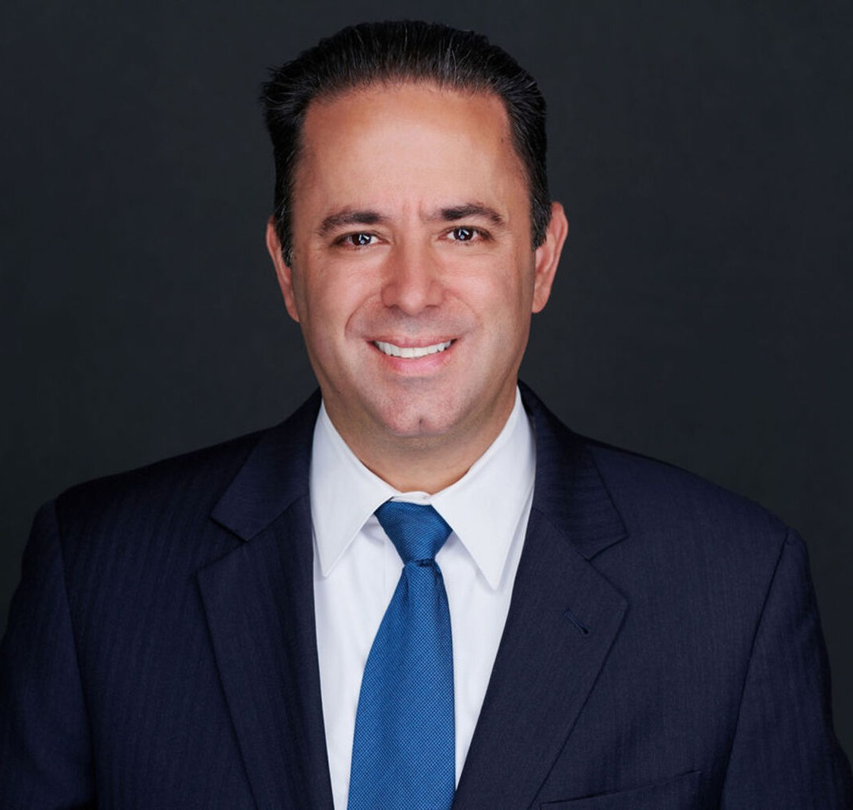

BART M. BOTTA

Director

[Agribusiness](https://www.fennemorelaw.com/services/agribusiness/)

[Orange County](https://www.fennemorelaw.com/contact-us/orange-county/)

P: 949.430.3422 F: 949.752.0953

[bbotta@fennemorelaw.com](mailto:bbotta@fennemorelaw.com)

# BART M. BOTTA

Bart M. Botta is a director in our Irvine office who works in our Agribusiness Law Practice Group. He is involved in all aspects of proceedings arising under the PACA and the California Food and Agricultural Code. Bart maintains relationships with long-term produce companies, and works closely with members of Western Growers in handling matters from PACA trust enforcement, federal and appellate court litigation, marketing agreements and general agricultural law, business transactions, commercial litigation, California Department of Food and Agriculture and USDA administrative proceedings.

Bart previously served as the Co-Chair of the Agribusiness Committee of the State Bar of California’s Business Law Section. He has been the attorney on several published appellate judicial case decisions interpreting issues under the PACA, and also has a published law review article on the PACA.

Agribusiness

# EDUCATION

J.D., Washburn University School of Law, *cum laude*

Associate Editor and Member, *Washburn Law Journal*

Recipient, American Jurisprudence Award in Research and Writing, and Torts Recipient, Tax Law Proficiency Certificate

B.A., Seton Hall University, *cum laude*

Phi Delta Phi

# AREAS OF PRACTICE

OTHER EXPERIENCE

PACA

Commercial and Federal Court Litigation Administrative Proceedings

Agribusiness

# PROFESSIONAL AND COMMUNITY ACTIVITIES

Member, State Bar of California

Member, Orange County Bar Association

Alternate Advisory Board Member, California Department of Food & Agriculture, Market Enforcement Branch

Past Co-Chair of the Agribusiness Committee; Business Law Section, California Lawyers Association

# ARTICLES AND PRESENTATIONS

[Featuring, “A Conversation On Leadership & Life In The Law With Attorney Bart Botta,”](https://www.fennemorelaw.com/i-am-constantly-learning-from-clients/) [Fennemore Blog, January 19, 2023](https://www.fennemorelaw.com/i-am-constantly-learning-from-clients/)

Featuring, “As 90-year-old Law Draws SCOTUS Attention, Billions of Producers Dollars on the Line,” The Business Journal, March 1, 2023

*Potato Sales Co., Inc. v. Dept. of Agriculture*, 92 F.3d 800 (9th Cir. 1996)

*Tanimura & Antle, Inc. v. Packed Fresh Produce, Inc.*, 222 F.3d 132 (3rd Cir. 2000)

*Patterson Frozen Foods v. Crown Foods Int’l*, 307 F.3d 666 (7th Cir. 2002)

*Koam Produce, Inc. v. DiMare Homestead, Inc.*, 329 F.3d 123 (2nd Cir. 2003)

*Morillion v. Royal Packing Co.*, 22 Cal. 4th 575; 995 P.2d 139; 94 Cal. Rptr. 2d 3 (2000)

Bartholomew M. Botta, Personal Liability for Corporate Debts: The Reach of the Perishable Agricultural

Commodities Act Continues to Expand, 2 Drake J.Agric.L. 339 (1997)

# ADMISSIONS

California

U.S. District Court, Northern District of California

U.S. District Court, Eastern District of California

U.S. District Court, Central District of California

U.S. District Court, Southern District of California

U.S. Court of Appeals for the First, Second, Third, Fifth, Seventh, and Ninth Circuits