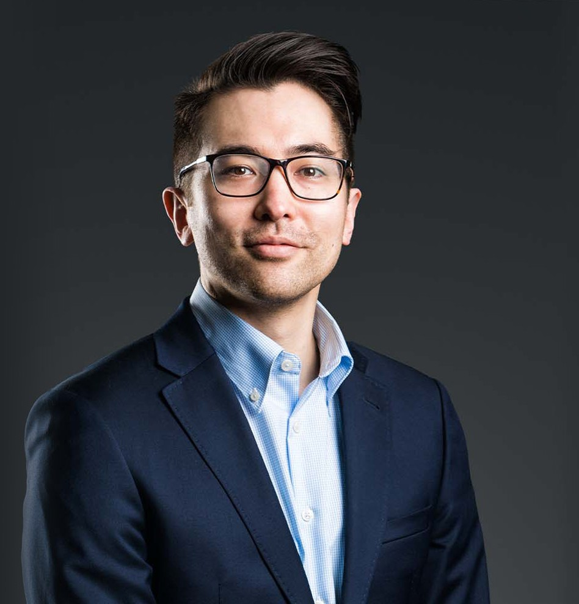

BRANDIN A. INOUYE

Associate

[Business & Finance](https://www.fennemorelaw.com/services/business-and-finance/)

[Fresno](https://www.fennemorelaw.com/contact-us/fresno/)

P: 559.446.3234 F: 559.432.4590

[binouye@fennemorelaw.com](mailto:binouye@fennemorelaw.com)

“

The Devil is in the details, but so is salvation.

- Adm. Hyman G. Rickover

**BRANDIN A. INOUYE**

”

Brandin Inouye is an associate in our Fresno office who works in our Business & Finance and Intellectual Property groups. He focuses his practice on transactional work, including contract and mergers and acquisitions matters, as well as IP matters in the copyright and patent portfolio management space.

Brandin grew up in Southern California and served six years in the U.S. Navy, running nuclear power plants aboard the USS Enterprise. Following his Navy service, he received his bachelor’s degree in Philosophy from the University of California, Los Angeles, then worked in the power plant construction industry for three years in Chicago. In 2020, Brandin earned his J.D. from the

Georgetown University Law Center. His Philosophy background informs his practice today, and he thoroughly enjoys working with clients on intellectual property matters.

Outside of work, Brandin recharges his batteries with wine tasting, playing tennis, hiking, and reading Philosophy – he recommends René Descartes’ “Meditations On First Philosophy” for those interested in learning more about the field.

# EDUCATION

J.D., Georgetown University Law Center B.A., University of California, Los Angeles

# AREAS OF PRACTICE

Business & Finance

Intellectual Property

# AWARDS AND HONORS

*Best Lawyers in America*®, Ones to Watch –Mergers and Acquisitions Law, 2024-2025

# ARTICLES AND PRESENTATIONS

[Interview, “The attention to detail developed in the nuclear navy helped prepare me for the](https://www.fennemorelaw.com/the-attention-to-detail-developed-in-the-nuclear-navy-helped-prepare-me-for-the-legal-profession/) [legal profession.,” Fennemore Blog, November 11, 2021](https://www.fennemorelaw.com/the-attention-to-detail-developed-in-the-nuclear-navy-helped-prepare-me-for-the-legal-profession/)

# ADMISSIONS

California