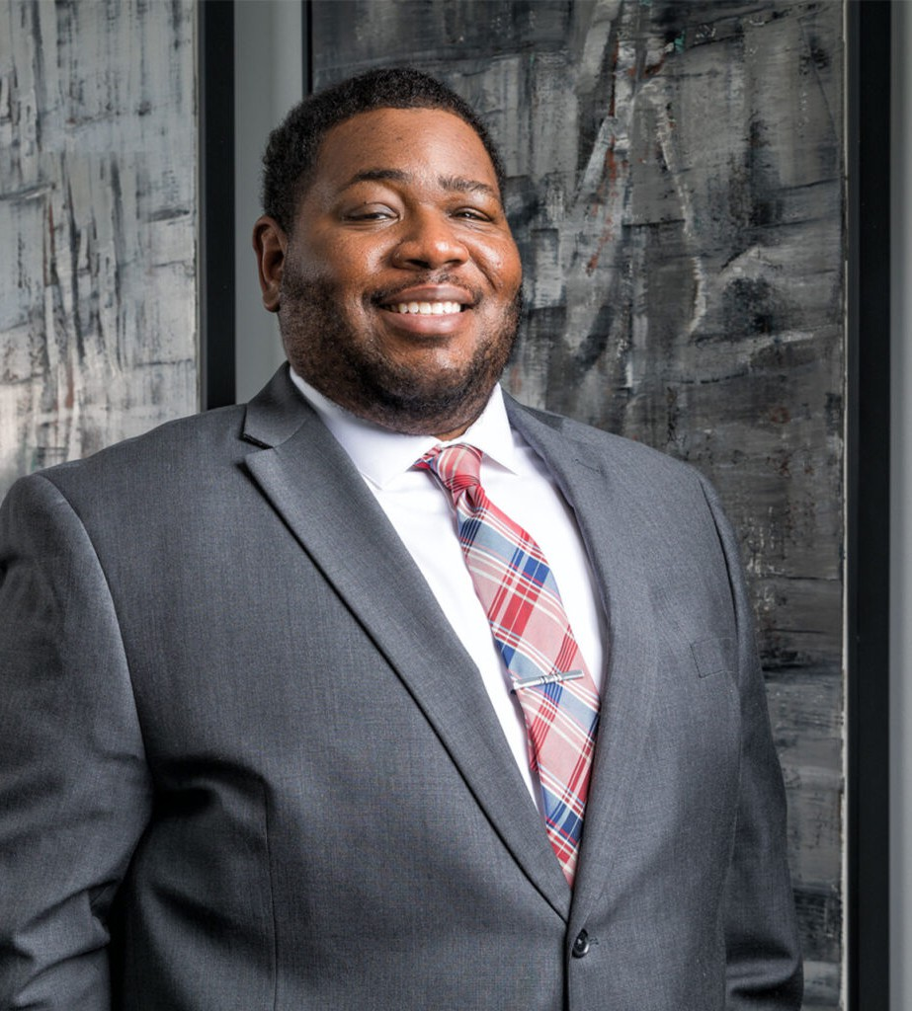

BRANDON L. BLAKELY

Pronouns: he/him

Associate

[Trusts & Estates](https://www.fennemorelaw.com/services/trusts-estates/)

[Phoenix](https://www.fennemorelaw.com/contact-us/phoenix/)

P: 602.916.5322 F: 602.916.5522

[bblakely@fennemorelaw.com](mailto:bblakely@fennemorelaw.com)

“

The best way to predict the future is to create it.

-Peter Drucker

**BRANDON L. BLAKELY**

”

Brandon Blakely is an associate who works out of our Phoenix office in the firm’s Trusts & Estates practice group. His work focuses on drafting complex estate plans and fiduciary documents, preparing trust and probate petitions and developing strategies for fiduciary litigation, as well as completing gift and estate tax filings and trusts accountings. He’s also adept at counseling clients on tax planning and anticipating potential changes in tax laws, as well as preserving assets through coordinated estate plan transactions, business succession tactics and entity

formation.

Originally from Torrance, California, Brandon’s approach to his life and career has had a very non-linear, non-traditional approach, but with a guiding north star valuing education, while helping others. After graduating from college at Arizona State University, he worked for two years as a Child Services Specialist for the State of Arizona. Then, while completing his Master’s of Science in Education at the University of Kansas, he served as an Assistant Complex Director in the university’s department of housing, assisting students with a diversity of human services issues. Brandon ended up in Minnesota where he worked as a Residence Director, adjudicating and managing ongoing cases for the residence hall hearing process, which ultimately led him to pursuing a career in the legal profession. He then earned his J.D. at the University of Minnesota

Law School To this day, Brandon relishes the mentally challenging nature of being a lawyer, with the ability to help his clients solve their problems.

Outside of work, Brandon, his wife and their young son enjoy spending time with their “village,” a great group of family and friends in the valley of the sun. Brandon also plays hockey and as a

huge sports fan, he faithfully follows ASU’s teams and the Los Angeles Lakers.

Trusts & Estates Estate Planning

# EDUCATION

J.D., University of Minnesota Law School M.S., University of Kansas

B.A., Arizona State University

# AREAS OF PRACTICE

Trusts & Estates Estate Planning

# AWARDS AND HONORS

*Best Lawyers in America*®, Ones to Watch – Tax Law, Trusts and Estates, 2024 – 2025

# ARTICLES AND PRESENTATIONS

[Interview, “I think I would tell myself that i belong,” Fennemore Blog, February 23, 2023](https://www.fennemorelaw.com/i-think-i-would-tell-myself-that-i-belong/)

# PROFESSIONAL AND COMMUNITY ACTIVITIES

Board of Advisors, U of M Law School Mentor Lead, Twin Cities Diversity in Practice

# ADMISSIONS

Minnesota Arizona