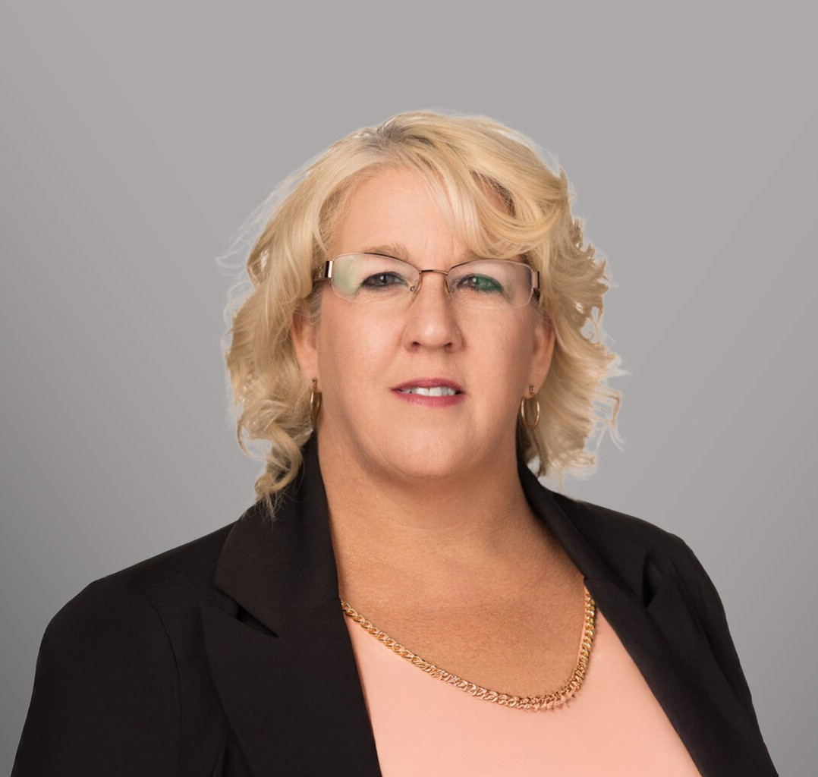

CANDY L. MANN

Paralegal

[Real Estate](https://www.fennemorelaw.com/services/real-estate/)

[Spokane](https://www.fennemorelaw.com/contact-us/spokane/)

P: 602.916.5710 F: 602.916.5710

[cmann@fennemorelaw.com](mailto:cmann@fennemorelaw.com)

**CANDY L**“**. MANN**

When you're accustomed to privilege, equality feels like oppression.

”

With over a decade of experience, Candy Mann brings a wealth of legal knowledge and experience to every case she helps manage. As a registered paralegal, Candy has worked across multiple practice areas, including real estate, probate, and civil litigation.

Known for a proactive and detail-oriented approach, Candy is highly skilled in drafting complex legal documents and utilizes discretion and sound judgment to ensure successful case

outcomes. She excels in client communication, keeping both clients and attorneys informed on case progress, and is committed to providing clear, thorough information to guide clients through the legal process. With 20 years of prior customer service experience, Candy brings a unique ability to empathize and communicate with clients in a respectful and supportive manner, ensuring they feel heard and understood.

# AREAS OF PRACTICE

Real Estate Estate Planning

# EDUCATION

A.A.S. Paralegal Degree, *magna cum laude*, Spokane Community College

# ADMISSIONS

*\*Not licensed to the practice of law*