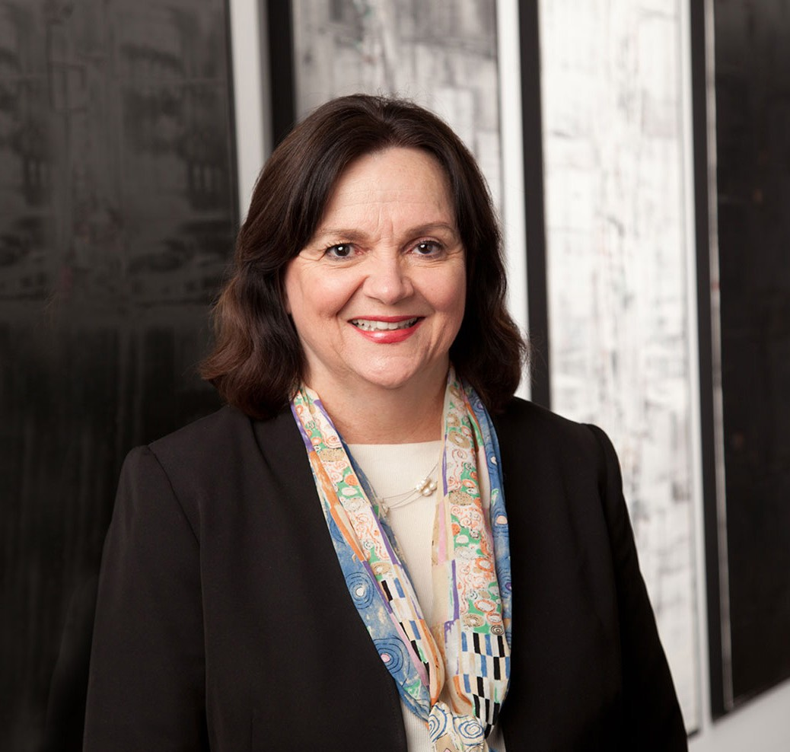

CATHY L. REECE

Director

[Financial Restructuring](https://www.fennemorelaw.com/services/financial-restructuring-bankruptcy-creditors-rights/)

[Phoenix](https://www.fennemorelaw.com/contact-us/phoenix/)

P: 602.916.5343 F: 602.916.5543

[creece@fennemorelaw.com](mailto:creece@fennemorelaw.com)

**CATHY L. REECE**

Cathy practices in the financial restructuring, bankruptcy and creditors’ rights practice group. She has broad experience in every aspect of corporate workouts and bankruptcies, and also works with clients structuring complex transactions and purchasing distressed assets.

Cathy has held a variety of leadership positions at state and national associations related to bankruptcy, commercial finance and corporate renewal.

# EDUCATION

J.D. Arizona State University, Sandra Day O?onnor College of Law Bachelor of Music, with high distinction University of Arizona Managing Editor, *Arizona State University Law Journal,* 1979

Judicial law clerk to the Honorable Sandra Day O’Connor at the Arizona Court of Appeals, 1979

# AREAS OF PRACTICE

OTHER EXPERIENCE

Aviation, Aerospace and Autonomous Systems Commercial and Real Estate Finance Commercial Contingency Litigation

Litigation

Real Estate Finance and Lending Financial Restructuring

Business Litigation

Blockchain & Cryptocurrency

# REPRESENTATIVE CASES

Represented the Official Investors Committee in the bankruptcy of Mortgages Ltd., which managed the $900 million loan portfolio involving over 1700 investors. The Committee successfully confirmed its own Plan of Reorganization. The firm currently represents ML Manager that manages and liquidates the loan portfolio under the Plan.

Represented Textron Financial Corporation, the largest secured creditor, in the ILX Resorts bankruptcies and filed a Joint Plan of Reorganization with the Debtors.

Represented the City of Glendale, Arizona, the arena landlord concerning the management and lease of the arena, in the bankruptcy of the NHL Arizona Coyotes hockey team.

Represented the Unsecured Creditors Committee in an alleged Ponzi scheme bankruptcy case and successfully obtained a consensual Plan of Reorganization appointing a liquidating trustee after capturing several million dollars for the trust.

Represented the Unsecured Creditors’ Committee in the Baptist Foundation of Arizona bankruptcy cases with liabilities of $650 million and over 13,000 creditors.

Represented the lead prepetition and postpetition lender of $220 million in the MicroAge bankruptcy cases.

Represented a major prepetition and postpetition construction and acquisition and development lender in the UDC Homes, Inc. bankruptcy.

Represented a major gasoline trade creditor and chair of the unofficial reclamation creditors’ committee in the consolidated Circle K bankruptcies.

Represented the indenture trustee of several public bond issuances in an airline bankruptcy.

Represented a major administrative and unsecured creditor in the consolidated National Convenience Stores bankruptcy.

Represented the prepetition and postpetition secured lender in the Foster Grant bankruptcy.

Represented the indenture trustee of approximately $52 million of public bonds secured by a lien on 80,000 acres of land involving over 50 separate Sun Valley Parkway bankruptcies.

Represented a major prepetition and postpetition lender in the Copperstate Metals bankruptcy.

Represented the major asset based lender in the Unitech Industries Inc. bankruptcy.

Represented a major petroleum marketer and distributor on environmental claims in various bankruptcies.

Represented numerous secured lenders, landlords and unsecured creditors in manufacturing, retail and real estate bankruptcies.

Represented the Chapter 11 Trustee in seven related health care bankruptcies, which operated several skilled care facilities, assisted living facilities, and independent facilities.

Represented Tucson Electric Power Company, in an involuntary proceeding which was dismissed and in related state court litigation which was also dismissed.

Represented Famous Restaurants Inc. and its related entities which successfully confirmed a plan of reorganization.

Represented a debtor before the United States Supreme Court in a 1992 landmark case involving the exemption or exclusion of an ERISA qualified pension plan from the bankruptcy estate.

# AWARDS AND HONORS

*Southwest Super Lawyers®,* Top 25 Women in Arizona, 2015-2017, 2021-2024

*Best Lawyers in America®,* Bankruptcy and Creditor Debtor Rights/Insolvency and Reorganization Law, 2009-2025

*Best Lawyers in America®,* Litigation – Bankruptcy, 2011-2024 *Top 100 Lawyers, AZ Business Magazine,* 2016-2018, 2022-2023 *Southwest Super Lawyers®,* Top 50 Arizona, 2015-2016

Recipient, Legal Advisor of the Year, M&A Advisor, 2014

*Arizona’s Best Lawyers,* Bankruptcy and Creditor Debtor Rights/Insolvency and Reorganization Law

*Benchmark Litigation,* Local Litigation Star

*Benchmark Litigation,* Top 250 Women in Litigation

*Southwest Super Lawyers®,* Bankruptcy & Creditor/Debtor Rights Fellow, American College of Commercial Finance Lawyers

AV® Preeminent™ Peer Review Rated (the highest rating available), by Martindale-Hubbell

# ARTICLES AND PRESENTATIONS

Presenter, “Maximizing Deals through Third-Party Litigation Financing,” M&A Advisor, November 18, 2020

Quoted, “Road to Recovery: A Look Sector by Sector,” *InBusiness,* August 2020 [Author, “Bankruptcy in a Distressed Post-COVID-19 World,”](https://inbusinessphx.com/in-business/bankruptcy-in-a-distressed-post-covid-19-world#.XygY1ChKhhH) [*InBusiness*, August 2020](https://inbusinessphx.com/in-business/bankruptcy-in-a-distressed-post-covid-19-world#.XygY1ChKhhH)

Speaker, “Corporate Governance During Financial Distress,” Women in the Boardroom, March 24, 2020

Speaker, “Real Estate in Bankruptcy,” Modern Real Estate Transactions, ALI CLE, February 6, 2020

Speaker, “Third-Party Litigation Funding in Bankruptcy Cases: Recent Trends and Key Issues,” Strafford Publications, September 24, 2019

Quoted, “Tate’s Auto Group Toppled by Financial, Legal Troubles,” *Automotive News*, May 6, 2019

[Author, “The Changing Landscape of Commercial Real Estate: Repurposing Spaces in Retail,](https://businesslawtoday.org/2018/12/changing-landscape-commercial-real-estate-repurposing-spaces-retail-shopping-centers-healthcare-golf-courses/) [Shopping Centers, Healthcare and Golf Courses,”](https://businesslawtoday.org/2018/12/changing-landscape-commercial-real-estate-repurposing-spaces-retail-shopping-centers-healthcare-golf-courses/) [*Business Law Today,*](https://businesslawtoday.org/2018/12/changing-landscape-commercial-real-estate-repurposing-spaces-retail-shopping-centers-healthcare-golf-courses/)[December 18, 2018](https://businesslawtoday.org/2018/12/changing-landscape-commercial-real-estate-repurposing-spaces-retail-shopping-centers-healthcare-golf-courses/)

Interview, “Litigation Finance Experts Discuss Recent Industry Growth,” *Debwire*, October 2018

Speaker, “The Changing Landscape of Commercial Real Estate—Retail, Shopping Centers, Healthcare and Golf Courses—Repurposing the Space,” ABA Business Law Section Annual Meeting, September 13, 2018

Speaker, “Post-Confirmation Liquidating and Litigation Trusts,” 26th Annual Southwest Bankruptcy Conference, September 7, 2018

Speaker, “Liquidating Trusts in Bankruptcy: A Review of Current Issues,” The Knowledge Group, July 12, 2018

Moderator, “2017 TMA Small Company Turnaround Award Winner: Vermont Aerospace Once Again Takes Flight,” *ABF Journal*, April 2018

Speaker, “Third Party Financing of Litigation–Structure, Documentation And Outlook for 2018,” American Bar Association Business Law Spring Meeting, April 2018

[Author, “Mayday! Mayday! Mayday! Saving the Vermont Aerospace Company,”](https://turnaround.org/jcr/2018/04/mayday-mayday-mayday-saving-vermont-aerospace-company) [*TMA,*](https://turnaround.org/jcr/2018/04/mayday-mayday-mayday-saving-vermont-aerospace-company)[April](https://turnaround.org/jcr/2018/04/mayday-mayday-mayday-saving-vermont-aerospace-company) [2018](https://turnaround.org/jcr/2018/04/mayday-mayday-mayday-saving-vermont-aerospace-company)

Speaker, “Faster, Higher Returns: With Ponzi Schemes, All That Glitters Is Not Gold,” 2018 Distressed Investing Summit, March 21, 2018

[Speaker, “Litigation Trusts in Business Bankruptcies,” The Knowledge Group, March 5, 2018](https://www.youtube.com/watch?v=ZE8FRLL4KS0&t)

Speaker, “Post-Confirmation Liquidation and Litigation Trusts in Business Bankruptices: What Lies Ahead in 2018,” March 2, 2018

# PROFESSIONAL AND COMMUNITY ACTIVITIES

Member, State Bar of Arizona Member, Federal Bar Association

Member, Board of Regents, American College of Commercial Finance Lawyers

Member, Board of Trustees and Former Vice-President of Communications, Vice President of Conferences, and Vice President of Membership, International Turnaround Management Association

Member, American Bankruptcy Institute

Member, The American Law Institute, which drafts and sponsors the Restatements of the Law and the Uniform Commercial Code

Treasurer, American College of Commercial Finance Lawyers

Immediate Past Chair, Loan Workout Subcommittee, American Bar Association, Business Law Section

Past President, Arizona Chapter, Turnaround Management Association Past Chair, Bankruptcy Section, State Bar of Arizona

Past Chair, Local Bankruptcy Rules Committee, State Bar of Arizona Former Lawyer Delegate to the Ninth Circuit Judicial Conference

# ADMISSIONS

Arizona

U.S. Supreme Court

Board Certified, Business Bankruptcy Law, American Board of Certification