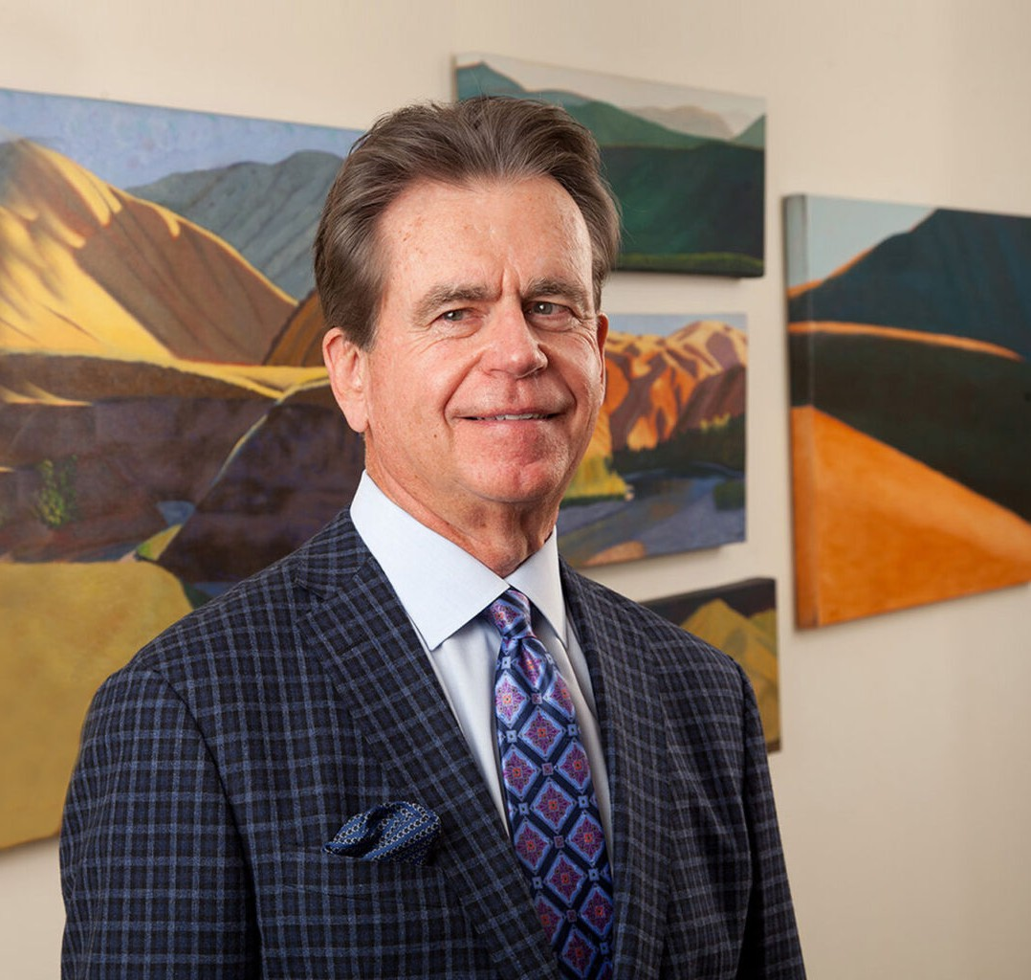

CHRIS H. BYRD

Director

[Business Litigation](https://www.fennemorelaw.com/services/business-litigation/)

[Las Vegas](https://www.fennemorelaw.com/contact-us/las-vegas/)

P: 702.692.8002 F: 702.692.8062

[cbyrd@fennemorelaw.com](mailto:cbyrd@fennemorelaw.com)

**CHRIS H. BYRD**

Chris represents a wide variety of businesses and their owners in commercial transactions, litigation, mediation and arbitration. His experience includes the formation of companies, business sales and acquisitions, mergers, financing transactions and security agreements,

shareholder agreements, employment contracts, construction contracts for owners and general contractors, real property purchase and sale agreements, leases (retail and industrial), distribution agreements, and lien perfection.

When businesses have been unable to resolve their disputes, Chris has represented clients before a variety of state and federal courts, administrative agencies, and dispute resolution forums such as the [American Arbitration Association](https://www.adr.org/), JAMS, and the Nevada Arbitration Association.

Chris enjoys collaborating with his clients, most of whom are business owners or entrepreneurs, and finding common-sense solutions to their business challenges.

Away from work, Chris is an avid cook, traveler and golfer. He served two years as the chairman of the PGA Tour’s Las Vegas Invitational which raised over $2,000,000 for local charities.

# EDUCATION

J.D., Notre Dame Law School

A.B., University of Notre Dame, *magna cum laude*

# AREAS OF PRACTICE

OTHER EXPERIENCE

Aviation, Aerospace and Autonomous Systems Commercial Transactions

Litigation

Business Litigation Business & Finance

Real Estate Construction Law

# REPRESENTATIVE CASES

*Harris Associates v. Clark County School Dist.,* 119 Nev. 638, 81 P.3d 532 (2003)

*Southwest Gas Corp v. Vargas,* 111 Nev. 1064, 901 P.2d 693 (1995)

*Mason v. Fakhimi,* 109 Nev. 1153, 865 P.2d 333 (1993)

# AWARDS AND HONORS

*Best Lawyers in America®,* Commercial Litigation, Construction Law, Litigation – Construction, 2013-2025

*Mountain States Super Lawyers®,* Business Litigation, 2018-2021

*Best Lawyers in America®,* Lawyer of the Year, Construction Law, 2019 *Mountain States Super Lawyers®,* Construction Litigation, 2008-2017 “Legal Elite,” *Nevada Business Magazine,* 2016

*Nevada’s Best Lawyers®*, 2013

*Top Lawyers, Vegas Inc.,* 2013

AV® Preeminent™ Peer Review Rated (the highest rating available), by Martindale-Hubbell

# ARTICLES AND PRESENTATIONS

Co-Author, “Compelling and Staying Arbitration in Nevada,” *Practical Law,* June, 2017 Co-Author, “Enforcing Arbitration Awards in Nevada,” *Practical Law,* November, 2016

# PROFESSIONAL AND COMMUNITY ACTIVITIES

Senior Fellow, Litigation Counsel of America Member, State Bar of Nevada

Member, Clark County Bar Association Member, American Bar Association

Member, Construction Forum, American Bar Association Member, Nevada Trial Lawyers Association

Member, National Institute of Trial Advocates President, Las Vegas Founders’ Foundation

Past President, Las Vegas Founders Club, 1999-2000

Past Chairman, PGA Tour, Las Vegas Invitational, 1997-1998

# ADMISSIONS

Nevada

U.S. District Court, District of Nevada

U.S. Court of Appeals, Ninth Circuit