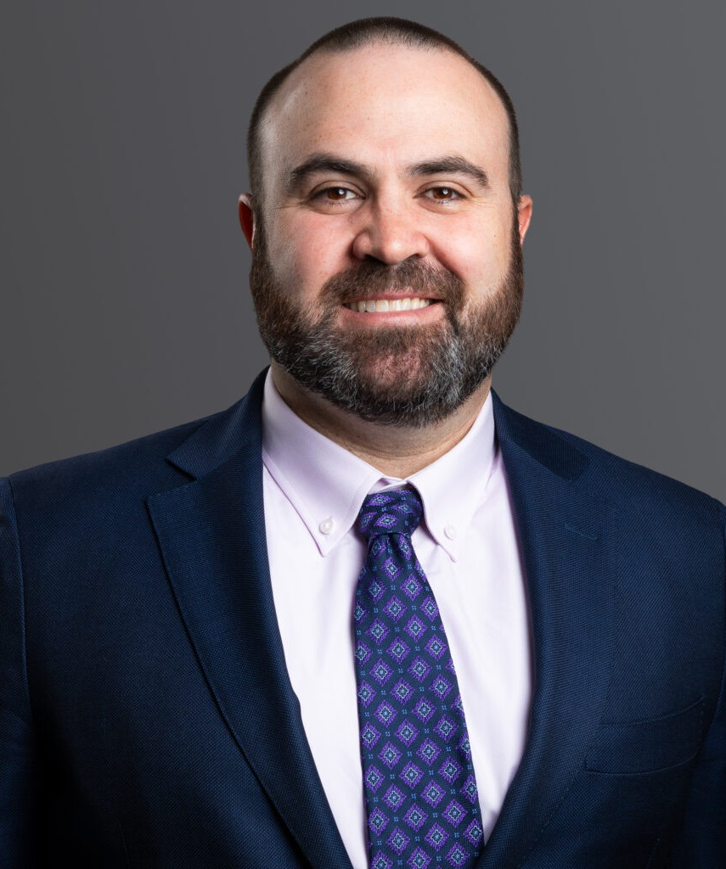

CHRIS W. SCOLARI

Director

[Trusts & Estates](https://www.fennemorelaw.com/services/trusts-estates/)

[Denver](https://www.fennemorelaw.com/contact-us/denver-2/)

P: 303.813.3880 F: 303.291.3201

[Basalt](https://www.fennemorelaw.com/contact-us/basalt/)

P: 970.431.9060 F: 303.291.3201

[cscolari@fennemorelaw.com](mailto:cscolari@fennemorelaw.com)

# CHRIS W. SCOLARI

Chris Scolari is a trust and estates and corporate attorney with expertise in business planning and property law, including Colorado land and resource ownership and conveyance. In his practice, he is focused on working with individuals, business owners, and multi-generation families on an array of estate planning, estate administration, and probate matters ranging from the simple to complex, including the transfer of wealth and closely held businesses, as well as estate tax and

gift planning, planned charitable giving, and supplemental needs trust planning.

Estate planning and wealth transfer can raise sensitive issues and questions, and Chris often works as both a legal advisor and trusted counselor, helping clients leverage legal tools to achieve their goals. He takes pride in finding practical and efficient options to achieve clients’ objectives, and he actively works with other members of a client’s advisory team to achieve desired and cost-effective outcomes across multiple levels.

Chris’ experience also includes other transactional matters such as drafting and negotiating business contracts including governing documents, service agreements, and license

agreements, as well as real property law, including Colorado land and resource ownership matters as well as related family ownership and conveyance issues.

Chris is a member of the Colorado Bar Association’s Trusts and Estates Section and Tax Section and is currently pursuing a Master of Laws (LLM) degree in Taxation from the University of Denver, Sturm College of Law.

Born and raised on Colorado’s Front Range, Chris is proud to serve members of the local

community. He knows that a smart, comprehensive estate plan is a vital tool that can and should grow and change to reflect a family’s changing circumstances. He is honored to be able to serve his clients and help them secure their legacies.

# EDUCATION

J.D., University of Denver

B.A., University of Kansas

# AREAS OF PRACTICE

Trusts & Estates Tax Law

Estate Planning

# REPRESENTATIVE MATTERS

Designed and successfully sought court approval of supplemental needs trust to receive a large judicial personal injury settlement on behalf of a disabled recipient and victim.

Handled the probate and trust administration of multiple sizable estates, including those left by Colorado philanthropist and Colorado art collectors.

Assisted in intergenerational transfers of closely held businesses, maintaining company viability and daily operations, while minimizing tax impacts.

Created tax efficient trust and business ownership plan to facilitate the development of innovative resource extraction company with family ownership.

# PROFESSIONAL AND COMMUNITY AFFILIATIONS

Colorado Bar Association, Trusts & Estates Section, Tax Section Denver Bar Association

Denver Estate Planning Council

Rocky Mountain Estate Planning Council Colorado Attorneys for the Arts

# AWARDS AND HONORS

[*Best Lawyers®*](https://www.bestlawyers.com/lawyers/christopher-scolari/352799)[Ones to Watch: Trusts and Estates, 2023-2025](https://www.bestlawyers.com/lawyers/christopher-scolari/352799)

# ARTICLES AND PRESENTATIONS

Co-Presenter, “Oh, No, You Deedn’t – The Real State of Real Estate Fraud in Decedent Estates,” Colorado Bar Association Estate Planning Retreat, June 2023

Co-Presenter, [“Comments to the Inflation Reduction Act,”](https://www.regulations.gov/comment/IRS-2022-0025-0194) Internal Revenue Service, November 2022

Author, [“W. Virginia: Commercial, Economic Impacts & Implications,”](https://www.moyewhite.com/news-insights/blog/october-2022/w-virginia-commercial%2C-economic-impacts-implicatio) Colorado Real Estate Journal, October 2022

Presenter, “Lifetime Retirement Planning” and “Lifetime Financial Planning,” 67th Annual Employee Benefits Conference, October 2021

Co-Author, [“Proposed Changes to the Federal Tax Law and Their Potential Impact on Existing](https://www.moyewhite.com/news-insights/blog/october-202/proposed-changes-to-the-federal-tax-law-and-their) [Estate Plans,”](https://www.moyewhite.com/news-insights/blog/october-202/proposed-changes-to-the-federal-tax-law-and-their) Firm Blog, October 2021

# ADMISSIONS

Colorado