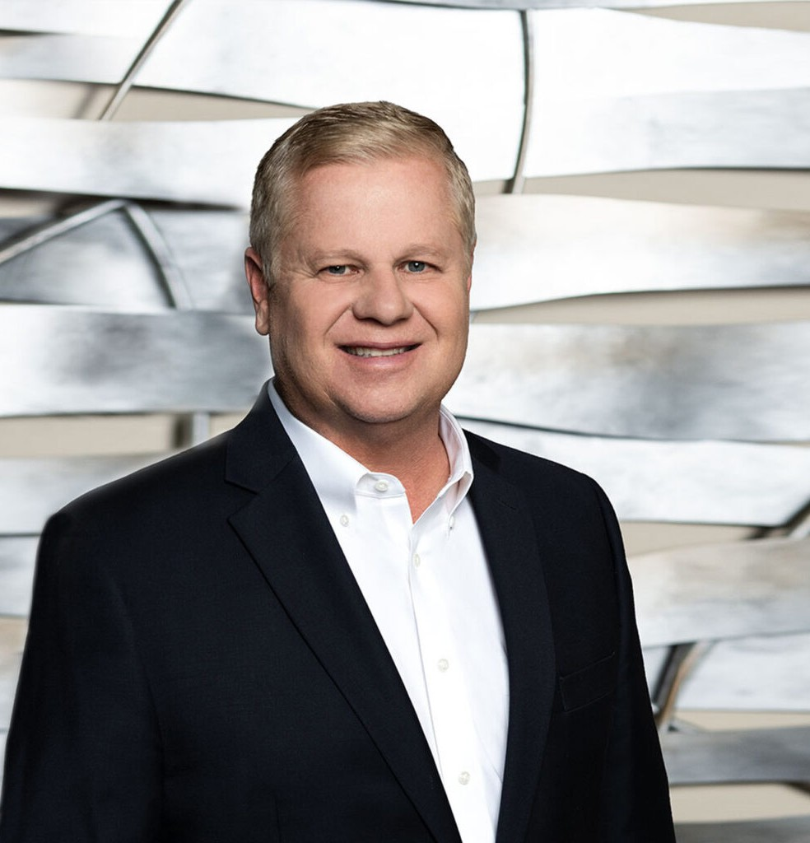

CHRISTOPHER A. BROWN

Director

[Real Estate](https://www.fennemorelaw.com/services/real-estate/)

[Fresno](https://www.fennemorelaw.com/contact-us/fresno/)

P: 559.432.4500 F: 559.432.4590

[cbrown@fennemorelaw.com](mailto:cbrown@fennemorelaw.com)

“

You Miss Every Shot You Don’t Take

- Benjamin Hardy

**CHRISTOPHER A. BROWN**

”

Chris Brown has extensive knowledge in real estate, energy, water, land use, environmental, title insurance, non-profit, secured transactions/banking, and entity formation areas of law. Clients come to him for more than black-letter law; they seek out his over 30 years of experience, including his practical knowledge, and business understanding and application. Chris’s clients find they not only achieve their goals, but they exceed them.

Establishing his reputation on the foundation of a friendly, welcoming and comforting

personality, Chris likes creating and critical thinking where the end product is substantive, like a new facility or non-profit. His experience also includes representing landowners, developers, agriculture, energy companies, business owners, lenders, title companies, banks, non-profits, funeral and cemetery establishments, and government entities. Chris has guided private and public clients through all aspects of real estate and business transactions from acquisitions and financing, entity formation and guidance, to permitting and development, to the holding for

investment or disposition for profit or reinvestment. In addition, should a dispute develop, he will work closely with the firm’s civil litigation and dispute resolution group to resolve the matter. His pragmatic approach allows his clients to achieve an objective in a cost-effective manner.

Chris has experience representing clients before city councils, board of supervisors, planning commissions, regulatory agencies and community organizations. The representation of his title

company clients and their insureds in title and escrow litigation provides added value to his real estate clients. His environmental legal services include representing clients through all facets of regulatory and legal hurdles related to compliance and cleanup, including UST and superfund cleanups and regulatory violations. His representation of companies engaged in oil and gas, wind power, solar power and other alternative energy projects includes development, financing

and operation. Chris takes great pride in being able to foresee hurdles in advance and taking early action to counter, in order to bring about his client’s goal, often time without the client even knowing how it could have turned out if he wasn’t so forward-thinking. His non-profit work gives also gives his life and career deep satisfaction.

Chris cherishes his family time, when he’s lucky enough to have time with his adult children, time with his wife, along with hiking, skiing, rafting, watching a good movie, Peloton cycling, walks, and having a good sense of humor to get through the stressful times of our work.

# EDUCATION

J.D., Santa Clara University School of Law B.S., Occidental College

# AREAS OF PRACTICE

**OTHER EXPERIENCE**

Environmental Law

Nonprofit and Tax-Exempt Organizations Title Insurance Law

Real Estate Natural Resources Business & Finance Agribusiness

Land Use Advanced Energy

# AWARDS AND HONORS

Recipient, American Jurisprudence Award

AV® Preeminent™ Peer Review Rated (the highest rating available), by Martindale-Hubbell

# ARTICLES AND PRESENTATIONS

[Interview, ” A Conversation on Leadership and Life in the Law,” Fennemore Blog, December 1,](https://www.fennemorelaw.com/i-truly-like-helping-people-its-part-of-me/) [2022](https://www.fennemorelaw.com/i-truly-like-helping-people-its-part-of-me/)

[Interview, “Central Valley Talk,” CentralValleyTalk.com,](https://www.youtube.com/watch?reload=9&v=kuh3mh0vHy4&feature=youtu.be) [February 12, 2021](https://www.youtube.com/watch?reload=9&v=kuh3mh0vHy4&feature=youtu.be)

# PROFESSIONAL AND COMMUNITY ACTIVITIES

Board Member, Fresno County Economic Development Corporation Member, California Land Title Association

Steering Committee, Real Property Section Fresno County Member, Real Property Section California State Bar Member, American Planning Association

Member, Association of Environmental Professionals Member, Funeral Director Association

Member, Interment Association of California

General Counsel, San Joaquin River Parkway and Conservation Trust, Inc. Former General Counsel, Junior League of Fresno

Founder, Charter School

Member, Fresno Nonprofit Advancement Council’s Consultants Circle Member, Leadership Fresno Class XI

General Counsel, Fresno State Alumni Association

# ADMISSIONS

California