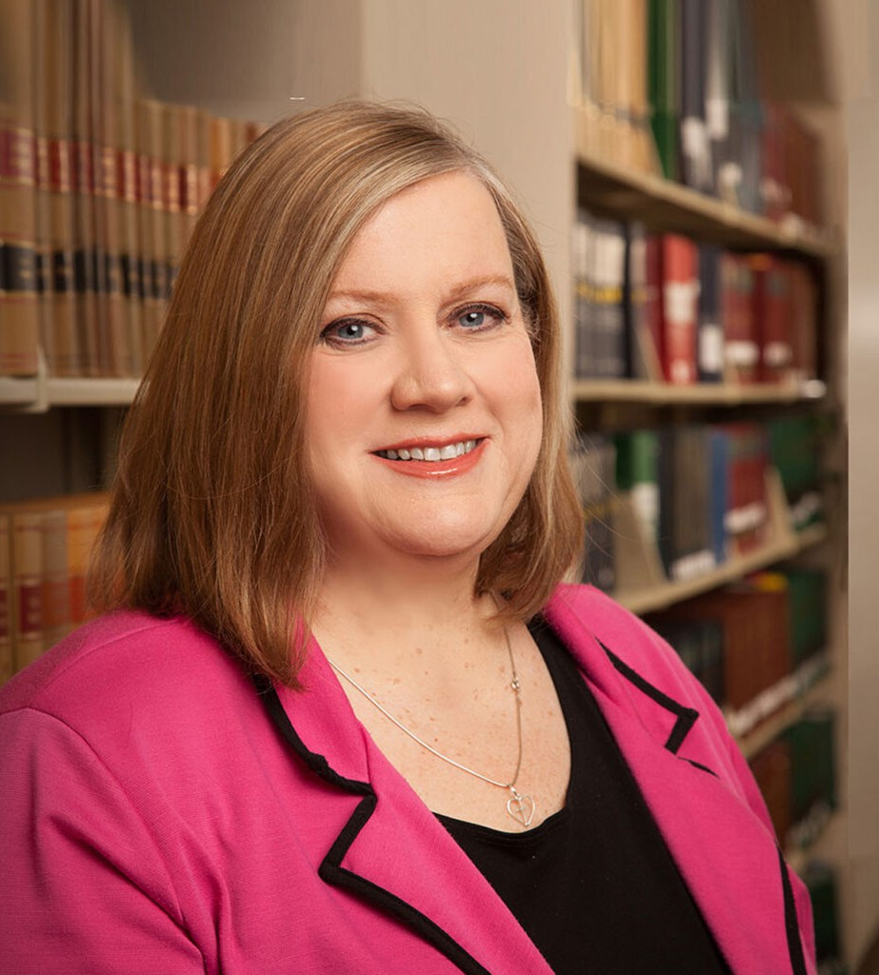

COLLEEN A. DOLAN

Pronouns: she/her

Director

[Real Estate](https://www.fennemorelaw.com/services/real-estate/)

[Reno](https://www.fennemorelaw.com/contact-us/reno/)

P: 775.788.2218 F: 775.778.2219

[cdolan@fennemorelaw.com](mailto:cdolan@fennemorelaw.com)

**COLLEEN A. DOLAN**

Colleen focuses her practice in the areas of real estate development, general real estate

transactions, leasing, commercial finance and corporate law. Her experience includes lender liability and real property transactions including renewable energy, finance mining, and finance and business acquisitions.

At a young age, Colleen watched “Perry Mason” which inspired her to pursue a career as an attorney. When she’s not at work, Colleen volunteers with Northern Nevada Kairos, a prison ministry organization.

# EDUCATION

J.D., University of California, Davis School of Law B.A., University of Nevada, Reno, with distinction Order of the Coif

# AREAS OF PRACTICE

OTHER EXPERIENCE

Bankruptcy

Real Estate Finance and Lending Real Estate

Business & Finance Gaming & Hospitality Mining Law Cannabis Business

# AWARDS AND HONORS

*Best Lawyers in America®,* Corporate Law, Real Estate Law, 1995-2025 “Legal Elite,” *Nevada Business Magazine,* 2015-2016, 2019-2020 Recommended in *The Legal 500 US,* Real Estate, 2015

*Best Lawyers in America®,* Reno Lawyer of the Year for Real Estate Law, 2013

*Mountain States Super Lawyers®*

AV® Preeminent™ Peer Review Rated (the highest rating available), by Martindale-Hubbell

# ARTICLES AND PRESENTATIONS

[Author, “Avoid Significant Consequences by Reading the Boilerplate in Every Contract,”](https://issuu.com/snmginteractive/docs/businesslaw.101016-rfs/13)

[*Northern Nevada Business Weekly,*](https://issuu.com/snmginteractive/docs/businesslaw.101016-rfs/13)[October 9, 2016](https://issuu.com/snmginteractive/docs/businesslaw.101016-rfs/13)

# PROFESSIONAL AND COMMUNITY ACTIVITIES

Member, American College of Real Estate Lawyers Member, Washoe County Bar Association Member, Clark County Bar Association

Member, American Bar Association Member, State Bar of Nevada

# ADMISSIONS

Nevada

# LANGUAGES

Spanish, Fluent