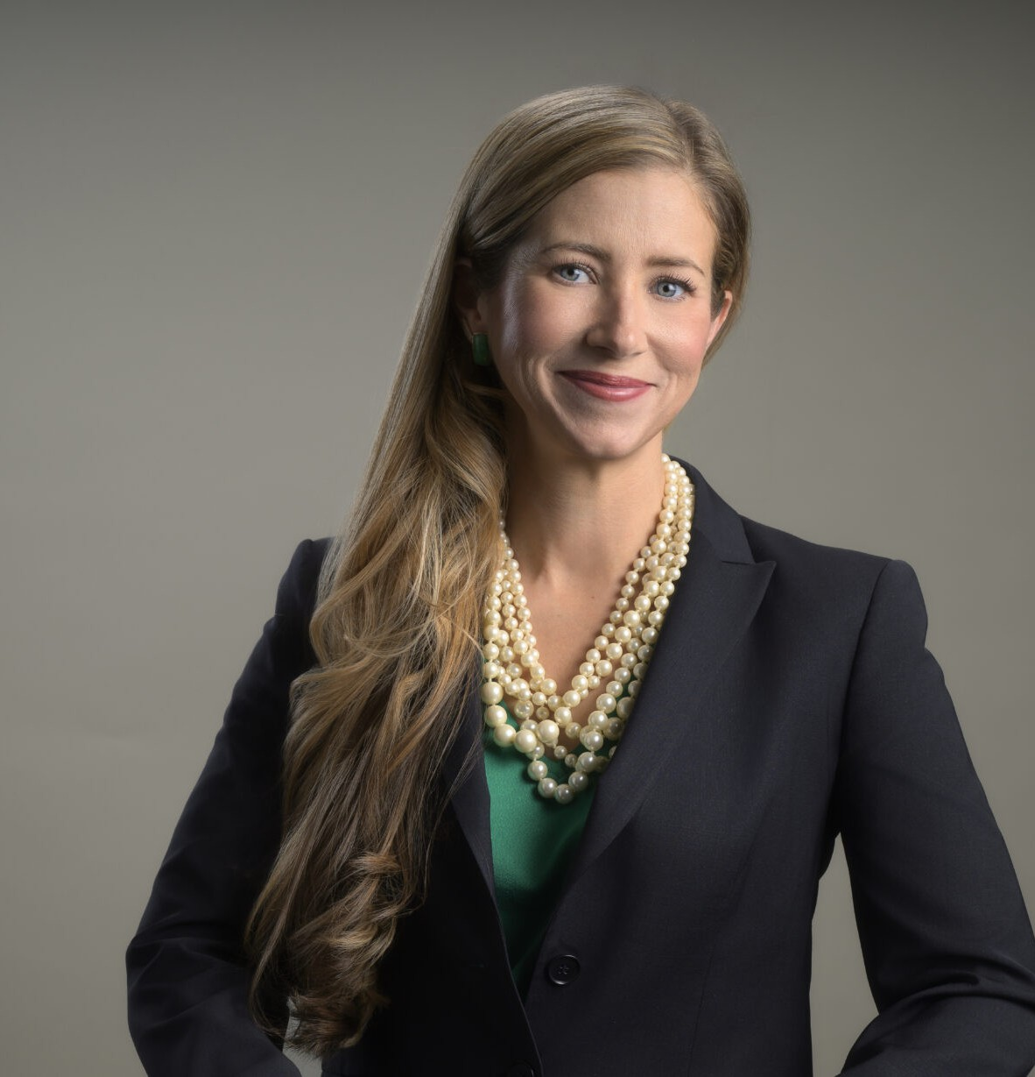

COURTNEY MILLER O’MARA

Director

[Business Litigation](https://www.fennemorelaw.com/services/business-litigation/)

[Reno](https://www.fennemorelaw.com/contact-us/reno/)

P: 775.788.2205 F: 775.788.2206

[comara@fennemorelaw.com](mailto:comara@fennemorelaw.com)

“

Even paradise must have rules.

-Mary Oliver, Long Life

**COURTNEY MILLER O'MARA**

”

Courtney is a director in our Reno office, and her practice focuses on business litigation,

creditors’ rights and bankruptcy litigation, and trusts and estates matters, including planning, administration, and litigation

In recent years, her practice has included substantial litigation involving rights under commercial loans, both inside and outside of bankruptcy. She has also worked extensively on litigation matters involving contract and business disputes.

Courtney approaches each case like a puzzle; while some are more complex than others, it is the challenge of solving the puzzle that intrigues her. She takes a practical approach to the law, and carefully outlines options and obligations to her clients.

Courtney is experienced in helping clients navigate civil discovery, including depositions and expert issues. She has helped obtain many favorable results for her clients, including millions of dollars in judgments, dismissal of claims through dispositive motions, favorable settlements and other victories.

In her spare time, Courtney enjoys gardening, running, the beauty of Lake Tahoe and spending time with her family.

# EDUCATION

J.D., University of Southern California, Gould School of Law B.A., University of Notre Dame, *magna cum laude*

Judicial Clerkship, Honorable Robert A. McQuaid, Jr., United States Magistrate for the District of Nevada

Judicial Extern, Honorable Justice Michael Nott, California Court of Appeal, 2nd District Production Editor, *The Southern California Review of Law and Women’s Rights*

# AREAS OF PRACTICE

**OTHER EXPERIENCE**

Commercial Contingency Litigation Litigation

Mediation and Arbitration Real Estate Litigation

Trust and Estate Litigation Business Litigation

Estate Litigation Estate Planning

Financial Restructuring Trusts & Estates

# AWARDS AND HONORS

*Best Lawyers in America®,* Commercial Litigation, 2020-2025

*Mountain West Super Lawyers®,* 2024

“Legal Elite,” *Nevada Business Magazine,* 2011-2022

*Benchmark Litigation*, 40 & Under Hot List, 2018-2020

*Mountain States Super Lawyers Rising Stars®,* 2010, 2015-2020

Twenty Under 40, Reno Tahoe Young Professional Network/*Reno Gazette-Journal,* 2015 Nevada Women’s Fund Woman of Achievement, 2013

# ARTICLES AND PRESENTATIONS

Featured, “Woman Suing Parents for Secretly Spending Her College Fund Backed Online,” Newsweek, March 23, 2023

[Interview, “A Conversation On Leadership & Life In The Law With Courtney Miller O’Mara,”](https://www.fennemorelaw.com/im-incredibly-thankful-for-the-team-approach/) [Fennemore Blog, November 17, 2022](https://www.fennemorelaw.com/im-incredibly-thankful-for-the-team-approach/)

Interview, “Death Disputes/Post-Mortem Creditor Claims,” KKOH, February 4, 2021

Quoted, “Eviction Moratorium Phase-Out Begins,” Nevada Public Radio, July 8, 2020

Speaker, “Forms of Administration and When They Are Used,” “First Steps and Notices, Executor Duties, Opening the Estate,” “Marshalling the Assets,” “Estate and Trust Contests, Disputes, Challenges,” Estate Administration Bootcamp, National Business Institute Seminar, August 5-6, 2019

Speaker, “Probate and Trust Essentials for Realtors,” June 13, 2019 Speaker, “What Every Realtor Should Know About Probate,” May 23, 2019

Speaker, “What Every Realtor Should Know About Probate Trusts & Powers of Attorney,” April 4- 5, 2019

Speaker, “Levitate Probate: What Every Nevada Realtor Should Know About Probate,” Master Class, August 7, 2018

Interview, “Lawyers in Love,” *The Good Life*, July 2018

Author, “Document Preservation Obligations When Litigation is on the Horizon,” *Northern Nevada Law Journal*, November 6, 2017

Speaker, “Maintaining the Estate and Preparing Assets for Distribution,” “Beneficiary

Distributions, Final Account and Closing of the Estate,” National Business Institute Seminar, September 12, 2017

Interview, “Grow Nevada Team Radio,” KFOY (Reno, Nevada), October 14, 2015

# PROFESSIONAL AND COMMUNITY ACTIVITIES

Member, Washoe County Bar Association

Member, Probate Bar Association of Washoe County Member, Northern Nevada Women Lawyers Association Member, Probate Section, State Bar of Nevada

Board Member, Development Committee, Nevada Discovery Museum Secretary and Member of the Board of Trustees, Casa de Vida, 2013-2017 Co-President, Northern Nevada Bankruptcy Bar Association, 2013-2015

Member, Local Rules Committee, United States Bankruptcy Court for the District of Nevada, 2015

Graduate, Chamber of Commerce’s Leadership Reno-Sparks program, 2010

Member, Bruce R. Thompson Chapter, American Inns of Court, Associate, 2006-2008, 2010; Barrister, 2011-2014

Social Chair, Young Lawyers Section, State Bar of Nevada, 2007-2010

Notre Dame Club of Northern Nevada, President, 2007-2010; Service Chair, 2006-2007

# ADMISSIONS

Nevada