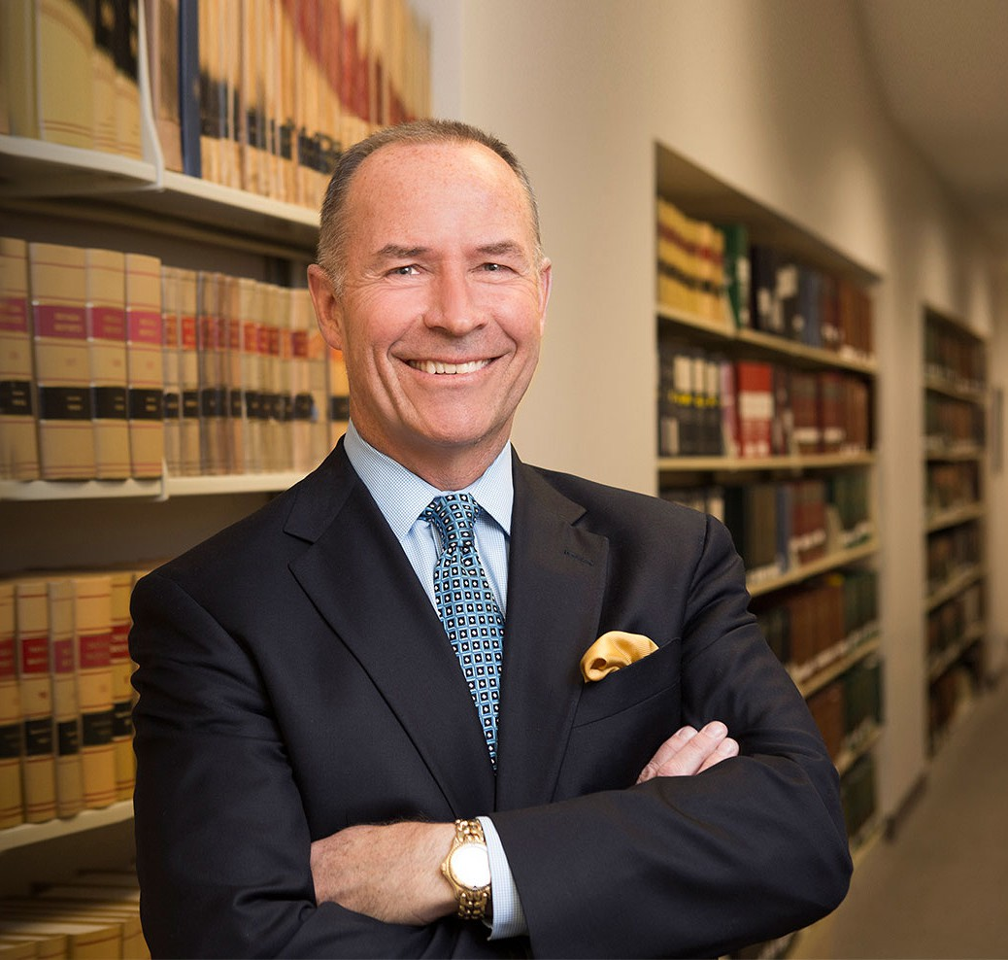

CRAIG ETEM

Director

[Real Estate](https://www.fennemorelaw.com/services/real-estate/)

[Reno](https://www.fennemorelaw.com/contact-us/reno/)

P: 775.788.2224 F: 775.788.2225

[cetem@fennemorelaw.com](mailto:cetem@fennemorelaw.com)

“

If you think you can or you think you can't, you're right.

-Generally attributed to Henry Ford

**CRAIG ETEM**

”

Craig Etem represents a number of clients, and loves working cooperatively with them to solve complex problems. He takes great pride in listening to their concerns carefully as deep understanding often leads to creative strategies. This business attorney’s experience covers a wide range of business matters, including real estate acquisitions, corporate mergers,

acquisitions, recapitalization and formations, and loan workouts and foreclosures. As the managing partner of our Reno office, Craig has been instrumental in the city’s rebirth as a tech hotspot, and this seasoned finance attorney leads the firm’s venture accelerator program in northern Nevada, which focuses on providing affordable legal services to startup companies.

As a prominent member of the community, Craig is a member of the board of directors for the

[Economic Development Authority of Western Nevada](https://www.edawn.org/) (EDAWN). He also led a team of attorneys that produced the Nevada section of the Lexis Practice Advisor, an online publication that provides practical guidance, legal content and analysis designed for use by finance attorneys handling transactional matters.

Prior to becoming an attorney, Craig held a number of jobs, he was a part-time painter, worked at McDonald’s and then drove floats in the parades at Disneyland – culminating in numerous appearances as Pluto! He also worked as a property manager and budget analyst. In the latter role, while working with some attorneys on a property tax appeal, their passion for the work led Craig to applying to and then attending law school. Outside of the office, you will probably find him on the go with his wife and two daughters – the whole family hits the ski slopes together, and Craig and his wife cycle, run and workout together.

# EDUCATION

J.D., Georgetown University Law Center, *magna cum laud*e

B.S. California State University, Long Beach

# AREAS OF PRACTICE

**OTHER EXPERIENCE**

Real Estate Finance and Lending Real Estate

Business & Finance Mergers & Acquisitions Cannabis Business

# AWARDS AND HONORS

*Best Lawyers in America®,* Banking & Finance Law, Corporate Law, Real Estate Law, 2008-2025

*Best Lawyers in America®,* Lawyer of the Year, Corporate Law, 2020 “Legal Elite,” *Nevada Business Magazine,* 2015-2019, 2021

Highly Regarded – Banking, IFLR 1000, 2019 Recommended in *The Legal 500 US,* Real Estate, 2015 *Chambers USA,* Leading Lawyers for Business

AV® Preeminent™ Peer Review Rated (the highest rating available), by Martindale-Hubbell

# ARTICLES AND PRESENTATIONS

[Interview, “Find solutions to a problem your client is facing,” Fennemore Blog, July 22, 2021](https://www.fennemorelaw.com/find-solutions-to-a-problem-your-client-is-facing-with-craig-etem/)

[Quoted, “Let’s Celebrate Random Acts of Kindness Day,” Fennemore Blog, February 18, 2021](https://www.fennemorelaw.com/insights/blogs/2021/let-s-celebrate-random-acts-of-kindness-day) Quoted, “Home means Nevada? No, it means office,” *This is Reno,* November 11, 2020

Quoted, “Fennemore Craig merger gives Reno branch a ‘deeper bench’,” *Northern Nevada Business Weekly,* August 3, 2020

Interview, “Face the State: Small Business Loans,” KTVN TV, May 23, 2020 Interview, “Face the State: Small Business Loans,” 2 News, May 10, 2020

Quoted, “Small Business Will Have Another Chance to Receive Financial Assistance,” 2 News Reno, April 24, 2020

Quoted, “‘We Hope This Ends Quickly’: Northern Nevada Businesses Face Uncertain Future,”

*Northern Nevada Business Weekly*, March 20, 2020

Co-author, “What You Need to Know About Opportunity Zone Funds,” *Daily Press*, May 5, 2019

[Co-author, “What You Need to Know About Opportunity Zone Funds,” Fennemore Client Alert,](https://clientalert.fennemorecraig.com/opportunity_zones) [April 30, 2019](https://clientalert.fennemorecraig.com/opportunity_zones)

[Co-author, “What You Need to Know About Opportunity Zone Funds,”](https://www.insidesources.com/what-you-need-to-know-about-opportunity-zone-funds/) [*Inside Sources,*](https://www.insidesources.com/what-you-need-to-know-about-opportunity-zone-funds/)[April 29,](https://www.insidesources.com/what-you-need-to-know-about-opportunity-zone-funds/) [2019](https://www.insidesources.com/what-you-need-to-know-about-opportunity-zone-funds/)

Co-author, “Inside the Do’s and Don’ts of How to Name Your Company (Opinion),” *Northern Nevada Business View,* October 31, 2018

Co-author, “All Dollars Are Not Created Equal,” *Northern Nevada Business Weekly Smart Money,* March 19, 2018

# PROFESSIONAL AND COMMUNITY ACTIVITIES

Member, Board of Directors, Economic Development Authority of Western Nevada (EDAWN) Member, Board of Directors, Food Bank of Northern Nevada

Member, Washoe County Bar Association Member, State Bar of Nevada

Member, American Bar Association Advisory Board, Nevada Land Trust

Volunteer Tutor, Washoe County School District

# ADMISSIONS

Nevada