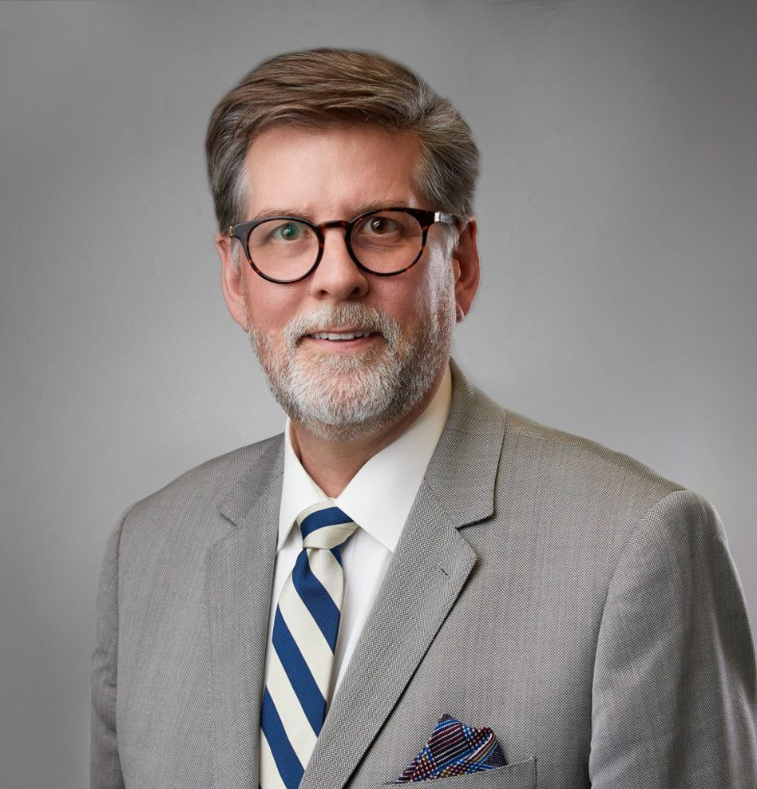

DAVID D. WERNER

Director

[Business Litigation](https://www.fennemorelaw.com/services/business-litigation/)

[San Bernardino](https://www.fennemorelaw.com/contact-us/san-bernardino/)

P: 909.890.4499 F: 909.890.9877

[dwerner@fennemorelaw.com](mailto:dwerner@fennemorelaw.com)

“

Never look down on anybody unless you are helping him up.

- Jesse Jackson

**DAVID D. WERNER**

”

David Werner is a director in our San Bernardino office who has more than 25 years of civil litigation experience and focuses his practice primarily on matters involving business and real estate disputes, business torts, contracts, healthcare coverage, and probate, estate, and trust litigation.

As a probate, estate, and trust litigator, he has a unique understanding of the various and complex facets of probate and trust law, as well as other related areas of the law, such as financial elder abuse. David has briefed and argued cases before the California Court of

Appeal for Districts Two, Four, and Five. He also briefed and successfully argued a case that was accepted for review by the California Supreme Court.

In addition to practicing law, David is a member of several local professional organizations and supports multiple community and philanthropic organizations. Previously, he brought his interest and expertise in elder law to Plymouth Tower, a senior residence facility, where he served as board president of its foundation.

# EDUCATION

J.D., Whittier College School of Law, *cum laude*

B.B.A., Pacific Union College

# AREAS OF PRACTICE

Business Litigation

Trusts & Estates Estate Planning

# REPRESENTATIVE MATTERS

*Wilson v. Parker, Covert & Chidester,* 28 Cal.4th 811 (2002)

*Rivas v. Safety-Kleen Corp*., 98 Cal.App.4th 218 (2002)

*Ghazarian v. Wheeler*, 177 F.R.D. 482 (C.D. Cal. 1997)

# PROFESSIONAL AND COMMUNITY ACTIVITIES

Member, State Bar of California Member, State Bar of Oregon

Member, Riverside County Bar Association, Chair, Civil Litigation Section, 2008-2010 Attorney Master, Leo A. Deegan Inn of Court

Trustee, Riverside City Library

Member, Riverside City Library Foundation Planning Commissioner, City of Loma Linda

Committee Member, Loma Linda University Church Building Fund Committee Member, Parkview Community Hospital Foundation

Board Chair, Plymouth Tower Senior Residence Foundation,

Member, The Unforgettables Foundation, Board Chair from 2011-2012

Advisory Board Member and Revenue Committee Member, Big Brothers Big Sisters of the Inland Empire

# AWARDS AND HONORS

American Jurisprudence Award Recipient

# ADMISSIONS

California Oregon

U.S. District Court, Central District of California