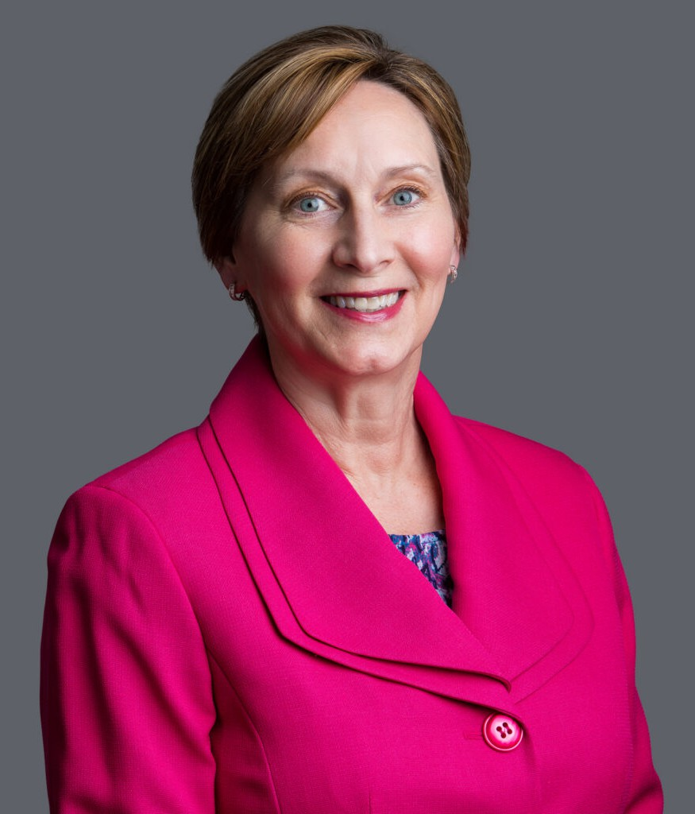

DEBRA J. POLLY

Director

[Trusts & Estates](https://www.fennemorelaw.com/services/trusts-estates/)

[Phoenix](https://www.fennemorelaw.com/contact-us/phoenix/)

P: 602.916.5309 F: 602.916.5509

[Las Vegas](https://www.fennemorelaw.com/contact-us/las-vegas/)

P: 602.916.5309 F: 602.916.5509

[Reno](https://www.fennemorelaw.com/contact-us/reno/) [dpolly@fennemorelaw.com](mailto:dpolly@fennemorelaw.com)

“

In Iroquois society, leaders are encouraged to remember seven generations in the past and consider seven generations in the future when making decisions that affect the people.

Wilma Mankiller

”

# DEBRA J. POLLY

Deb Polly is a director in our Trusts & Estates practice group who works out of our Phoenix office. Her practice focuses on probate; estate & trust administration; estate planning; retirement benefits planning and administration; estate tax, gift tax, and generation-skipping transfer tax planning, strategy and compliance; and family settlement agreements and negotiation. Deb is also an Arizona Certified Public Accountant.

Originally from Sioux City, Iowa, Deb began her professional career working for KPMG, one of the “Big Four” – the four largest accounting firms in the United States. She gravitated to work involving consulting for estate planning strategies, however, to fully assist her clients, it was

evident that she needed to become an attorney – and this led her to law school and a rewarding career in the legal profession. In her work involving estate planning and

administration, Deb takes great pride in creating customized solutions – never a “one size fits all” approach – on behalf of her esteemed clients.

[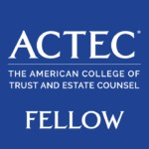](https://www.actec.org/find-a-lawyer/profile/%23/Debra-Polly/34767)



Deb is a fellow of the American College of Trust and Estate Counsel (ACTEC), a group of peer- elected trust and estate attorneys spanning the U.S. and abroad. She regularly delivers presentations on estate and trust law to fellow attorneys and CPAs, and is a Certified Specialist in estate and trust law through the State Bar of Arizona.

Outside of the office, Deb’s life is an enjoyable blur as the mother of three teenagers, including a daughter on a travel ice hockey team. Her family also loves exploring Arizona, especially Flagstaff where one memorable trip in July involved torrential hail on the ski lift, and hot cocoa served once they made it back to the lodge.

# EDUCATION

J.D., Arizona State University Sandra Day O’Connor School of Law Master of Taxation, Arizona State University W.P. Carey School of Business

B.S. in Accountancy, Arizona State University W.P. Carey School of Business

# AREAS OF PRACTICE

Trusts & Estates Estate Planning

# AWARDS AND HONORS

Super Lawyers Southwest Rising Stars 2012-2015

# ARTICLES AND PRESENTATIONS

Organizations: State Bar of Arizona, Arizona ACTEC Meeting, National Business Institute, Valley Estate Planners, East Valley Estate Planning Council, Arizona Community Foundation, Planned Giving Roundtable, Catholic Community Foundation, Central Phoenix Women

Topics: Advanced Generation-Skipping Transfer Tax and Marital Deduction Issues, Income Tax Planning for Trusts and Estates, Probate Process, Generation-Skipping Transfer Tax Issues in Gift Tax Returns, Other Various Generation-Skipping Transfer Tax Issues (War Stories, General, and Current Status), Tips for Effective Estate Planning

# PROFESSIONAL AND COMMUNITY ACTIVITIES

Fellow, American College of Trust and Estate Counsel

Vice Chair, Secretary and Board Member of the Estate Planning, Probate, and Trust Section of the Maricopa County Bar Association; Probate & Trust Section of the State Bar of Arizona

Co-Author, LexisNexis Practical Guidance Estate Planning Forms Member, Tax Section, American Institute of Certified Public Accountants

Member, Tax & Legal Seminar Committee, Arizona Community Foundation / Center for Jewish Philanthropy

Valley Estate Planners Past President (2011) and prior Board Member

Former Vice President, Treasurer, and Board Member for the Copper State Skating Club Presenter, Financial Series, Fresh Start Foundation for Women

Volunteer, Habitat for Humanity Volunteer, Fennemore Foundation

Regular Volunteer at her children’s school (Great Hearts Academies)

# ADMISSIONS

Arizona Nevada