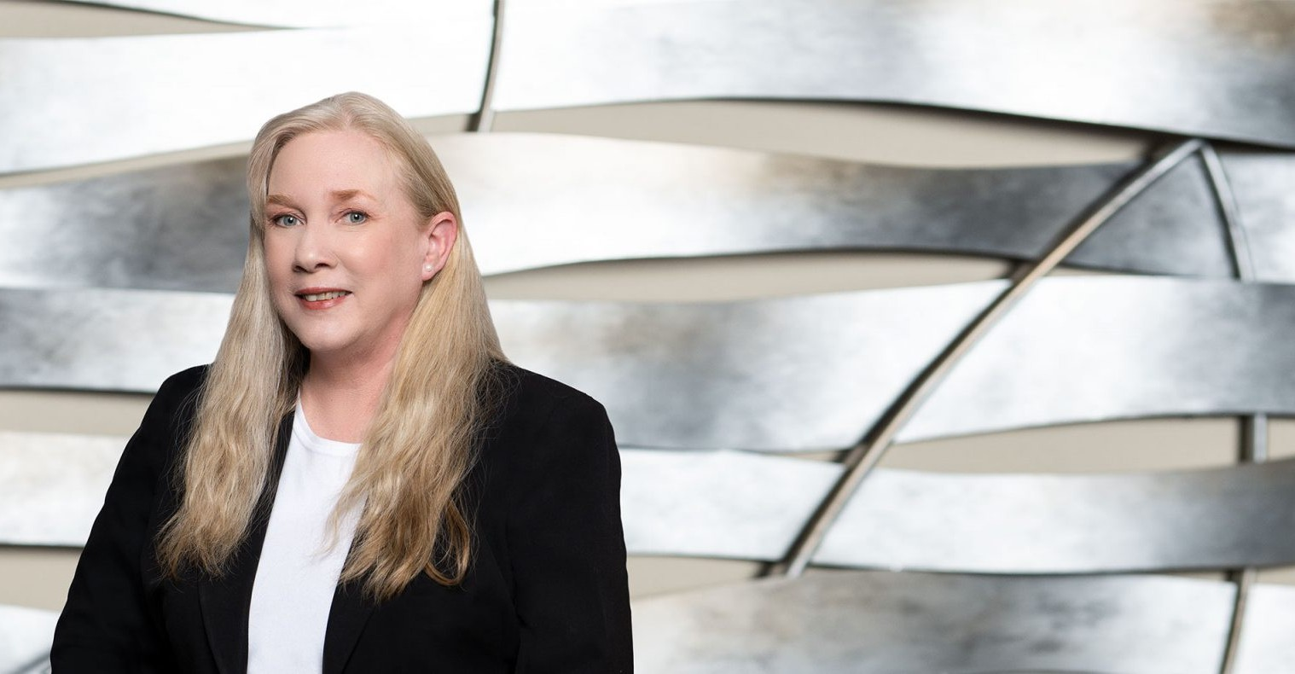

DENISE J. CHAFFEE

Paralegal

[Business Litigation](https://www.fennemorelaw.com/services/business-litigation/)

[Fresno](https://www.fennemorelaw.com/contact-us/fresno/)

P: 559.432.4500 F: 559.432.4590

[dchaffee@fennemorelaw.com](mailto:dchaffee@fennemorelaw.com)

**DENISE J.**“**CHAFFEE**

Nothing can dim the light that shines from within. -Maya Angelou

”

Denise Chaffee is a proactive, efficient, and highly organized paralegal with our firm and is a Certified eDiscovery Specialist from the Association of Certified eDiscovery Specialists. She attended California State University in Fresno (CSUF), graduating *summa cum laude*, as well as the San Joaquin College of Law Paralegal Program where she was valedictorian.

After working in the restaurant business for 27 years, Denise felt the need for a change. Her husband was going to law school and she saw a television commercial for the school’s paralegal program. She started the application process the next day. To this day, Denise enjoys assisting our clients to achieve the best possible outcome for their case.

As a University of California Certified Master Gardener, nothing decompresses Denise like puttering in her garden. She also designs and creates bead and wire work earrings, and is a voracious reader.

# EDUCATION

B.A., *summa cum laude*, California State University, Fresno Paralegal Program, San Joaquin College of Law

# AREAS OF PRACTICE

Business Litigation Construction Law

Employment & Labor

# PROFESSIONAL AND COMMUNITY ACTIVITIES

Certified eDiscovery Specialist, Association of Certified eDiscovery Specialists, 2018-2020 Member and Advanced Certified Paralegal, National Association of Legal Assistants (NALA) Member, Association of Certified eDiscovery Specialists

Director, Paul (Doc) and Jean Chaffee Scholarship Committee

Master Gardener, University of California Cooperative Extension, 2007-2018 Past President, Fresno County Legal Professionals Association, 2010-2015

# ADMISSIONS

*\*Not licensed to the practice of law*