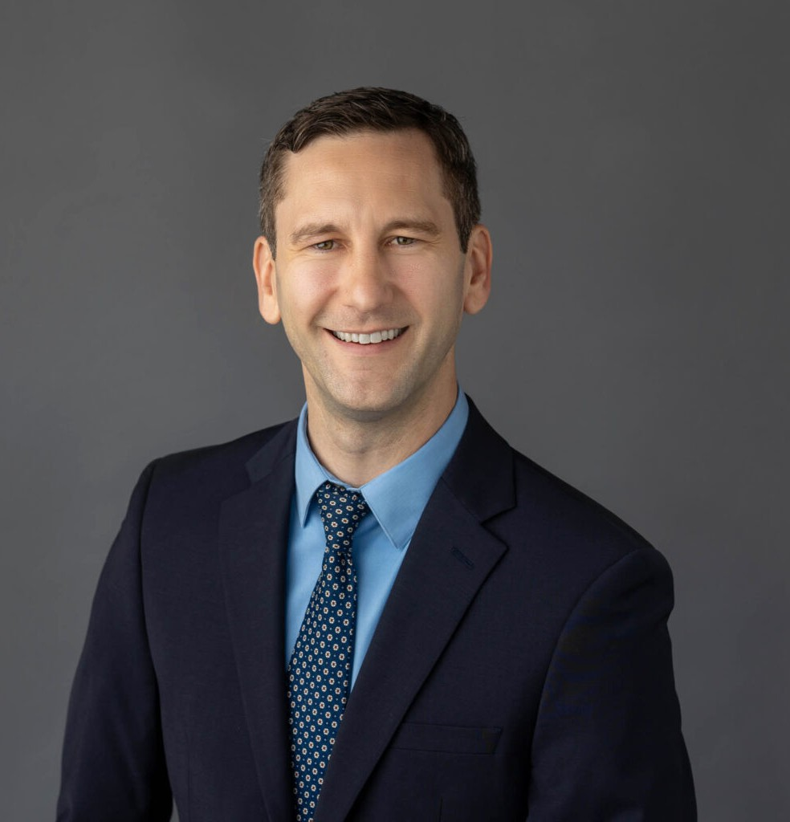

DONALD J. SLATER

Of Counsel

[Trusts & Estates](https://www.fennemorelaw.com/services/trusts-estates/)

[Oakland](https://www.fennemorelaw.com/contact-us/oakland/)

P: 510.622.7509 F: 510.622.7509

[dslater@fennemorelaw.com](mailto:dslater@fennemorelaw.com)

# DONALD J. SLATER

Don is an estate planning attorney with over ten years of experience and a focus on estate and gift taxation. He serves high net worth clients and structures estate plans for smooth and tax-

efficient transitions tailored to each client’s circumstances and wishes. Don also advises and assists trustees, executors, and surviving spouses in trust and probate administrations to guide them through the complex laws, duties, and unique family dynamics they face.

Having litigated trust, estate, and conservatorship matters through trial, Don relies on his experience and practical knowledge to help clients reduce litigation risk in their plans, meet their fiduciary responsibilities as trustees, counsel them through difficult situations, and settle disputes.

Don has an L.L.M. (Master of Laws) in taxation with an emphasis on estate and gift tax and earned his J.D. with honors at U.C. College of the Law, San Francisco (formerly U.C. Hastings).

He has been selected to the Super Lawyers® Rising Stars list each year since 2018 and appeared as a live legal commentator regarding the conservatorship of Britney Spears on over eight major news networks, including BBC World News and Fox News.

In his free time, Don enjoys playing board games with his wife and friends, chasing after his terrier, getting outdoors, and seeing live music.

# EDUCATION

LL.M., University of San Francisco, School of Law

J.D., University of California, College of the Law, San Francisco (Formerly U.C. Hastings) B.S., University of Washington

# AREAS OF PRACTICE

Trusts & Estates Estate Planning

Tax Law

# AWARDS AND HONORS

Rising Star, Super Lawyers, 2018-2024

# PROFESSIONAL AND COMMUNITY ACTIVITIES

Board Member, Litigation and Mediation Committee, Chair of East Bay Trusts & Estates Lawyers, 2023

# ADMISSIONS

California