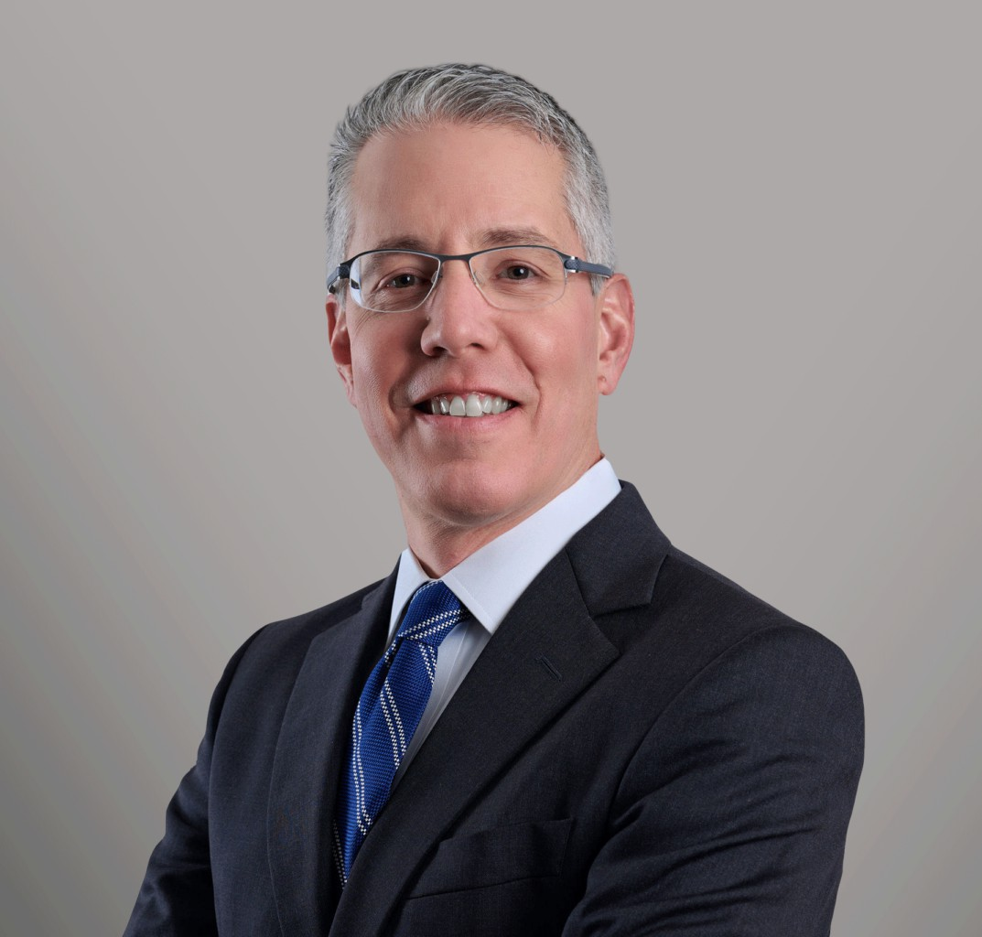

DUNCAN E. MANVILLE

Director

[Business Litigation](https://www.fennemorelaw.com/services/business-litigation/)

[Seattle](https://www.fennemorelaw.com/contact-us/seattle/)

P: 206.749.0500

F: 206.749.0600

[dmanville@fennemorelaw.com](mailto:dmanville@fennemorelaw.com)

# DUNCAN E. MANVILLE

Duncan Manville is a creative, solution-oriented advisor and litigator. Dedicated to client- centered representation, he helps entities (both private and public) and individuals avoid

disputes, and, when necessary, resolve them through negotiation, mediation, arbitration and litigation. He consistently achieves excellent results for his clients through a mix of pragmatic counseling and strong advocacy.

Duncan understands that every case presents unique issues and challenges, and that legal disputes – whether embryonic or active – don’t lend themselves to cookie-cutter solutions. In each case, he works closely with his client to develop a clear picture of the background giving rise to the conflict, to clarify business objectives and strategic options, and to develop and efficiently implement a case plan aimed at accomplishing his client’s goals.

Duncan has deep experience in a wide range of litigation matters. He has helped clients resolve disputes valued at a few thousand dollars, and has successfully represented large corporate clients in multi-million-dollar bet-the-company litigation. He handles breach-of-contract,

employment, intellectual-property, real-estate and securities cases, lawsuits involving a variety of tort claims, and other commercial disputes. He regularly serves as local counsel for out-of-state clients litigating cases in Washington. He also represents government entities in employment

cases, landslide and land-use litigation, and other complex disputes that defy categorization. He is well-versed in all phases of trial and appellate work, and has argued multiple cases before the Washington State Supreme Court.

Over the years, Duncan has been a cooperating attorney with the ACLU, and has represented the Fremont Sunday Market and many other clients pro bono. He has been active in the Federal Bar Association of the Western District of Washington, and is a Past President of the Board of Directors of On the Boards, a contemporary performing arts organization. He graduated cum laude from the University of Chicago Law School.

When not in the office, Duncan spends as much time as he can with his wife (also a lawyer) and their two lovely daughters. His other interests include cycling, hiking, and taking many, many

photos, some of which are in focus.

# EDUCATION

J.D., University of Chicago Law School, *cum laude*

A.B., Princeton University

# AREAS OF PRACTICE

Business Litigation

Employment & Labor Cannabis Business

Eminent Domain

# REPRESENTATIVE MATTERS

***Sound Mind & Body, Inc. v. City of Seattle, et al.*** Defended operators of Fremont Sunday

Market against lawsuit alleging that market was injuring adjacent business; obtained dismissal of all claims on summary judgment, and appellate order affirming dismissal.

***Lane v. Port of Seattle, et al.*** Defended King County in class action alleging that acquisition of rail corridor for use in trail system exceeded governmental authority; obtained dismissal of all claims on summary judgment.

***Bradburn v. North Central Regional Library District.*** Constitutional free speech challenge to library district’s Internet filtering policy; argued case before Washington Supreme Court.

***Simmons v. State of Washington and Simmons v. Arnold-Williams, et al.*** Represented State of Washington and several individual defendants in state and federal lawsuits alleging race

discrimination; obtained dismissal of all claims on summary judgment.

***Eagle Harbor Holdings LLC, et al. v. Ford Motor Company.*** Served as local counsel in defending against $250M patent-infringement lawsuit relating to automobile collision- avoidance and infotainment systems; litigation ended in defense verdict.

***Gamble v. City of Seattle, et al.*** Defended City of Seattle against discrimination and failure-to- accommodate claims; obtained dismissal of some claims on summary judgment, and defense verdict on remaining claims after three-week jury trial.

***Public Utility District No. 1 of Snohomish County v. City of Everett***. Defended City of Everett against claims for negligence, inverse condemnation, trespass and nuisance arising out of flooding that allegedly resulted from backup of combined sewer and stormwater system during severe thunderstorm; obtained settlement for fraction of damages claimed.

***Plausible Products, LLC v. Washington State Liquor and Cannabis Board.*** Represented cannabis retailer in appeal challenging WSLCB’s issuance of administrative violation notices related to advertising signage; obtained order holding that statutes at issue unconstitutionally burdened commercial speech, and granting relief from agency action.

***GunUp, Inc. v. Media Lodge, Inc.*** Represented firearms media and marketing company in lawsuit against entity that had acquired client’s subsidiary in exchange for cash and stock, and against certain officers of defendant entity; obtained summary judgment on liability under Washington State Securities Act and merger agreement, and $2.5 million judgment after bench trial.

***Coalview Centralia, LLC v. TransAlta Centralia Mining LLC.*** Represented owner and operator of coal-fired power plant in $16 million dispute with contractor hired to dredge and reprocess waste coal slurry; obtained favorable settlement.

***Himmelman v. City of Everett.*** Defended City of Everett against homeowner claims for inverse condemnation and negligence arising from landslide; after protracted litigation, plaintiffs voluntarily dismissed all claims with prejudice.

***A and R Solar SPC v. American States Ins. Co.*** Represented solar installer in bad-faith action against insurance carrier; obtained favorable settlement.

***Kulinovsky v. City of Everett and Credible Commodities, LLC.*** Represented cannabis retailer in competitor’s LUPA appeal challenging City of Everett’s approval of client’s application to establish marijuana retail use; obtained dismissal of appeal.

***Wallace/Scott Bellevue II, LLC v. City of Bellevue***. Defended City of Bellevue against lawsuit seeking declaratory judgment and injunction that would have allowed developer to encroach on City-owned sidewalk and utility easement; obtained dismissal of claims on summary judgment.

# AWARDS AND HONORS

Best Lawyers in America, 2018-2025

Washington Super Lawyers Top 100 List, 2015 and 2024 Washington Super Lawyers, 2008-2024

Washington Rising Stars, 2002-2008

4.9 AV Preeminent Rating from Martindale-Hubbell

10.0 Rating on Avvo.com

# ARTICLES AND PRESENTATIONS

Presenter, Landslide Litigation: Legal Theories and Strategies, Landslides in Washington CLE Conference, Law Seminars International, 2017

Presenter, Landslides: The Science, Changing Regulations, Risk Assessment in Public Policy and Proof in Litigation, Law Seminars International, 2014

Presenter, Libraries, Internet Filters, the First Amendment and the Law, Washington Library Association/Oregon Library Association Conference, 2013

Presenter, Internet Filtering in Public Libraries: Bradburn, et al. v. North Central Regional Library District, Washington Library Association Conference, 2011

Presenter, E-Discovery, Advanced E-Discovery Conference, 2009

[Profile of Judge Richard A. Jones](http://www.fba-wdwash.org/newsletters/FBAFall08.pdf), Federal Bar Association of the Western District of Washington News, Fall 2008

Presenter, Issues Relating to Condominium Development and the Management of

Homeowners’ Associations, Legal Aspects of Condominium Development and Homeowners’ Associations, 2007

Presenter, Unequal Network Access, ACLU Biennial Conference, 2007

Presenter, Recently-enacted Construction Legislation, Mealey’s Pacific Northwest Construction Defect Conference, 2006

Presenter, Issues Relating to the Establishment and Operation of Homeowners’ Associations, Establishing and Operating Homeowners’ Associations: Understanding the Legal Issues, 2006

[Profile of Judge James P. Donohue](http://www.fba-wdwash.org/newsletters/FBAFall06.pdf), Federal Bar Association of the Western District of Washington News, Fall 2006

Co-Author with Kevin Swan, [Ninth Circuit Judicial Conference Focuses on Human Rights, Race](http://www.fba-wdwash.org/newsletters/FBAFall04.pdf) [and Diversity](http://www.fba-wdwash.org/newsletters/FBAFall04.pdf), Federal Bar Association of the Western District of Washington News, Fall 2004

[Federal Judiciary Faces Funding Crisis](http://www.fba-wdwash.org/newsletters/FBAFall04.pdf), Federal Bar Association of the Western District of Washington News, Fall 2004

[U.S. Supreme Court to Decide Landmark Free-Exercise Case](http://www.fba-wdwash.org/newsletters/FBAFall03.pdf), Federal Bar Association of the Western District of Washington News, Fall 2003

[Profile of Judge Ronald B. Leighton](http://www.fba-wdwash.org/newsletters/FBASummer03.pdf), Federal Bar Association of the Western District of Washington News, Summer 2003

[The Consummate Judge: Best Wishes to U.S. Magistrate Judge John L. Weinberg on His](http://www.fba-wdwash.org/newsletters/FBAFall02.pdf) [Retirement](http://www.fba-wdwash.org/newsletters/FBAFall02.pdf), Federal Bar Association of the Western District of Washington News, Fall 2002

[Profile of U.S. Attorney John McKay](http://www.fba-wdwash.org/newsletters/FBASpring02.pdf), Federal Bar Association of the Western District of Washington News, Spring 2002

[Seattle’s New Federal Courthouse: Dignified, Accessible, Contemporary,](http://www.fba-wdwash.org/newsletters/FBAFall01.pdf) Federal Bar Association of the Western District of Washington News, Fall 2001

[Innovative Federal Program Brings New Courthouse to Seattle](http://www.fba-wdwash.org/newsletters/FBASpring01.pdf), Federal Bar Association of the Western District of Washington News, Spring 2001

# PROFESSIONAL AND COMMUNITY ACTIVITIES

Former member and Past President, Board of Directors, On the Boards Former Cooperating Attorney, American Civil Liberties Union of Washington Member, Federal Bar Association of the Western District of Washington Member, Washington State Bar Association

# ADMISSIONS

Washington

United States Court of Appeals, Ninth Circuit

United States District Court, Western District of Washington United States District Court, Eastern District of Washington