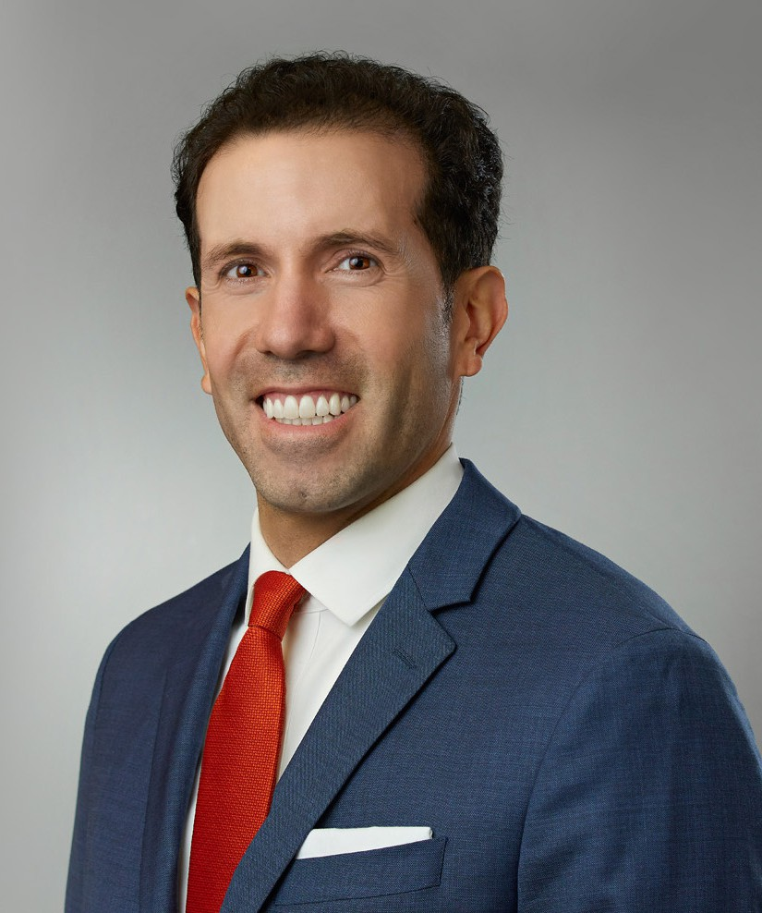

ENRIQUE SCHAERER

Of Counsel

[Business Litigation](https://www.fennemorelaw.com/services/business-litigation/)

[Las Vegas](https://www.fennemorelaw.com/contact-us/las-vegas/)

P: 702.692.8013 F: 702.692.8099

[Reno](https://www.fennemorelaw.com/contact-us/reno/)

P: 702.692.8013 F: 702.692.8099

[eschaerer@fennemorelaw.com](mailto:eschaerer@fennemorelaw.com)

# ENRIQUE SCHAERER

Enrique Schaerer is an Of Counsel attorney who works in our Business Litigation and Estate Litigation practice groups from our Las Vegas office. His practice focuses on business and commercial matters, contract disputes, trust-and-estate litigation, employment cases, and criminal defense and investigations. Enrique has represented clients on high-profile, high-stakes cases in state and federal courts in Arizona, California, and Nevada.

A skilled trial lawyer and appellate advocate, Enrique believes clients are best served by a comprehensive, big-picture strategy—even at the earliest stages of a case. Previously, he served as a criminal prosecutor and tried dozens of misdemeanor and felony cases. He has briefed and argued civil and criminal issues before various courts, including the U.S. Supreme Court, the Ninth Circuit Court of Appeals, and the Nevada Supreme Court.

From 2008-2009, he served as a judicial law clerk for the Honorable James V. Selna of the U.S. District Court for the Central District of California. From 2009-2010, he served as a judicial law clerk for the Honorable Carlos T. Bea of the U.S. Court of Appeals for the Ninth Circuit.

# EDUCATION

J.D., Yale Law School

Potter Stewart Prize, Moot Court Winner Senior Editor, *Yale Law Journal*

B.A., University of Notre Dame, *summa cum laude*

Valedictorian of Class of 2005 Helen Kellogg Prize

Herman Crown Award Phi Beta Kappa

# AREAS OF PRACTICE

Business Litigation Cannabis Business

# REPRESENTATIVE MATTERS

Advised and counseled on legal protections under Nevada law for spendthrift trusts with assets worth billions of dollars.

Crafted complex legal argument that helped settle multi-million-dollar dispute over holographic will on favorable terms for prestigious out-of-state university.

Exposed fabricated claims by plaintiff that resulted in complete dismissal of federal lawsuit with serious allegations against client under quasi-criminal, sex-trafficking law.

Spearheaded litigation in probate/guardianship cases with 3/4 of a billion dollars in trust at stake.

Achieved restatement of trust over allegations of testamentary incapacity/undue influence. Achieved removal of personal representative of estate and successor trustee of trust.

Achieved trial verdict for damages and order for company to recover assets from exmanager.

Achieved arbitration award that police department had just cause to fire police officer. Achieved order issuing pretrial writ of habeas corpus and dismissing felony perjury charge. Achieved favorable settlement in mediation of federal employment discrimination claims. Deposed expert witness and helped settle trust contest of hundreds of millions of dollars.

Deposed party opponent and her accountant in litigation over personal service agreement.

Negotiated favorable settlement of trust contest of millions of dollars for prestigious out-of- state university.

Removed notice of pendency of litigation on real estate and had quiet title action dismissed.

Represented applicants seeking protection orders and defendants charged with nonviolent crimes.

# AWARDS AND HONORS

*Best Lawyers in America®,* Commercial Litigation, 2024 and 2025

# ARTICLES AND PRESENTATIONS

Featuring, “On the Move,” Las Vegas Business Press, November 1, 2022

*Proving the Constitution: Burdens of Proof and the Confrontation Clause*, 55 University of Richmond Law Review 491, 2021

*What the Heller?: An Originalist Critique of Justice Scalia’s Second Amendment Jurisprudence*, 82 University of Cincinnati Law Review 795, 2014

*A Rose by Any Other Name: Why a Parens Patriae Action Can Be a “Mass Action” under the Class Action Fairness Act of 2005*, 6 N.Y.U. Journal of Legislation & Public Policy 39, 2013

*Intragroup Discrimination in the Workplace: The Case for “Race Plus,”* 45 Harvard Civil Rights– Civil Liberties Law Review 57, 2010

*Liability in Robotics: An International Perspective on Robots as Animals*, Advanced Robotics, 2010 (co-authored with Richard C. Kelley, Monica Nicolescu, and Micaela Gomez)

*Robots as Animals: A Framework for Liability and Responsibility in Human-Robot Interactions*, Proceedings of the 18th IEEE Symposium on Robot & Human Interactive Communication, 2009 (co-authored with Richard C. Kelley and Monica Nicolescu)

# PROFESSIONAL AND COMMUNITY ACTIVITIES

Part-Time Olin-Searle Fellow, Federalist Society, UCLA Law School, 2016-2019 Member, Executive Committee, Yale Law School Association, 2011-2014

Member, College of Arts and Letters Advisory Council, University of Notre Dame, 2009-2012

# ADMISSIONS

All Nevada and California state courts

U.S. Supreme Court

U.S. Court of Appeals for the Ninth Circuit

U.S. District Court for the Central District of California

U.S. District Court for the Southern District of California

U.S. District Court for the District of Nevada

# LANGUAGES

Spanish, Fluent

Italian, Conversational