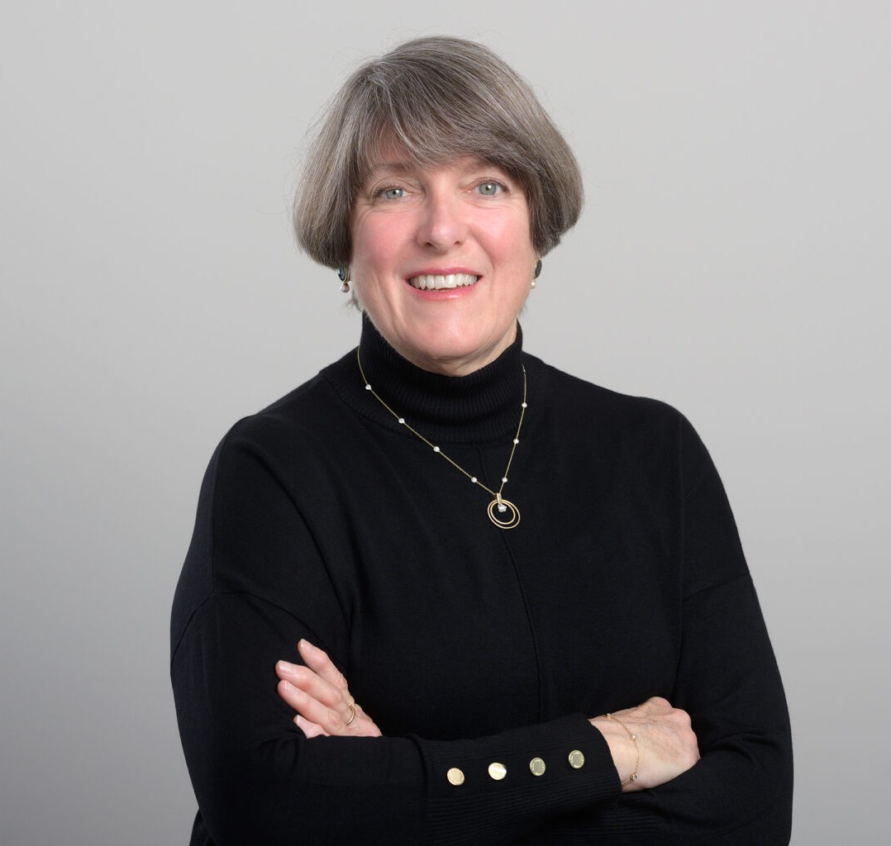

ERIN BARBER

Paralegal

[Business Litigation](https://www.fennemorelaw.com/services/business-litigation/)

[San Diego](https://www.fennemorelaw.com/contact-us/san-diego/)

P: 619.595.3283 F: 619.595.3283

[ebarber@fennemorelaw.com](mailto:ebarber@fennemorelaw.com)

“

Worry is a thin stream of fear trickling through the mind. If encouraged, it cuts a channel into which all other thoughts are drained.

Arthur Somers Roche

”

**ERIN BARBER**

Erin Barber is a seasoned paralegal with a wealth of experience spanning multiple areas of law.

Currently focused on business and civil litigation, insurance coverage, and construction law matters, Erin has a diverse background that includes employment law and securities litigation.

One of the most intriguing aspects of her career was working on an airplane crash litigation. Erin’s career began in an era when discovery involved poring over roomfuls of bankers’ boxes filled with documents. Today, she uses technology to navigates through terabytes of discovery data.

Outside of the office, Erin makes time to serve the underprivileged with her Church community. She also enjoys sports when she can find the time including, skiing, skateboard racing, golf,

standup paddleboarding, and hiking.

# AREAS OF PRACTICE

Business Litigation Insurance Coverage Construction Law

# EDUCATION

Paralegal Certificate, University of San Diego B.S., San Diego State University

# PROFESSIONAL AND COMMUNITY ACTIVITIES

Former Member, Women in eDiscovery, San Diego Paralegal Association

# ADMISSIONS

*\*Not licensed to the practice of law*