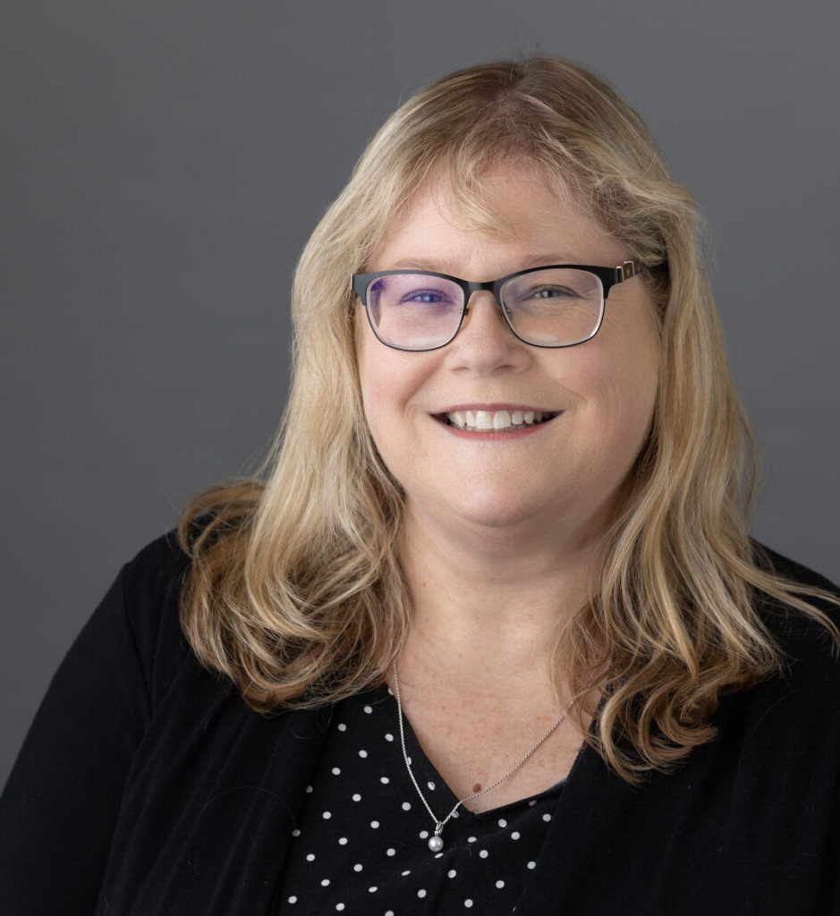

GINA OLDENBURG

Operations Manager/Administration

[Gina Oldenburg](https://www.fennemorelaw.com/people/professionals/gina-oldenburg/)

[Oakland](https://www.fennemorelaw.com/contact-us/oakland/)

P: 510.622.7556 F: 510.834.1928

[goldenburg@fennemorelaw.com](mailto:goldenburg@fennemorelaw.com)

# GINA OLDENBURG

Gina Oldenburg is a key figure in our team, boasting over 20 years of experience in the legal industry. As our Office Operations Manager, she has been instrumental since her start. Gina’s deep knowledge of the legal sector’s evolution ensures our operations run smoothly and

efficiently. Her expertise enables her to adeptly handle the complexities of the industry.

In her role, Gina works closely with our C-Team, providing strategic insights and contributing to resource optimization. She is crucial in supporting our remote workforce, ensuring a unified and effective work environment across geographical boundaries. Gina’s commitment to employee well-being and productivity has made her an invaluable asset in maintaining a cohesive team dynamic.

Gina is also a passionate advocate for workplace efficiency and employee satisfaction. Her

leadership style emphasizes inclusivity, productivity, and harmony. Outside of work, she enjoys exploring the Bay Area’s rich cultural diversity and participates actively in community initiatives. Gina’s blend of experience, adaptability, and dedication not only enriches our workplace but also drives us towards continued success.

# ADMISSIONS

*\*Not licensed to the practice of law*