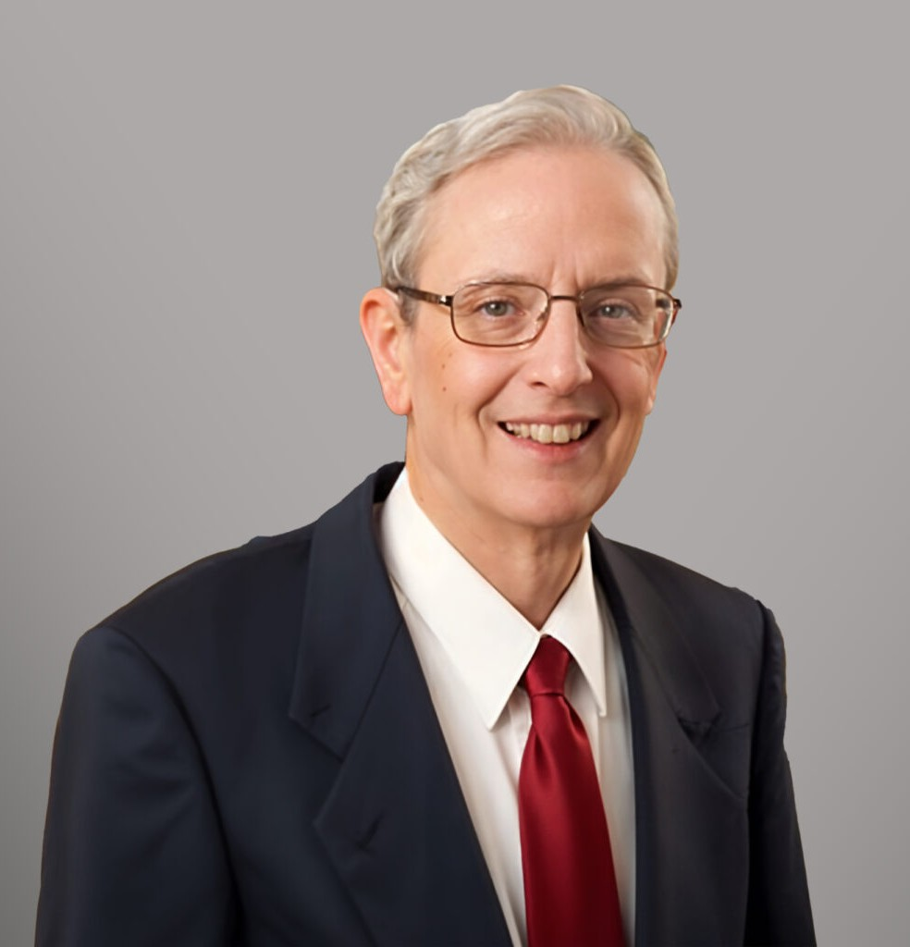

GREGORY BORGEL

Land Use Professional

[Government Relations & Regulatory](https://www.fennemorelaw.com/services/government-relations-and-regulatory-law/)

[Las Vegas](https://www.fennemorelaw.com/contact-us/las-vegas/)

P: 702.791.8219 F: 702.692.8076

[gborgel@fennemorelaw.com](mailto:gborgel@fennemorelaw.com)

# GREGORY BORGEL

Gregory is a land use consultant with our government relations and regulatory group. He brings specialized knowledge from his prior employment with the Clark County Planning Department and service as the Zoning Administrator and head of the Zoning Division to assist clients in the complicated procedures of land use. He represents clients in the areas of home building, commercial development, health care, resort casinos, and high rise development.

# EDUCATION

M.B.A., University of Nevada, Las Vegas M.A., University of California, Los Angeles

B.A., *summa cum laude*, University of California, Los Angeles

# AREAS OF PRACTICE

*\*Not licensed to the practice of law*

Government Relations & Regulatory

# PROFESSIONAL AND COMMUNITY ACTIVITIES

Member, and past Vice Chair and Chair, Clark County Affordable Housing Committee Member, Las Vegas City Technology Center Committee, 1991

Member, Code Update Committee, City Title 19A, 1997 Member, Code Update Committee, County Title 30, 1999-2000

# ADMISSIONS

*\*Not licensed to the practice of law*