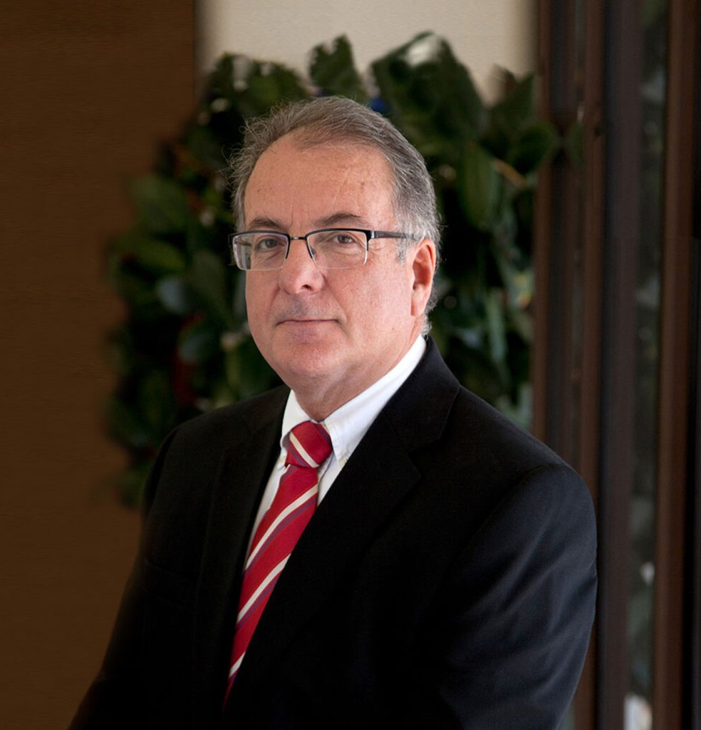

HECTOR G. ARANA

Director

[Business & Finance](https://www.fennemorelaw.com/services/business-and-finance/)

[Nogales](https://www.fennemorelaw.com/contact-us/nogales/)

P: 520.281.3482 F: 520.281.3499

[harana@fennemorelaw.com](mailto:harana@fennemorelaw.com)

**HECTOR G. ARANA**

Hector practices in the areas of agribusiness, corporate and securities, estate planning and probate, international, real estate, and tax law. He has significant experience in handling tax disputes with the IRS Office of Appeals, district counsel offices, and advance pricing teams.

Fluent in Spanish, Hector represents both foreigners and U.S. residents with U.S. businesses and property interests and deals with the business and tax aspects of those businesses and holdings.

# EDUCATION

J.D., University of Arizona, James E. Rogers College of Law B.S., Accounting, Arizona State University, *cum laude*

# AREAS OF PRACTICE

OTHER EXPERIENCE

International Business & Finance Estate Planning Agribusiness

Tax Law Real Estate

Estate Litigation Trusts & Estates

# AWARDS AND HONORS

*Best Lawyers in America®,* International Trade and Finance Law, Tax Law, 2005-2025

AV® Preeminent™ Peer Review Rated (the highest rating available), by Martindale-Hubbell

# PROFESSIONAL AND COMMUNITY ACTIVITIES

Member, State Bar of Arizona

Member, Santa Cruz County Bar Association Member, American Bar Association

Member, American Association of Attorney Certified Public Accountants Former Board Member, International Law Center, University of Arizona

# ADMISSIONS

Arizona

U.S. District Court, District of Arizona

U.S. Court of Appeals, Ninth Circuit

U.S. Supreme Court

U.S. Tax Court

# LANGUAGES

Spanish, Fluent