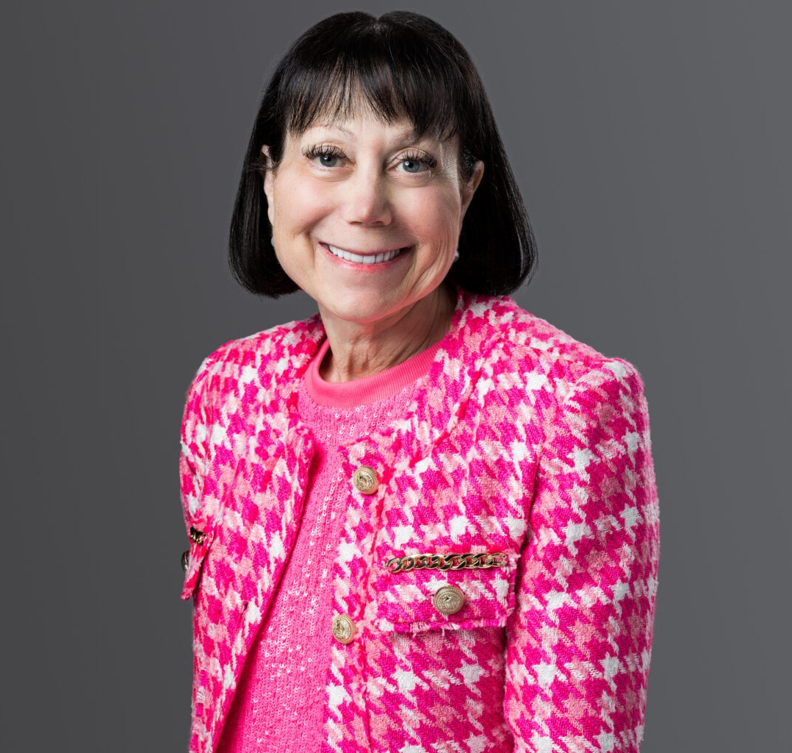

HOPE LEIBSOHN

Director

[Trusts & Estates](https://www.fennemorelaw.com/services/trusts-estates/)

[Phoenix](https://www.fennemorelaw.com/contact-us/phoenix/)

P: 602.916.5328 F: 602.916.5999

[hleibsohn@fennemorelaw.com](mailto:hleibsohn@fennemorelaw.com)

# HOPE LEIBSOHN

Hope Leibsohn brings extensive experience in estate planning, covering wills, trusts, charitable

techniques, estate freezes, and advanced wealth transfer strategies. She is a valued member of Fennemore’s Estate Planning Department, where she focuses on crafting customized legacy plans that go beyond tax planning strategies to reflect each client’s unique family dynamics and core life values.

Hope is known for her creative solutions, particularly in designing trusts that incentivize beneficiaries to contribute positively to society. She lives by the personal and professional motto of “how best may I serve,” which underscores her commitment to addressing her clients’ needs with dedication and empathy. In her practice, Hope provides comprehensive counsel on estate, gift, and multi-generational tax planning. She offers guidance on the creation of wills, trusts, powers of attorney, and on navigating gift and generation-skipping transfer taxes. Her approach to lifetime wealth transfer includes the use of qualified personal residence trusts, grantor retained annuity trusts, family limited partnerships, and various planned giving strategies.

Hope is adept at establishing charitable remainder trusts, charitable lead trusts, private

foundations, spousal lifetime access trusts, and other sophisticated estate and gift tax planning methods. Her unique approach to legacy planning is distinguished by customizing trust language to encourage younger generations to become productive, contributing members of society, reflecting her innovative and thoughtful approach to estate planning.

# EDUCATION

J.D., University of California, Los Angeles School of Law B.A., *summa cum laude*, University of Arizona

# AREAS OF PRACTICE

Trusts & Estates Estate Planning

# PROFESSIONAL AND COMMUNITY ACTIVITIES

Former Board of Directors, Celebrity Fight Night

Former Board of Directors, Boys & Girls Clubs of the East Valley Former Board of Directors, Social Venture Partners

# AWARDS AND HONORS

*Best Lawyers in America®,* Trusts and Estates*,* 2025

# ADMISSIONS

Arizona