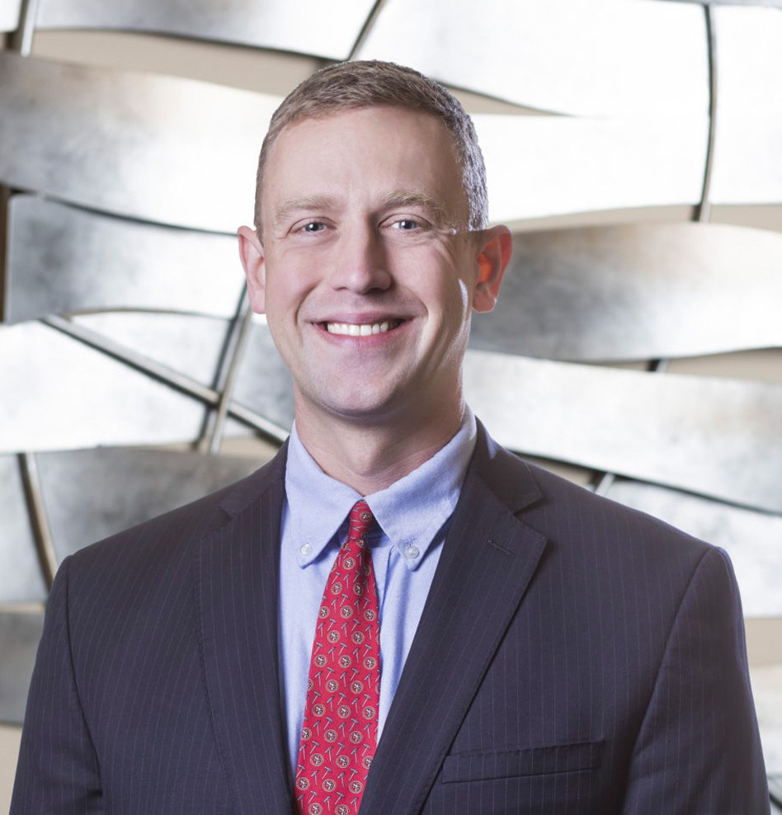

J. JACKSON WASTE

Director

[Business Litigation](https://www.fennemorelaw.com/services/business-litigation/)

[Fresno](https://www.fennemorelaw.com/contact-us/fresno/)

P: 559.446.3203 F: 559.432.4590

[jwaste@fennemorelaw.com](mailto:jwaste@fennemorelaw.com)

“

Nobody ever lives their life all the way except bullfighters.

-Quote from Hemingway’s “The Sun Also Rises.”

**J. JACKSON WASTE**

”

Jackson Waste is a director in our firm’s Business Litigation practice group who works out of our Fresno office. He has served as lead counsel in numerous complex, high-value cases across California. His broad-based litigation and financial restructuring practice operates at the intersection of law and finance, where he utilizes his knowledge of legal remedies and financial concepts to craft efficient and effective enforcement strategies for lenders and other creditors.

Jackson’s business litigation experience includes real property disputes, trade secret

misappropriation, and partnership and corporate governance disputes, as well as the defense of actions brought under the Fair Credit Reporting Act (“FCRA”) and Telephone Consumer Protection Act (“TCPA”). In 2021, he was named a “Rising Star” by *Super Lawyers* Magazine, placing him in the top-2.5% of attorneys in Northern California.

Originally a teacher, Jackson spent two years in rural New Mexico working for Teach For

America, a national non-profit organization that aims to close the educational achievement

gap in low-income areas. After law school, Jackson clerked for the Hon. Christopher Klein of the United States Bankruptcy Court for the Eastern District of California. During that time, he was able to work on many complex bankruptcy cases, including the City of Stockton’s landmark municipal bankruptcy.

Jackson believes that lawsuits are won by harnessing the power of narrative: every lawsuit is a contest between two stories, and the best lawyers use their knowledge of the law to tell their client’s story in the clearest, most compelling way possible. Jackson is truly happiest when he’s solving his clients’ most complicated problems.

Married with a young son, Jackson enjoys growing vegetables in his backyard garden and cooking for his family.

Business Litigation Financial Restructuring

# EDUCATION

J.D., University of California Davis School of Law B.A., University of California, Berkeley

Business Litigation Financial Restructuring

# AREAS OF PRACTICE

**OTHER EXPERIENCE**

Bankruptcy Business Litigation

Financial Restructuring

# ARTICLES AND PRESENTATIONS

Author, “Inflating Away Till,” *American Bankruptcy Institute Journal*, July 2022

Presenter, “Rights and Obligations Following Death of Borrower,” Bankruptcy Association, January 2018

Presenter, “Bankruptcy for Litigators: An Overview,” Baker Manock & Jensen, January 2017

# AWARDS AND HONORS

Rising Star, *Northern California Super Lawyers*®, 2024

*Northern California Super Lawyers*®, 2023

# PROFESSIONAL AND COMMUNITY ACTIVITIES

Member, Fresno County Bar Association Member, Fresno’s Leading Young Professionals Leadership Fresno graduate (Class 33)

# ADMISSIONS

California