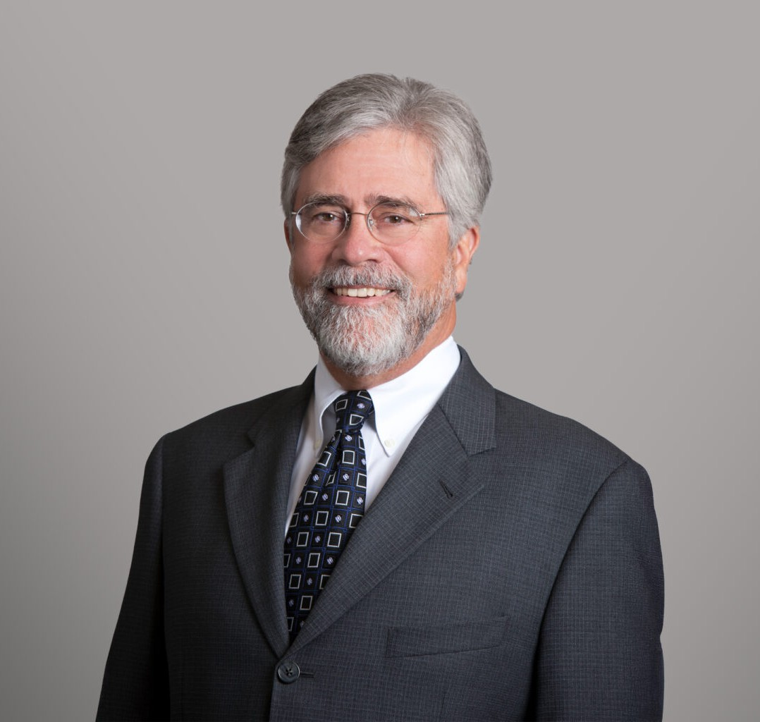

JAMES P. HILL

Director

[Financial Restructuring](https://www.fennemorelaw.com/services/financial-restructuring-bankruptcy-creditors-rights/)

[San Diego](https://www.fennemorelaw.com/contact-us/san-diego/)

P: 619.595.3226 F: 619.231.4372

[jhill@fennemorelaw.com](mailto:jhill@fennemorelaw.com)

# JAMES P. HILL

Jim Hill is a seasoned bankruptcy, insolvency, and commercial law attorney. His practice, emphasizing personalized debt relief strategies and comprehensive financial analysis, includes representing creditors, bankruptcy trustees, and select bankruptcy debtors in Chapter 11 business reorganization cases. He also serves as a court-appointed examiner and mediator, showcasing his versatility and in-depth knowledge in the field.

In addition to his bankruptcy work, Jim is adept in asset sales and acquisitions, state and federal court receivership cases, and business workouts, restructuring, and dissolution matters. His approach to providing tailored solutions and conducting detailed financial assessments makes him a sought-after advisor in complex commercial law matters.

Jim’s leadership extends beyond his practice. He served two terms as the inaugural Chair of the California Lawyers Association (CLA) Board of Representatives from its launch in January 2018 through October 2019, representing nearly 100,000 California attorneys and other members of the CLA’s various Sections. Jim previously served as the CLA Board Representative of the Business Law Section, of which he was the chair in when it was still part of the State Bar of California. Prior to that, Mr. Hill was co-chair of the BLS Insolvency Law Committee. His dedication to the legal community is further shown by his recognition of receiving the California Lawyers Association’s Business Law Section Lifetime Achievement Award in October 2022, highlighting his contributions to business law in California.

# EDUCATION

J.D., The University of Texas at Austin, School of Law B.J., University of Texas, High Honors

# AREAS OF PRACTICE

Financial Restructuring Agribusiness

Business Litigation Business & Finance

Real Estate

# AWARDS AND HONORS

Best Lawyers® “Lawyer of the Year” in San Diego – Bankruptcy and Creditor Debtor Rights/Insolvency and Reorganization Law

Best Lawyers in America®, Bankruptcy and Creditor Debtor Rights/Insolvency and Reorganization Law

Best Lawyers in America®, Commercial Litigation Top Rated Lawyer by Martindale-Hubbell

Top Rated Lawyer by American Lawyer Media, Commercial Bankruptcy and Creditor-Debtor Rights

Top Rated Lawyer by American Lawyer Media, Corporate Restructuring and Bankruptcy AV® Preeminent™ Peer Review Rating by Martindale-Hubbell

Lifetime Achievement Award, Business Law Section, California Lawyers Association Super Lawyer, Bankruptcy and Creditor/Debtor Rights, 2007-2023

Top San Diego Lawyer by San Diego Magazine, 2015-2023

50 Influential Leaders in San Diego Business Community by the Daily Transcript, 2018

Mediator of the Year by the Bankruptcy Court for the Southern District of California, 2013-2015 San Diego Business Journal’s Best of The Bar

# ARTICLES AND PRESENTATION

Panelist, “Stalking Horse Real Property Sales in Bankruptcy: To Stalk or Not to Stalk,” California Lawyer Association, October 11, 2023

Presenter, “Litigation Funding in Bankruptcy Cases: How to Get it & Potential Pitfalls (Help Me Legalist, You’re My Only Hope,” California Lawyer Association, October 21, 2021

# PROFESSIONAL AND COMMUNITY ACTIVITIES

Order of the Coif Member, Phi Kappa PHi

Member, Kappa Tau Alpha Member, American Bar Association

Member, Subcommittee on Business Bankruptcy, American Bar Association Member, San Diego County Bar Association

Member, Bankruptcy Law Section, San Diego County Bar Association Member, San Diego County Chapter of the Federal Bar Association Member, National Association of Bankruptcy Trustees

Member, California Bankruptcy Forum Member, San Diego Bankruptcy Forum Member, San Diego Receivers Forum

Member, California Receivers Forum

# ADMISSIONS

California Texas

U.S. Supreme Court

U.S. Court of Appeals, Ninth Circuit

U.S. District and Bankruptcy Courts for Southern, Central, Eastern and Northern Districts of California