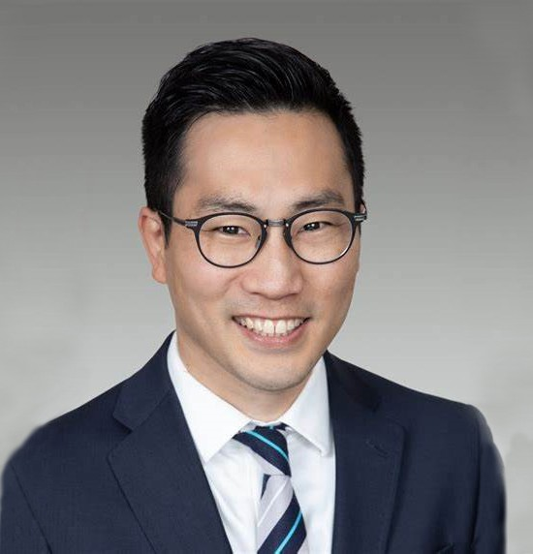

JEFFREY S. TACHIKI

Director

[Trusts & Estates](https://www.fennemorelaw.com/services/trusts-estates/)

[Oakland](https://www.fennemorelaw.com/contact-us/oakland/)

P: 510.622.7571 F: 510.622.7571

[jtachiki@fennemorelaw.com](mailto:jtachiki@fennemorelaw.com)

# JEFFREY S. TACHIKI

Jeff Tachiki is a director in our Trusts & Estates practice group, and has nearly two decades of experience guiding clients through the complexities of estate planning, trust administration and probate. He has particular knowledge of California’s nonconforming trust and estate law, specifically the elements relevant to trust and estate administration, and is a certified specialist with the State Bar of California in Estate Planning, Trust and Probate Law.

In his practice, counseling estate planning clients of all wealth levels, Jeff utilizes various wealth preservation and advanced tax planning techniques to create plans that meet their objectives in the most favorable way. He is also highly skilled at resolving disputes between trustees and

beneficiaries. His trust administration work includes experience addressing cross-border issues, and he has dealt with multiple jurisdictions when working through the estate tax issues related to trust and probate administrations.

A frequent speaker on a variety of trust and estate planning topics, Jeff has been selected as a Northern California Super Lawyer since 2021. He is also active in the Bay Area legal community, serving on the Board of Directors for Legal Assistance for Seniors of Alameda County since 2020.

Outside of work, Jeff and his wife enjoy the joyful blur created by two young children. He’s also an avid sports fan, following nearly every sport imaginable. But his favorite teams include the Utah Utes and Utah Jazz, and the San Francisco Giants and 49ers.

Trusts & Estates Estate Planning

# EDUCATION

J.D., The University of Utah, S.J. Quinney College of Law B.A., University of Utah

# AREAS OF PRACTICE

Trusts & Estates

Estate Planning

# AWARDS AND HONORS

*Northern California Super Lawyers®*

*Northern California Super Lawyers Rising Stars®*

Barristers’ Distinguished Service Award – Young Lawyer, Alameda County Bar Association, 2012

# ARTICLES AND PRESENTATIONS

San Luis Obispo County Bar Association: IRA Beneficiary Designations in the Age of the SECURE Act, September 23, 2020

Cameron House: Tail of the Charitable Dog: Tax and Control Considerations in Planned Giving, August 22, 2020.

Dying and Private Keys, Perkins Coie, LLP Virtual Currency Report, March 6, 2019.

Council of Business Advisors: Property Tax Issues in Estate Planning – An Overview, January 27, 2015;

IRA Trusts and Beneficiary Designations, May 22, 2018.

Continuing Education of the Bar (CEB): Drafting Revocable Trusts I and II, October 28, 2011; Estate Planning Intensive Course Faculty member 2015 and 2017 – Transfer Tax Issues;

“How to Be an Ethical Trusts and Estates Attorney” – Basics 2017: Estate Planning; “How to Be An Ethical Trusts and Estates Attorney” – Basics 2018: Estate Planning

East Bay Trusts and Estates Lawyers (EBTEL): “Taking the Certified Specialist Exam,” August 12, 2015.

National Business Institute: Trusts: The Ultimate Guide – Retirement Trusts, December 14, 2017; Probate Boot Camp – First Steps, October 28, 2014;

The Probate Process From Start to Finish – Maintaining an Ethical Balance in Probate, May 12, 2014; Trusts 101 – Ethical Considerations, August19, 2013;

Tax Planning for Trusts and Estates – Estate Tax Planning Considerations, September 19, 2012; Trusts 101 – Revocable Living Trusts and Irrevocable Life Insurance Trusts, December 9, 2011;

Trust Administration: Preventing and Litigating Fiduciary Liability – Managing and Modifying Trusts and Legal Ethics, June 22, 2011;

Drafting Effective Wills and Trusts – Using Living Trusts and Powers of Attorney as Estate Planning Tools, September 21, 2010.

Alameda County Bar Association: Volunteer Legal Services – Wills and Trusts Training Seminar, February 17, 24, 2011. Provided training to 40+ attorneys able to provide pro bono representation to over 80 low-income clients needing basic estate planning services.

PENSCO Trust Company: Roth Conversions and other Retirement Plan Exit Strategies, October 23-24, 2008.

Professional Fiduciary Association of California: Administering Special Needs Trusts, November 5-6, 2009.

Strafford Publications: “Mitigating Successor Trustee Liability for Prior Fiduciary Breach: Trust Structure and Administrative Tools,” October 31, 2017.

Berkeley Association of Realtors: Real Estate Planning: Real Property Issues from an Estate Planning Perspective, February 25, 2009.

# PROFESSIONAL AND COMMUNITY ACTIVITIES

Member, Board of Directors, Legal Assistance for Seniors, 2020-present

Liaison to Diversity, Equality and Inclusion Committee, Legal Assistance for Seniors, 2021- present

Vice President, East Bay Trusts and Estates Lawyers (EBTEL), 2022 Secretary, East Bay Trusts and Estates Lawyers (EBTEL), 2021

Chair, Estate Planning and Administration Committee, East Bay Trusts and Estates Lawyers (EBTEL), 2018-2020

Member, Judicial Appointment Evaluation Committee (JAEC), Alameda County Bar Association, 2016-2019

Vice Chair, Trusts and Estates Section, Alameda County Bar Association, 2011-2014 Volunteer Legal Services, Alameda County Bar Association

Mentor, Barristers’ Mentorship Program, Alameda County Bar Association, 2011-2013

Mentor, Young Lawyer Mentorship Program, Asian American Bar Association Mentorship Program, 2011-2013

Member, California Bar Association Member, San Francisco Bar Association Member, Alameda County Bar Association Member, East Bay Trusts and Estates Lawyers

Member, Asian American Bar Association, Bay Area Chapter

# ADMISSIONS

California