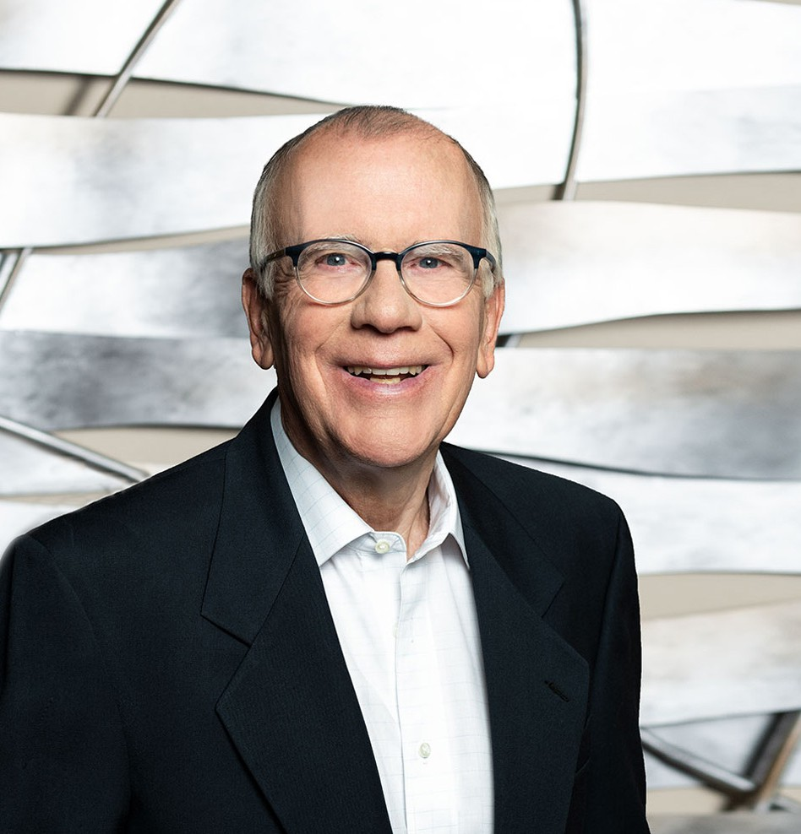

JOHN C. GANAHL

Director

[Business & Finance](https://www.fennemorelaw.com/services/business-and-finance/)

[Fresno](https://www.fennemorelaw.com/contact-us/fresno/)

P: 559.432.4500 F: 559.432.4590

[jganahl@fennemorelaw.com](mailto:jganahl@fennemorelaw.com)

**JOHN C.**“**GANAHL**

Plus ça change, plus c'est la même chose.

”

John Ganahl works out of our Fresno office where his main areas of practice are private

placements, securities law regulation (excluding public companies), business start-ups and acquisitions and debtor side lending. He has experience in a wide range of private securities matters, including multi-state and international (Regulation S) offerings. John also has extensive

experience in advising clients regarding private equity transactions and other capital generation projects. He represents and counsels clients of all sizes in the areas of business startups, acquisitions and sales of businesses, entity formation and operations, and complex debt financing matters. His clients include those in the e-commerce, software, professional sports, health care, real estate, product distribution and manufacturing business sectors.

The practice of law is truly in the family blood, and John’s grandfather and father were both attorneys, and his daughter and one of her cousins are also now attorneys. John cherishes his relationships created with clients and fellow attorneys; and receives great satisfaction in closing a deal, and obtaining good results.

Away from work, you’ll probably find John running; taking trips to the coast; walking the dog; or savoring food and wine with friends. John also spends time in the Phoenix area visiting friends, hiking in the Spur Cross Ranch and McDowell Mountain areas and enjoying Southwestern

cuisine.

John has been involved in a number of community activities, including director and president of the Notre Dame Club of Central California; alumni senator, University of Notre Dame Alumni

Association; director, Fresno Zoological Society, member and director (two terms) of Fig Garden Rotary Club; and director and president of the Hoop Club (Fresno State Women’s Basketball). For

a number of years, John was also one of the race directors of the Two Cities Marathon in the Fresno/Clovis area.

# EDUCATION

J.D., University of California, Davis School of Law B.A., University of Notre Dame

Beta Alpha Psi

# AREAS OF PRACTICE

**OTHER EXPERIENCE**

Nonprofit Law

Private Equity and Securities Business & Finance

Mergers & Acquisitions Land Use

Real Estate

# PROFESSIONAL AND COMMUNITY ACTIVITIES

Member, State Bar of California

Member, California Lawyers Association, Business Law Section

A Founder of and Legal Counsel since 1978 for Ag One, California State University, Fresno

Member, Fresno County Bar Association, Real Property Law Section; Delegate, Conference of Delegates, 1980-1983

Board of Directors, Fresno County Legal Services, 1975-1978

# ADMISSIONS

California

U.S. District Court, Eastern District of California