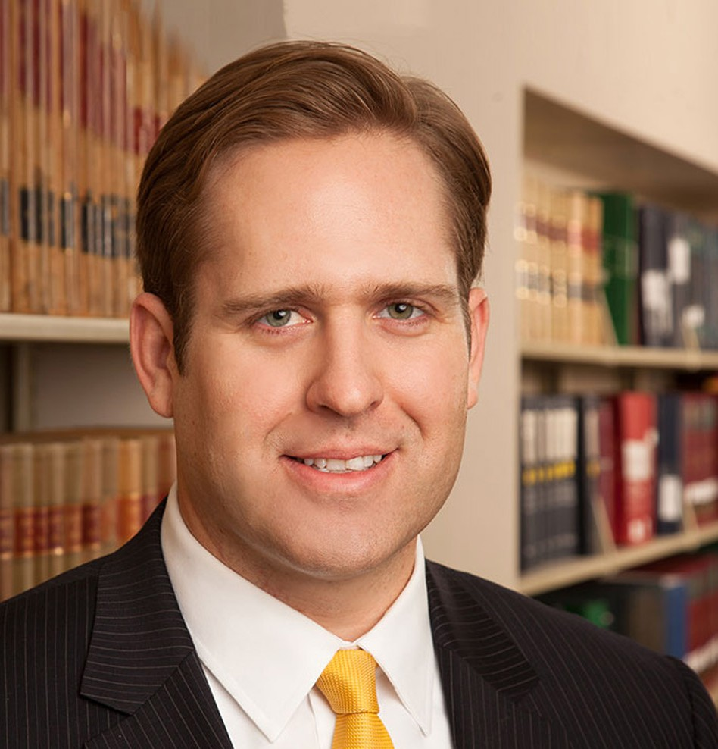

JOHN D. TENNERT III

Director

[Business Litigation](https://www.fennemorelaw.com/services/business-litigation/)

[Reno](https://www.fennemorelaw.com/contact-us/reno/)

P: 775.788.2212 F: 775.788.2213

[jtennert@fennemorelaw.com](mailto:jtennert@fennemorelaw.com)

**JOHN D. TENNERT III**

John is the managing partner of the Reno office and a member of the firm’s business litigation

practice. He represents businesses and individuals in a variety of complex civil litigation, financial service and natural resource matters, and has handled matters involving contract disputes, business torts, fraud, environmental issues and creditors’ rights litigation.

John is a fierce advocate for his clients, and enjoys finding creative strategies to complex legal issues. He has argued before Nevada State and Federal courts, including the Nevada Supreme Court and the Bankruptcy Appellate Panel for the Ninth Circuit, on multiple subjects including property law, Nevada foreclosure and deficiency laws, state and federal environmental law,

corporate law, constitutional law, federal and Nevada jurisdiction and procedure, and statutory interpretation.

Away from the office, John serves on the University of Nevada Planned Giving Advisory Council and enjoys rooting for the University of Nevada, Reno, where he was a four-year starter on the offensive line.

# EDUCATION

J.D., Gonzaga University School of Law, *magna cum laude*

B.S., University of Nevada, Reno

# AREAS OF PRACTICE

OTHER EXPERIENCE

Litigation

Business Litigation Business & Finance Financial Restructuring

Natural Resources Blockchain & Cryptocurrency

# REPRESENTATIVE CASES

Representing national bank in Attorney General lawsuit asserting violations of consumer protection laws.

Defending multinational telecommunications corporation in lawsuit asserting claims for

fraudulent inducement of advertising contract, obtaining dismissal of lawsuit prior to trial.

Representing international defendants in intentional tort action, resulting in dismissal for lack of personal jurisdiction.

Defending local property management company in personal injury lawsuit brought by former tenants, resulting in dismissal prior to trial.

Counseling mining companies on issues ranging from regulatory compliance and permitting to litigation.

Defending Nevada companies and their principal in a lawsuit asserting fraud and breach of contract, resulting in a favorable settlement and dismissal.

Representing secured creditors in numerous Chapter 11 bankruptcy proceedings.

# AWARDS AND HONORS

*Best Lawyers in America®,* Litigation – Construction, 2022-2025 “Legal Elite,” *Nevada Business Magazine,* 2012-2022

*Benchmark Litigation*, 40 & Under Hot List, 2018-2021

*Mountain States Super Lawyers Rising Stars®,* 2017-2021

“Best Up and Coming Attorneys,” *Nevada Business Magazine,* 2016

# ARTICLES AND PRESENTATIONS

Featured, “People: John Tennert transitions to managing partner of Fennemore Craig,” Northern Nevada Business Weekly, February 1, 2023

Co-Author, “Compelling and Staying Arbitration in Nevada,” *Practical Law,* June, 2017

# PROFESSIONAL AND COMMUNITY ACTIVITIES

Member, University of Nevada Planned Giving Advisory Council Member, Bruce R. Thompson Chapter, American Inns of Court Member, University of Nevada Football Alumni Association Executive Board Member, Young Professionals Committee

Graduate, Chamber of Commerce’s Leadership Reno-Sparks program, 2014

Past District Representative for Nevada and Utah American Bar Association, Young Lawyers Division, 2010-2012

# ADMISSIONS

Nevada