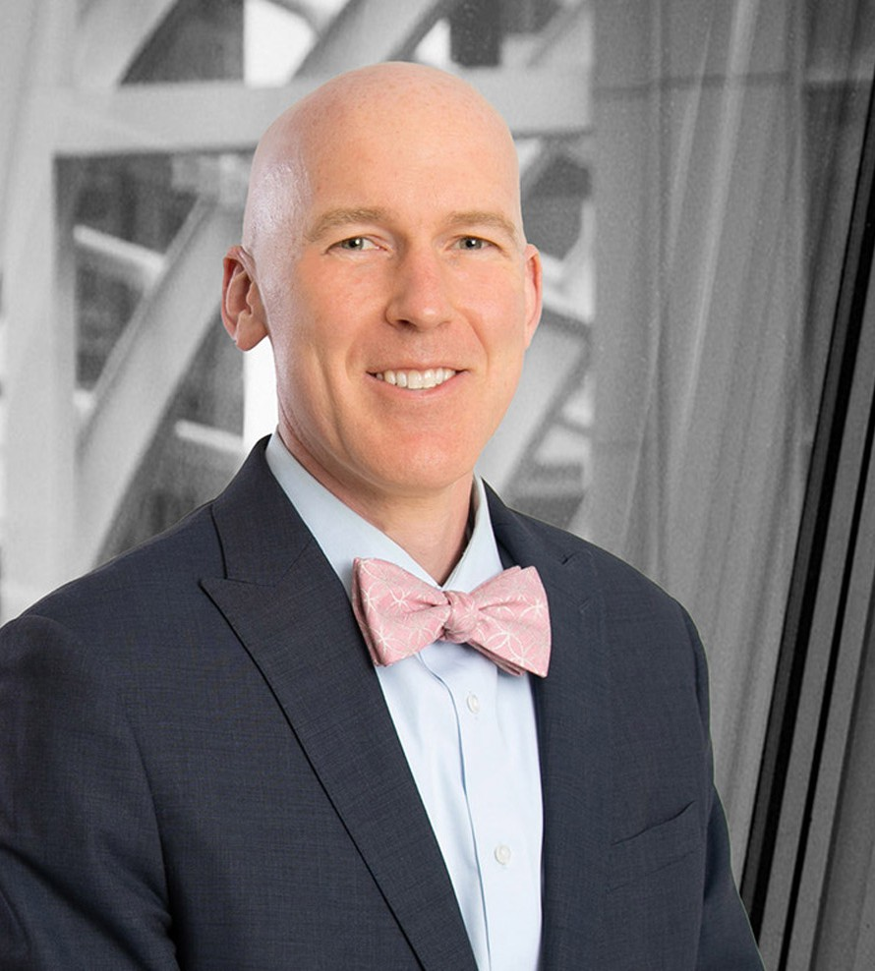

JOHN M. MCHUGH

Pronouns: he/him

Director

[Business Litigation](https://www.fennemorelaw.com/services/business-litigation/)

[Denver](https://www.fennemorelaw.com/contact-us/denver-2/)

P: 303.764.3722 F: 303.291.3201

[jmchugh@fennemorelaw.com](mailto:jmchugh@fennemorelaw.com)

“

Calm seas never made a skilled sailor.

-Franklin D. Roosevelt

**JOHN M. MCHUGH**

”

John McHugh is a skilled trial attorney with a wide civil practice that includes experience in cases in the financial services, insurance, energy industries and LGBT rights. An experienced trial attorney, John has experience in all phases of a case, including initiating lawsuits, document

discovery, depositions, motions practice, mediation, trial, and appeals. John is responsible for the oversight of litigation ranging from individual lawsuits to multimillion dollar business disputes. From the outset of each case, John works with his clients and the trial team to develop a theme and

strategy. His persuasive motion practice, writing skills, and in-court advocacy provide results- oriented service to his clients regardless of the size or complexity of their case. John’s experience as a trial lawyer allows to him effectively advocate for his clients to pursue the best remedy possible on their behalf.

Since becoming an attorney, John has worked on high-stakes and notable matters. At Reilly, he has enjoyed representing prominent clients including professional sports teams, SEC investment advisors, and national title companies. Prior to joining Reilly, he was an associate with the international law firm Quinn Emanuel Urquhart & Sullivan in New York City.

## *“I enjoyed attending law school and working at a big law firm in New York City, but it is really* great to be back in the West. I was raised on a small family ranch in rural Idaho. When you work on a ranch, there is no time clock. If something needs to be done, you work until it is done. I was raised this way, and I bring the same work ethic to the legal work that I do for my clients.”

John is active in his community and currently sits on the Board of Directors for the Colorado LGBT Bar Foundation. He also serves as the co-chair for the Colorado Lawyers Committee’s Hate

Crimes Education Task Force and Anti-Bullying Subcommittee of the Education Task Force. From 2014-2019, he served on the Board of Directors of the Colorado LGBT Bar Association, including as President in 2017. He was the lead attorney in the landmark lawsuit that challenged Colorado’s laws that prohibit same-sex marriage.

# EDUCATION

J.D., New York University School of Law B.A., University of Idaho, *cum laude*

# AREAS OF PRACTICE

**OTHER EXPERIENCE**

Appeals

Complex Civil and Commercial Litigation Business Litigation

# REPRESENTATIVE CASES

In 2014 as part of his succession plan, Pat Bowlen, owner of the Denver Broncos turned over the reins of the team to a three-person trust. The trustees are tasked with carrying out Mr.

Bowlen’s wishes to pick one of his children to become controlling owner or selling the team if it is in the best interest of the family. In 2018 a lawsuit commenced over who controls and will eventually own the Denver franchise. Mr. McHugh is part of the team that represents the Denver Broncos’ trustees in this matter. John also represents PDB Sports, Ltd. and Bowlen

Sports, Inc. in a currently pending declaratory judgment action concerning a right of first refusal granted in 1984.

As lead counsel, secured a trial judgment against a local business for denying services to a transgender woman in violation of Colorado’s Anti-Discrimination Act.

Member of a trial team that secured a combined $106 million judgment ($99 million in compensatory and punitive damages and $7 million in attorney fees and litigation costs)

against PNC Bank for breach of trust on behalf of 35 state life and health insurance guaranty associations, NOLHGA, and the Texas Special Deputy Receiver. The litigation arose out of a multi-state fraud scheme involving National Prearranged Services, Inc. (a Missouri-based preneed funeral contracts seller) and its two related insurance companies domiciled in Texas. The 8th Circuit affirmed the judgment in its entirety.

Successfully argued before the Colorado Supreme Court that Colorado’s common-law marriage laws could apply to same-sex relationships prior to the legalization of same-sex marriage in Colorado. The Court’s decisions ensured that same-sex couples are truly treated equally in Colorado.

Argued and secured a victory before the Colorado Supreme Court on the application of Colorado’s usury law to forbearance fees. The decision not only entitled John’s client to a refund of the excess interest charged, but clarified the protections available to all commercial borrowers in Colorado.

Member of a trial team representing a Colorado refinery owner seeking contractual indemnification from the refinery’s former owner for clean-up costs resulting from leakage from an underground pipe. Following a 3-week confidential arbitration that took place in April and May 2017, the parties reached an amicable settlement.

Lead attorney in the representation of nine same-sex couples who challenged the constitutionality of Colorado’s laws prohibiting same-sex couples from marrying and refusing

to recognize the marriages of same-sex couples entered into in other states. McDaniel-Miccio, et al. v. State of Colorado, Denver County District Court, Case No. 2014-cv-30731.

Served as co-counsel on an employment discrimination case against the Boy Scouts of

America that led to the Boy Scouts ending their decades-long discrimination against gay and lesbian scout leaders.

Prevailed on a motion to dismiss for the New Orleans Saints against claims by Travelers in federal district court seeking reimbursement of California workers compensation payments made by Travelers to a former Saints player and for a declaration of non- coverage for 11 former Saints players. The Travelers Indemnity Company v. New Orleans Louisiana Saints LLC, 2014 WL 1716056, No. 8:13-cv-1998-JLS-JPR (C.D. Cal 2014)., 2014.

Reached a successful resolution on behalf of the Denver Broncos Football Club in a dispute with former players to determine whether the current owner of the Denver Broncos football franchise is responsible for cumulative trauma claims brought by players employed by a prior owner. PDB Sports Ltd v. George Goeddeke, et al., No. 11- CV-8097 (Denver County, Colo.

2013).

Reached a successful resolution for the current owner of the Denver Broncos football franchise in an insurance coverage dispute relating to cumulative trauma claims of former players. St. Paul Fire & Marine Insurance Company, The Travelers Indemnity Company v. PDB Sports, Ltd d/b/a Denver Broncos, No. 11-cv-1476 (D. Colo. 2012).

Successfully defended a nationwide group of companies regarding the issuance of title commitments and insurance against a qui tam claimant. US Ex Re. Dale Todd v. Fidelity National Financial, Inc., et al., No. 12-cv-666 (D. Colo.).

Secured dismissal of breach of fiduciary duty claims against the former chairman of the board of directors for a large, multi-state energy organization. Chimney Rock Public Power District, et al. v. Tri-State Generation & Transmission Association, Inc., et al., 2010 CV 02349 (D. Colo.).

Successfully resolved an injunctive relief on behalf of Suncor Energy (U.S.A.) Inc. against ConocoPhillips and Phillip 66 under the Petroleum Marketing Practices Act to permit Suncor to continue selling Phillips 66 branded motor fuel in Colorado. Suncor Energy (U.S.A.) Inc. v.

ConocoPhillips et al., 2013 CV 34926 (D. Colo. 2013).

# AWARDS AND HONORS

*Best Lawyers in America®,* Commercial Litigation, 2024 and 2025

*Best Lawyers in America®,* Mass Tort Litigation / Class Actions – Plaintiffs, 2025

## *Colorado Super Lawyer®,* 2021

*Colorado Super Lawyers® Rising Star®,* 2014-2020

National LGBT Bar Association’s Best LGBT Lawyers under 40, 2018 Colorado General Counsel Group Advisor Program, 2015-2017 Denver Business Journal’s Power Book, Finalist, 2015

Denver Bar Association, Volunteer Lawyer of the Year, 2015 LGBT Community Center of Colorado, Barrister of the Year, 2015

Colorado Lawyers Committee, Award of Special Recognition, 2015

GLBT Community Center of Colorado, Visionaries in Action Award, 2015 Out Front Colorado Power Party, Honoree, 2015

Visionaries in Action Award, GLBT Community Center of Colorado, 2015 Law Week Colorado, Lawyer of the Year, 2014

Law Week Colorado, Up-and-Coming Lawyer, 2014

GLBT Community Center of Colorado’s “Barrister of the Year”

Out Front Colorado

“Volunteer Lawyer of the Year”, Denver Bar Association

# ARTICLES AND PRESENTATIONS

Featuring, “Colorado high court to hear case against Christian baker who refused to make LGBTQ-themed cake,” Law360 and SF Gate, October 3, 2023

Featuring, “Colorado baker loses appeal over refusal to make gender transition cake,” Reuters, Washington Post and Bloomberg January 26, 2023

Featuring, “Managing Partner John McHugh on Pride month, supporting the LGBTQ+ community,” Denver Business Journal, June 15, 2022

Author, “5 tips to protect your company’s trade secrets,” Denver Business Journal, April 21, 2022

Quoted, “Colorado Baker at the heart of 2018 Supreme Court case fined for refusing to bake transgender transition cake” *NY Daily News,* 2018

Co-Author, “*CADA: The Intersection of LGBT Civil Rights and Religious Freedom”*, 40 Colo. Lawyer 31, 2017

Presentor, “Trial Tactics: Openings/Closings”, University of Colorado Law School, 2015

Presentor, “Resume Writing and Interviewing for LGBT Attorneys and Law Students Panel”, Colorado LGBT Bar Association, 2014

Presentor, “Marriage Equality Update”, CLE Presentation, Colorado Bar Association, 2014 Presentor, “Litigating Marriage Equality”, University of Denver Sturm College of Law, 2014

Moderator, Marriage Equality Panel, Ira C. Rothgerber Conference, University of Colorado Law School, 2014

Quoted, “Rising Dissent and Lawsuits Pushed Scouts to Change”, *The New York Times*

Interview, “Colorado Eyes High Court for News on Gay Marriage”, *Colorado Independent*

Quoted, “Colorado Gay Couples Excited by Marriage Ruling”, *Denver Post* Quoted, “Colorado Defends Same-Sex Marriage Ban in Court”, *Denver Post* Featured, “Colorado’s Gay Marriage Ban Challenged”, TIME

# PROFESSIONAL AND COMMUNITY ACTIVITIES

Board Member, Colorado LGBT Bar Foundation Board Member, ARISE Adoption Academy

Co-Chair Hate Crimes Task Force, Colorado Lawyers Committee

Co-Chair Anti-Bullying Subcommittee of the Education Task Force, Colorado Lawyers Committee

Colorado Bar Association Leadership Training (COBALT), Class of 2017

Board Member, 2014-2019 and President 2017, Colorado LGBT Bar Association

# ADMISSIONS

Arizona Colorado New York

U.S. Court of Appeals Ninth Circuit

U.S. Court of Appeals Tenth Circuit

U.S. District Court, District of Colorado

U.S. District Court, Eastern District of New York

U.S. District Court, Southern District of New York