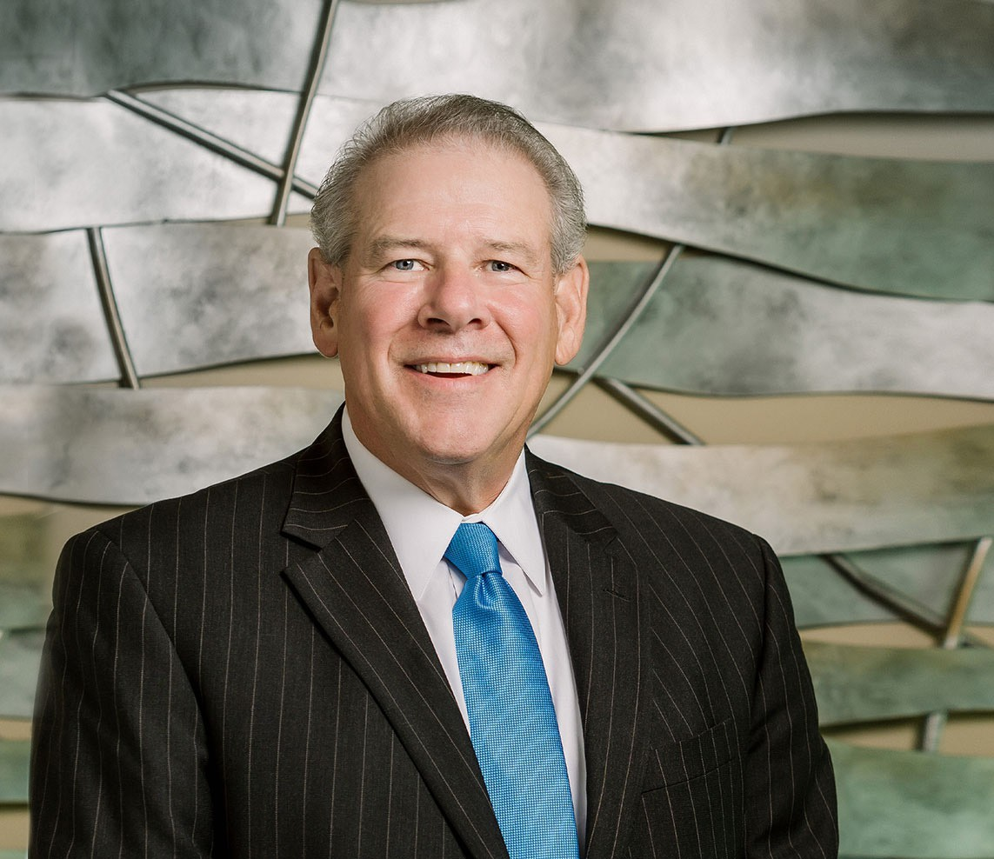

JOHN PHILLIPS

Director

[Business Litigation](https://www.fennemorelaw.com/services/business-litigation/)

[Fresno](https://www.fennemorelaw.com/contact-us/fresno/)

P: 559.432.4500 F: 559.432.4590

[jphillips@fennemorelaw.com](mailto:jphillips@fennemorelaw.com)

“

The way to get started is to quit talking and begin doing.

Walt Disney

**JOHN W. PHILLIPS**

”

John Phillips is a seasoned director who works in the business litigation practice group out of our Fresno office. Bringing transactional experience to the courtroom, John works on numerous commercial litigation matters, including failed agreements and transactions,partnership

disputes, eminent domain actions, breach of contract cases, and corporate break-ups. Over his distinguished 30-year career, John has obtained varied trial experience in federal district court,

tax court, and all state courts, including jury and bench trials, arbitrations, and evaluation of settlement. His practice also encompasses securing insurance coverage for defense matters, representation as insurance defense counsel, and representation in both unfair business

practice, and breach of fiduciary duty lawsuits.

A native of Fresno, John graduated from Fresno State University with a desire to learn transactions and initially worked as a CPA. Over the years, John realized that he wanted tobe the one using this information. This led him to law school – John’s father was an attorney – and with this life experience behind him, John found law school was right in his wheelhouse, John soon realized that legal work is part of his DNA. He finds great satisfaction in implementing his client’s business and litigation strategies. John also realizes that sometimes you can win in litigation but lose the war. To this end, he also employs risk-management and problem resolution strategies to find the right results for his clients, be it at trial, or in a negotiated result.

To relax and recharge his batteries, John loves to travel and enjoys family time at the Coast, golf, and fishing.

# EDUCATION

LL.M., Taxation University of San Diego School of Law

J.D. California Western School of Law

# AREAS OF PRACTICE

Business Litigation Eminent Domain

# AWARDS AND HONORS

CWSL Deans List

# ARTICLES AND PRESENTATIONS

Preventing Sexual Harassment in the Workplace for School Districts CANRA Reporting for Pubic Employees

Effective Credit and Collection Techniques Secured Transactions for Vendors

# PROFESSIONAL AND COMMUNITY ACTIVITIES

Member, Fresno County Bar Association

# ADMISSIONS

California

U.S. District Court Central District of California

U.S. District Court Eastern District of California

U.S. District Court Northern District of California

U.S. District Court Southern District of California

U.S. District Court District of Hawaii

U.S. Tax Court