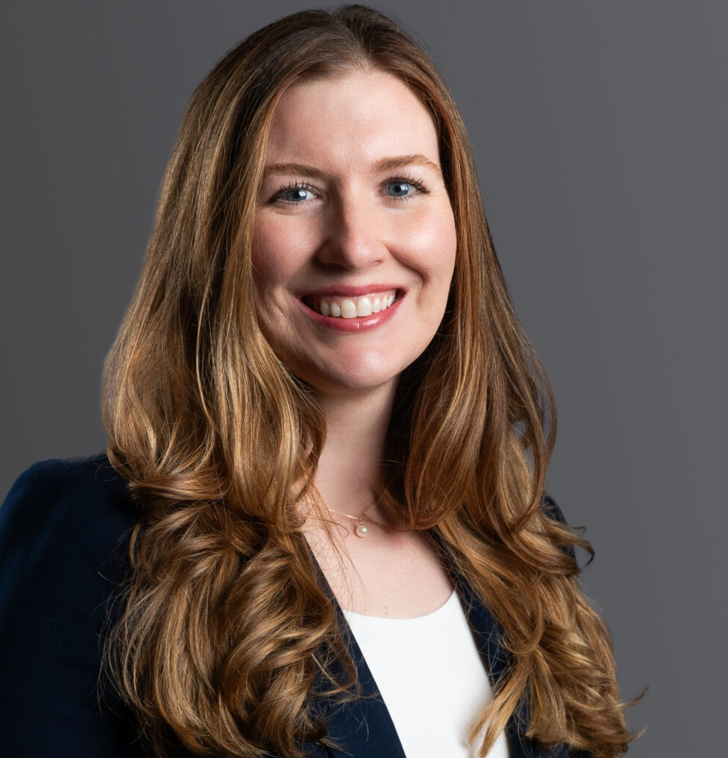

JORDAN E. HELTON

Associate

[Business Litigation](https://www.fennemorelaw.com/services/business-litigation/)

[Denver](https://www.fennemorelaw.com/contact-us/denver-2/)

P: 303.813.3828 F: 303.291.3201

[jhelton@fennemorelaw.com](mailto:jhelton@fennemorelaw.com)

# JORDAN E. HELTON

As a member of the firm’s Business Litigation group, Jordan assists clients with their most challenging commercial litigation disputes from pre-litigation case assessment to resolution. She has experience representing both businesses and individuals in complex commercial cases before state and federal courts.

Prior to joining Fennemore, Jordan served as a judicial law clerk to the Honorable Emmet G. Sullivan at the U.S. District Court for the District of Columbia. She also previously worked as an attorney at an international law firm in Washington, D.C. and at Moye White in Denver. During

law school, Jordan served as a legal assistant to the United Nations Committee Against Torture in Washington, D.C. and Geneva, Switzerland, and worked in the chambers of the Honorable Christopher R. Cooper at the U.S. District Court for the District of Columbia.

Before joining the legal field, Jordan worked as a communications manager for the International Rescue Committee. In her free time, Jordan enjoys fencing saber, cross-country skiing, and spending time with her family in the Colorado outdoors.

# EDUCATION

J.D., American University Washington College of Law, *summa cum laude*

Executive Editor, *American University Law Review Order of the Coif*

Lura E. Turley Prize for the best student work published in the *Law Review*

Mussey Prize for the highest scholastic average during the last year of study B.S., Northwestern University, Medill School of Journalism

News Anchor and Producer, *WNUR-FM Radio Station*

# AREAS OF PRACTICE

Business Litigation

Financial Restructuring

# PROFESSIONAL AND COMMUNITY AFFILIATIONS

International Rescue Committee in Denver

# ADMISSIONS

Colorado

District of Columbia