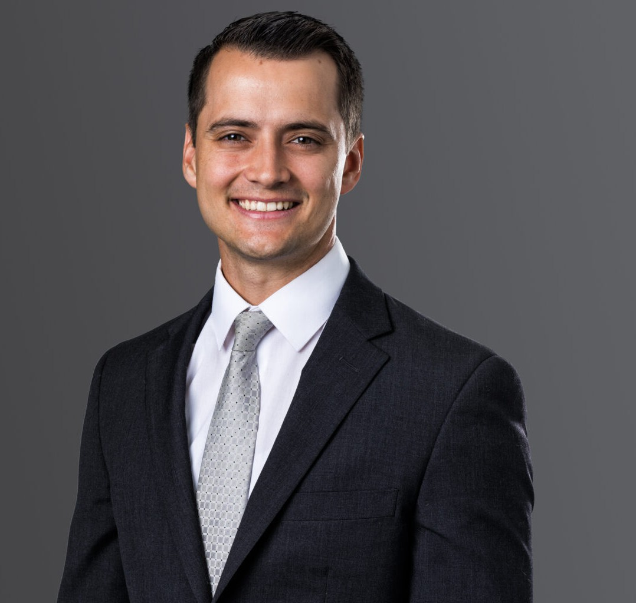

JOSH BETHEA

Associate

[Trusts & Estates](https://www.fennemorelaw.com/services/trusts-estates/)

[Phoenix](https://www.fennemorelaw.com/contact-us/phoenix/)

P: 602.916.5348 F: 602.916.5999

[joshbethea@fennemorelaw.com](mailto:joshbethea@fennemorelaw.com)

“

Fall down seven times – get up eight times.

Traditional Proverb

**JOSH BETHEA**

”

Josh Bethea is an associate attorney in our Trusts, Estates & Wealth Preservation practice group who works out of our Phoenix office. Josh has experience drafting durable powers of attorney, health care powers of attorney, deeds moving real property title into trust, diagrams of estate dispositions, and other ancillary estate planning documents. He also prepares IRC § 1023 filings creating charitable foundations for clients, and is familiar and comfortable with writing

engagement letters, corresponding with clients, and participating in estate planning sessions with clients.

Born in Utah, and raised in Mesa, AZ in a family where both parents are attorneys, Josh knew from an early age that a career in the legal profession would be a great match for his reasoning and analytical abilities. His grandfather, an estate planner, recommended the trusts & estates sector, and the rest is history. Josh truly enjoys being a trusted counselor – and playing an

important role in people’s lives. He finds it extremely fulfilling to serve others and form deep, meaningful relationships with his clients.

Outside of the office, Josh is a Strava addicted mountain biker, avid snowboarder, aspiring

guitarist, devout Star Wars patron of episodes I through VI only, and rarely defeated (unofficial) competitive eater of sushi.

# EDUCATION

J.D., Sandra Day O’Connor College of Law at Arizona State University, *magna cum laude* and Order of the Coif

B.A., Brigham Young University

# AREAS OF PRACTICE

Trusts & Estates Estate Planning

# AWARDS AND HONORS

Recipient, Dean’s Award in Recognition of Outstanding Performance at ASU Law, 2022

Recipient, Cali Excellence for the Future Awards (*Civil Procedure, Decedents’ Estates, Community Property, Secured Transactions, Advanced Estate Planning, and Trusts)*

Leo and Annette Beus Top Scholar and O’Connor Honors Fellow

# ARTICLES AND PRESENTATIONS

Author, “Tossing Baby with the Bathwater: Substantive Due Process and the Regulatory Takings Doctrine Applied to the COVID-19 Pandemic,” *ASU’s Corporate and Business Law Journal*, Winter 2022

# PROFESSIONAL AND COMMUNITY ACTIVITIES

Full-Time Missionary, The Church of Jesus Christ of Latter-day Saints Student Fellow, Parliament of the World’s Religions

Exhibit Interpreter, Loveland Living Planet Aquarium Student Mentor, Timpanogos Elementary School

# ADMISSIONS

Arizona Nevada