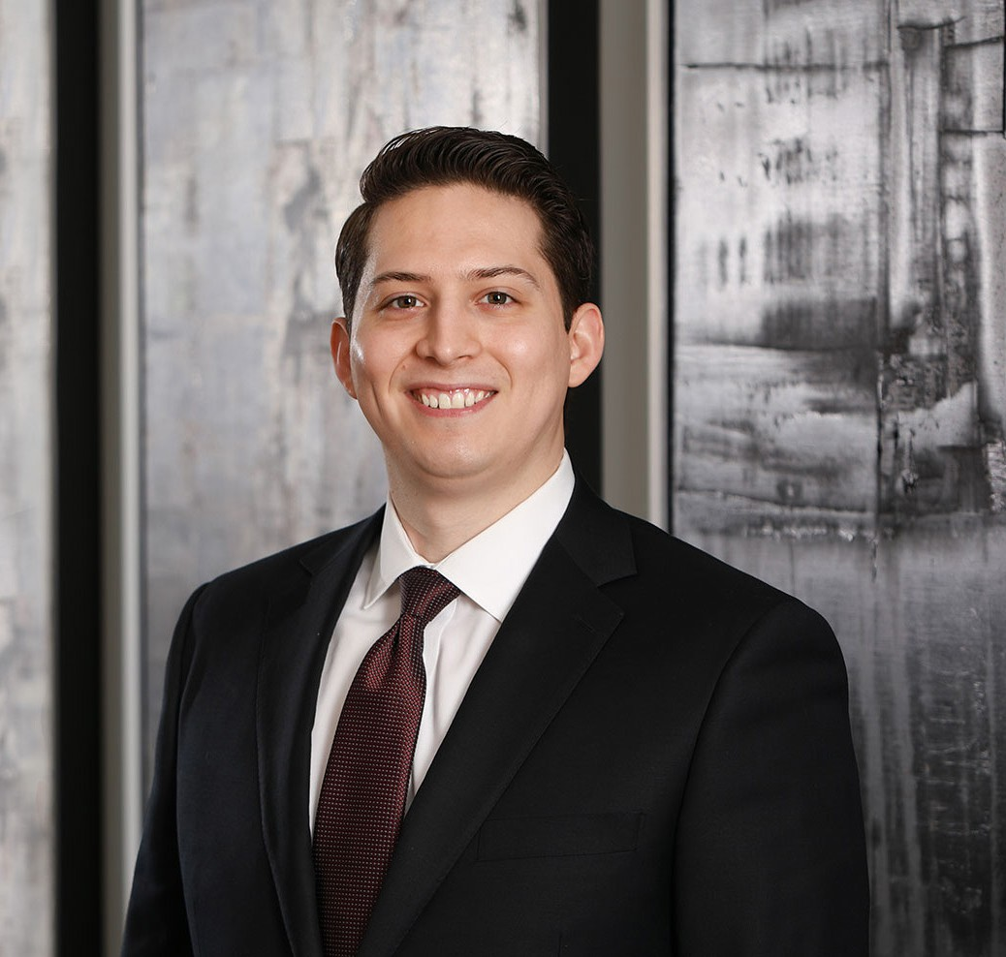

JUSTIN A. ROBLES

Associate

[Business Litigation](https://www.fennemorelaw.com/services/business-litigation/)

[Phoenix](https://www.fennemorelaw.com/contact-us/phoenix/)

P: 602.916.5415 F: 602.916.5615

[jrobles@fennemorelaw.com](mailto:jrobles@fennemorelaw.com)

# JUSTIN A. ROBLES

Justin A. Robles works out of our Phoenix office in our business litigation practice group focusing primarily on commercial litigation, including a broad array of construction matters between

owners, general contractors, and subcontractors.

A Phoenix native and fluent in Spanish, Justin is a graduate from the new downtown campus of the Sandra Day O’Connor College of Law at Arizona State University. During law school, Justin externed at the United States District Court for the District of Arizona and interned in the election law department at the Arizona Secretary of State’s Office. As a business litigation attorney, he enjoys the intellectual challenge of interpreting complex contracts and laws on behalf of his business clients to ensure their success.

Justin is married to his high school sweetheart, Katrina. Outside of his work as a business litigation attorney, Justin is a former wrestler and baseball player and enjoys following both sports. He enjoys traveling and spending time with his family.

# EDUCATION

J.D., *cum laude*, Arizona State University, Sandra Day O’Connor College of Law

B.S. University of Arizona

Research Editor, *Arizona State Law Journal,* 2018-2019 CALI Award for highest grade in International Contracts Pedrick Scholar, 2016-2018

# AREAS OF PRACTICE

Business Litigation Construction Law

# AWARDS AND HONORS

*Best Lawyers in America®,* Ones to Watch, 2022

# ADMISSIONS

Arizona Nevada

# LANGUAGES

Spanish, Fluent