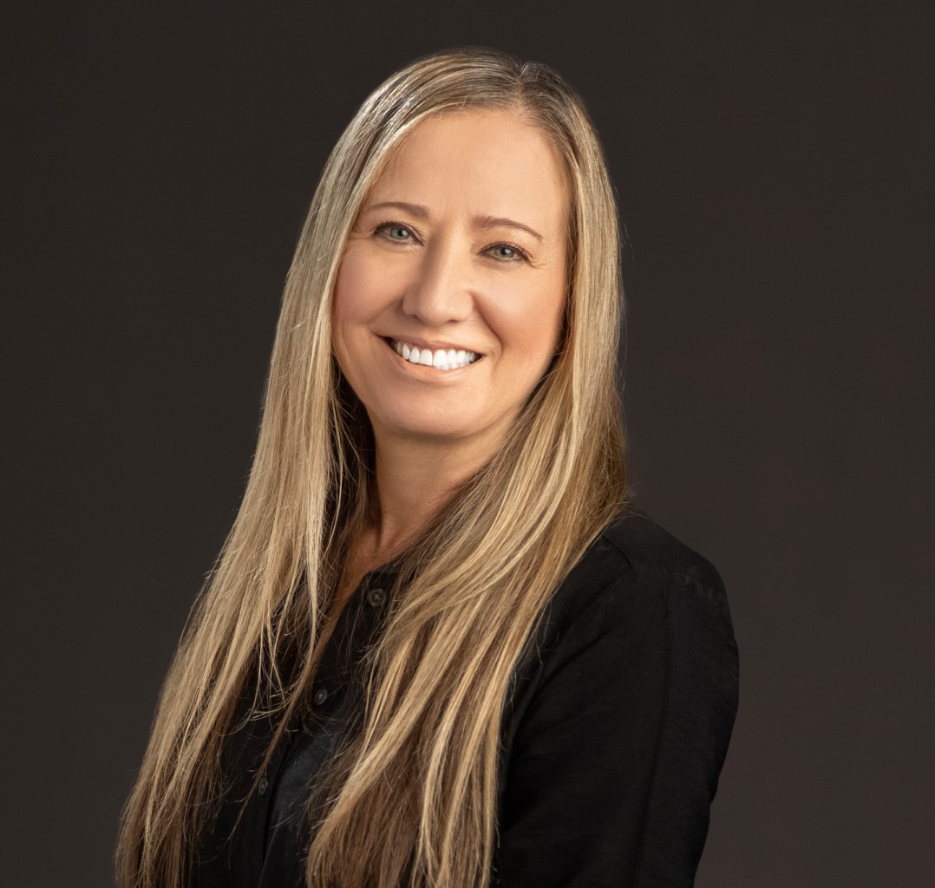

KELLENE PEIRSOL

Paralegal

[Trusts & Estates](https://www.fennemorelaw.com/services/trusts-estates/)

[Fresno](https://www.fennemorelaw.com/contact-us/fresno/)

P: 559.432.4500 F: 559.432.4590

[kpeirsol@fennemorelaw.com](mailto:kpeirsol@fennemorelaw.com)

“

Work smarter not harder.

Allen F. Morgenstern

**KELLENE PEIRSOL**

”

Kellene Peirsol is a paralegal who works out of our Fresno Office. Her work focuses on trust

administrations, probate, estate planning, real estate, and trust accountings – and she loves working with numbers.

She began her career in the legal profession as a junior legal secretary, and originally wanted to be a lawyer, but decided that she was better suited for paralegal work. Kellene enjoys helping clients go through the transition of managing their estate after losing a spouse and/or parent.

She takes great pride in establishing a personal relationship with her clients – working with them, not for them.

Outside of the office, Kellene reads, works crossword puzzles (she loves to expand her vocabulary), and goes to the coast as often as possible, spending time with her family.

# EDUCATION

Foothill College, Los Altos, CA

Paralegal Certificate, University of Hawaii

# AREAS OF PRACTICE

Trusts & Estates Estate Planning

# ADMISSIONS

*\*Not licensed to the practice of law*