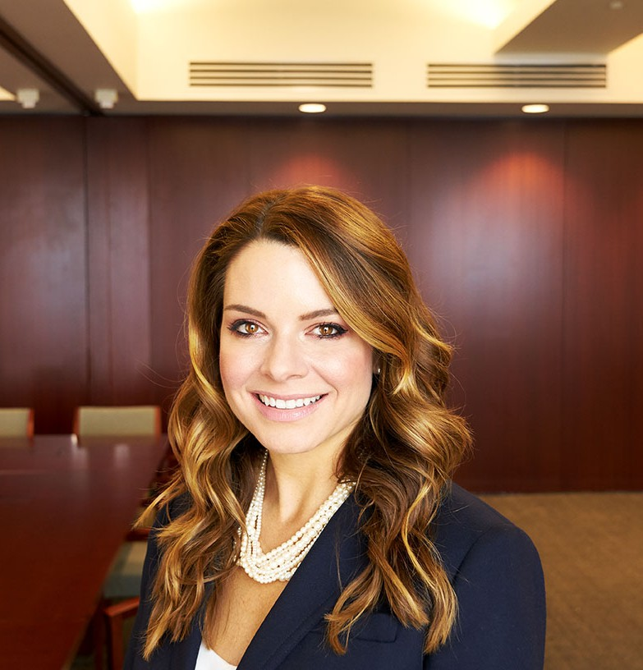

KENDRA G. GLAZER

Director of Recruiting

[Kendra G. Glazer](https://www.fennemorelaw.com/people/professionals/kendra-g-glazer/)

[Fennemore Forward](https://www.fennemorelaw.com/contact-us/fennemore-forward/)

P: 602.916.5050 F: 602.916.5999

[kglazer@fennemorelaw.com](mailto:kglazer@fennemorelaw.com)

“

"Your time is limited, so don't waste it living someone else's life ”

Ruth Bader Ginsburg

**KENDRA G. GLAZER**

”

Kendra G. Glazer is the Director of Recruiting who leads the firm’s legal recruiting efforts across all of our offices for new associates, lateral associates, summer associates, law clerks, and

contract attorneys.

As a first-generation lawyer, Kendra practiced law first in New York City and then in New Orleans, while also gaining experience in the political arena. Her experience in law school and as a practicing attorney revealed the distinct advantages enjoyed by some individuals when entering into the practice of law, and led to a pivot in her career towards legal recruiting. After five years in Career Development at a law school, in 2018 Kendra decided to return to private

practice, but this time as a legal recruiter.

Since that time, Kendra has focused on the recruitment and development of law students and attorneys, and is now an advocate for mentoring and empowering attorneys with the tools they need to succeed – with a passion for Diversity, Equity and Inclusion efforts in the law. Kendra has experience in researching, developing and coordinating a broad range of diversity initiatives, including a minority fellowship program, a diversity pipeline initiative, and numerous diversity

scholarships. Her goal is to ensure that each attorney is successful and happy – growing each person’s career with a unique plan focused on what’s important to them.

Outside of work, Kendra describes her life as “The Brady Bunch” – a joyous life with her partner and a blended family of four children, and their beloved dog. Kendra loves hiking, and travel, especially to places where long walks on the beach are part of the daily routine.

# EDUCATION

J.D., Southern Methodist University, Dedman School of Law

B.A., University of Wisconsin-Madison, *Bachelor of Arts in Political Science, Certificate in Environmental Studies, Concentration in African Studies.*

# ARTICLES AND PRESENTATIONS

[Featuring, “A Conversation On Life In The Legal Profession With Kendra Glazer,” Fennemore](https://www.fennemorelaw.com/there-is-not-one-path-to-success-at-fennemore-each-individual-is-valued-and-appreciated-for-their-unique-perspective-and-contributions/) [Blog, August 10, 2023](https://www.fennemorelaw.com/there-is-not-one-path-to-success-at-fennemore-each-individual-is-valued-and-appreciated-for-their-unique-perspective-and-contributions/)

*Navigating the Unwritten Rules: Helping Students and New Lawyers Succeed,* National Association for Law Placement (NALP) 2022 Annual Education Conference, April 6, 2022, New Orleans, Louisiana, Co-Presenter

*Louisiana Bar Journal*, Recent Developments, Bankruptcy Law section (Vol. 57, No. 5; Vol. 58, No. 1; Vol.58, No. 3; Vol. 58; No. 5; Vol. 59, No. 1; Vol. 59, No. 3)

# ADMISSIONS

Louisiana

Unites States Court of Appeals for the Fifth Circuit United States District Court, Eastern District of Louisiana United States District Court, Middle District of Louisiana United States District Court, Western District of Louisiana

State of New York Supreme Court, Appellate Division, Third Judicial Department United States District Court, Southern District of New York

United States District Court, Eastern District of New York