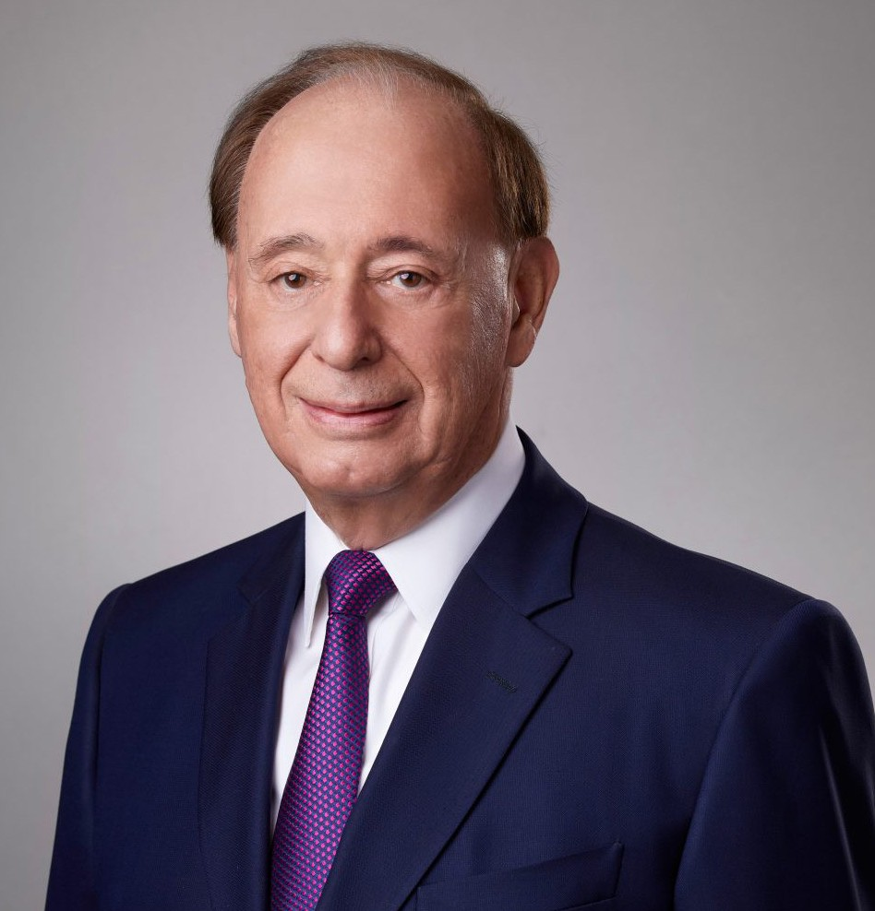

KENNETH B. STREAM

Of Counsel

[Business & Finance](https://www.fennemorelaw.com/services/business-and-finance/)

[San Bernardino](https://www.fennemorelaw.com/contact-us/san-bernardino/)

P: 909.890.4499 F: 909.890.9877

[kstream@fennemorelaw.com](mailto:kstream@fennemorelaw.com)

“

Nobody cares how much you know, until they know how much you care.”

- Theodore Roosevelt

**KENNETH B. STREAM**

”

Kenneth Stream is an Of Counsel Attorney working out of our San Bernardino office. He has extensive experience in the formation and operation of various business entities, as well as the restructuring of businesses in mergers and acquisitions.

For more than 30 years, including five years as general counsel of a public healthcare company, Ken represented a wide variety of clients in matters that involve business, corporate, financial, and trust entities. In addition, he brings expertise in business succession planning to the firm’s

clients.

Ken is active in many community organizations for which he has held a variety of leadership and membership positions. He was also co-founder and former chairman of a publicly traded community bank located in the Inland Empire.

Business & Finance Trusts & Estates Estate Litigation

# EDUCATION

J.D., McGeorge School of Law, University of the Pacific B.S., Chemistry, Walla Walla University

Business & Finance Trusts & Estates

Estate Litigation

# AREAS OF PRACTICE

Business & Finance Trusts & Estates Estate Litigation

# PROFESSIONAL AND COMMUNITY ACTIVITIES

Greater Riverside Chambers of Commerce, Board Chair 2008-2009, General Counsel, Chair of the Political Action Committee

Monday Morning Group, President, 2014-2016

Member, Mayor’s Council of Economic Development Advisors Member, La Sierra University Foundation Board of Directors Member, Riverside-Arlington Kiwanis Club, past President Director, Riverside County Lincoln Club

Co-founder and former Board Chair, Premier Service Bank Member, Silver Eagle Club

Member, UCR School of Business Dean’s Advisory Council

Member, Riverside National Cemetery Monuments and Memorials Committee Advisory Board, S. Vets

Board of Directors, March Field Air Museum

# AWARDS AND HONORS

YMCA former “Y’s Guy of the Year” Business & Finance

Trusts & Estates Estate Litigation

# ADMISSIONS

California

U.S. Court of Appeal, Ninth Circuit

U.S. District Court, Central District of California