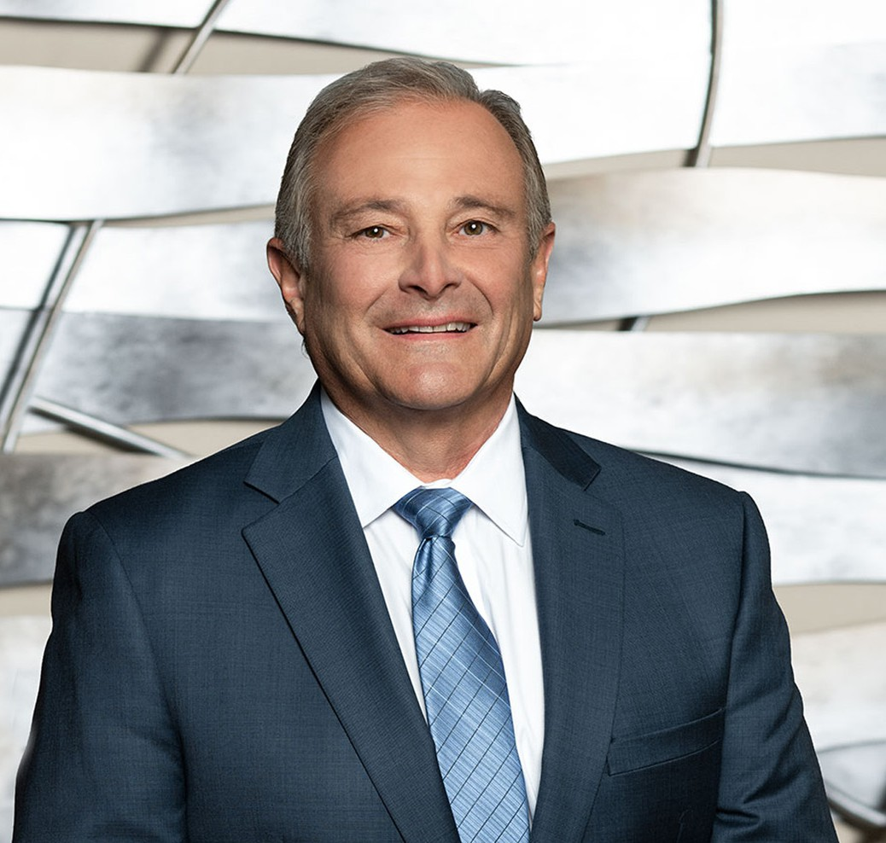

KEVIN D. GUNNER

Director

[Trusts & Estates](https://www.fennemorelaw.com/services/trusts-estates/)

[Fresno](https://www.fennemorelaw.com/contact-us/fresno/)

P: 559.432.4500 F: 559.432.4590

[kgunner@fennemorelaw.com](mailto:kgunner@fennemorelaw.com)

**KEVIN D.**“**GUNNER**

Let your word be your bond.

”

Kevin Gunner’s practice focuses primarily on estate planning, probate and trust administration, with a special emphasis on “Elder Law,” which includes assisting seniors with qualifying for governmental and private benefits (esp. “Medi-Cal”) to pay for long-term care situations and to shelter estate assets from post-mortem claims.

Like many folks who became lawyers, Kevin was tremendously influenced in pursuing a career in the law by the TV-series, Perry Mason, and the mental challenge of analytical problem-solving. His father was a critical thinker who could dismantle any flimsy argument. Dishonesty did not play in Kevin’s house. His mother drew upon her strong Christian faith to instill in him her courage in standing up actively against injustice (“be a help to the widow and orphan”). For over 30 years, Kevin has represented thousands of clients in strategic planning to lead them through the oftentimes confusing body of governmental regulations in qualifying for bona fide financial benefits to help pay for in-home, assisted-living and long-term health care needs. He takes great satisfaction from gratitude of clients, especially the elderly or disadvantaged who he’s been fortunate to help through difficult financial or personal problems, especially providing a means for paying health care expenses without losing their life savings or home.

Born and raised third generation in Fresno, Kevin worked through high school and college in farm-related jobs and continues today in the business management of a family ranch and a personal vineyard (for fun). He’s always enjoyed sports and games of all kinds, with tennis and swimming being his favorites. He also enjoy movies, hiking and card games, but most of all, spending quality time with family.

# EDUCATION

J.D., San Joaquin College of Law

B.S., Business Accounting ,California State University, Fresno

# AREAS OF PRACTICE

**OTHER EXPERIENCE**

Administration and Probate Elder Law

Trusts & Estates Estate Litigation Estate Planning

# PROFESSIONAL AND COMMUNITY ACTIVITIES

Member, Fresno County Bar Association

President, Valley Caregivers Resource Center

Founding Director, Alzheimer’s Foundation of Central California Member, National Association of Elder Law Attorneys

Member, California Advocates for Nursing Home Reform Co-Chancellor, Anglican Diocese of San Joaquin

# ADMISSIONS

California