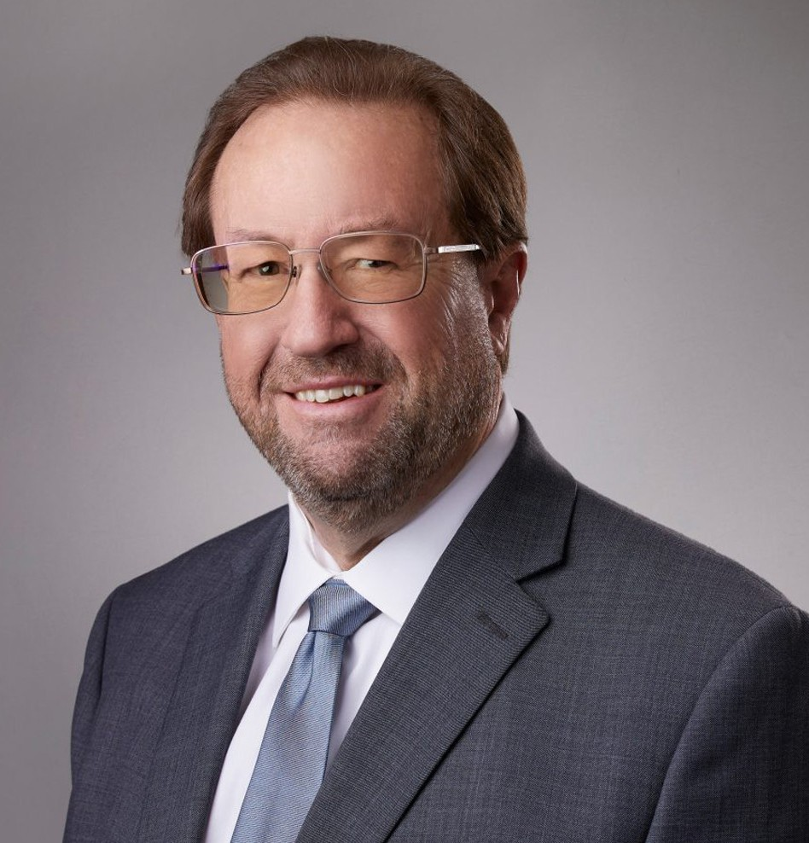

KEVIN K. RANDOLPH

Director

[Land Use](https://www.fennemorelaw.com/services/land-use/)

[San Bernardino](https://www.fennemorelaw.com/contact-us/san-bernardino/)

P: 909.723.1703 F: 909.890.9877

[krandolph@fennemorelaw.com](mailto:krandolph@fennemorelaw.com)

“

The challenge of leadership is to be strong, but not rude; be kind, but not weak; be bold, but not bully; be thoughtful, but not lazy; be humble, but not timid; be proud, but not arrogant; have humor, but without folly.

- Jim Rohn

”

# KEVIN K. RANDOLPH

Kevin Randolph is a shareholder with a practice focusing on complex real estate, land use, and public/private economic development projects. Mr. Randolph has for many years served as legal counsel to private and public entities involved in the assembly, disposition, and

development of land for residential, commercial, and governmental uses, including low- and moderate-income housing. He brings particular insight into the public sector after two decades of representing public agencies.

Mr. Randolph also serves as a state-court receiver and has been appointed in over 200 cases throughout California. He manages a team of litigation attorneys, real estate agents, and supporting staff in connection with his receivership work and, together, they have successfully completed single-family, multi-family, and commercial rehabilitation projects. His work in this area gives him the ability to carefully and effectively work with local land use and code

enforcement agencies and to assist the firm’s clients who need code enforcement and land use defense. Mr. Randolph is a member of the California Receivers Forum and speaks on the

strategic and effective use of the receivership remedy to various national, state and local organizations.

Mr. Randolph serves on the boards of directors of several non-profit community organizations, including the Southern California Mountains Foundation, the Riverside Housing Development Corporation, and SmartRiverside.

# EDUCATION

J.D., Loyola Law School, Los Angeles, *cum laude*

B.S., California State University, Pomona, *magna cum laude*

Order of the Coif

# AREAS OF PRACTICE

Land Use Real Estate

# REPRESENTATIVE MATTERS

City of Riverside v. Horspool (2014) 223 Cal.App.4th. Appellate court decision confirming that receiver’s liens placed on the property to secure rehabilitation and other receivership costs have super-priority and upholding the court’s right to order property in receivership sold free and clear of existing liens.

# ARTICLES AND PRESENTATIONS

[Author, “Navigating the Practice of Receivership with ‘Respect, Transparency and Diligence’,”](https://www.fennemorelaw.com/navigating-the-practice-of-receivership-with-respect-transparency-and-diligence/) [Fennemore Blog, July 6, 2023](https://www.fennemorelaw.com/navigating-the-practice-of-receivership-with-respect-transparency-and-diligence/)

[Interview, “A Conversation On Lessons Learned & Life In The Law With Kevin Randolph,”](https://www.fennemorelaw.com/the-habits-that-make-a-successful-person-and-lawyer-are-developed-early-in-life/)

[Fennemore Blog, April 28, 2022](https://www.fennemorelaw.com/the-habits-that-make-a-successful-person-and-lawyer-are-developed-early-in-life/)

“Receiverships for the Tough Problems,” International Municipal Lawyers Association, October 4, 2015

“Health & Safety Code Section 17980.7 Receiverships,” Riverside City Code Enforcement May 27-28, 2015

“Receiverships for the Tough Problems,” International Municipal Lawyers Association (2015)

“Health and Safety Code Receiverships in the County of Riverside,” Attorneys for the County of Riverside, November 13, 2014

“Enhancing Neighborhood Livability Through the Use of Code Enforcement Receiverships,” League of California Cities 2014 Annual Conference & Expo, September 4, 2014

“Protecting Neighborhood Livability: The Effective Use of Health & Safety Code

Receiverships,” League of California Cities – City Attorneys’ Department Spring 2014 Conference, May 7, 2014

“Health & Safety Code § 17980.7 – A How-To Manual for Dealing with Distressed Properties,” League of California Cities – City Attorneys’ Department (2014)

“Protecting Neighborhood Livability: Code Enforcement, Civil Penalties, Drug Abatements and Receiverships,” League of California Cities – Opening General Session (2014)

“Real Property Receiverships in the City of Riverside,” Attorneys for the City of Riverside, October 25, 2013

# PROFESSIONAL AND COMMUNITY ACTIVITIES

Board Member, Riverside Housing Development Corporation Board Member and General Counsel, SmartRiverside Member, State Bar of California

Member, American Bar Association Member, California Receivers Forum

# ADMISSIONS

California

U.S. Supreme Court

U.S. Court of Appeals, Ninth Circuit

U.S. District Court, Central District of California

U.S. District Court, Eastern District of California

U.S. District Court, Northern District of California

U.S. District Court, Southern District of California