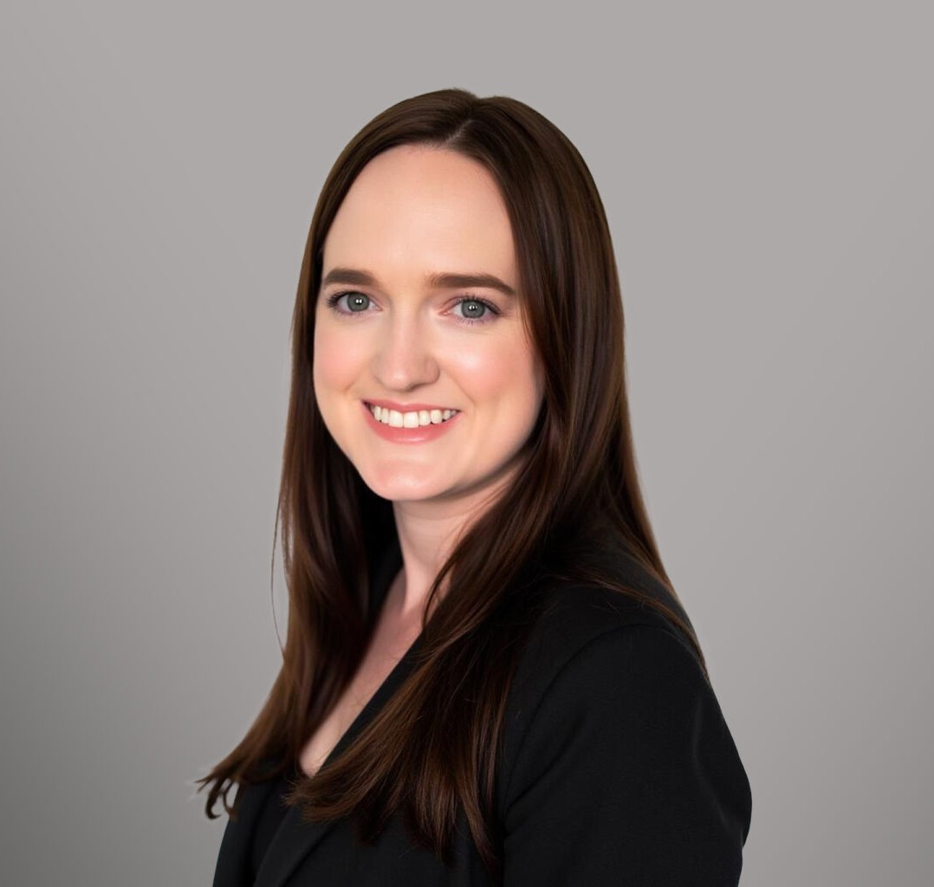

LARENA HOCH

Paralegal

[Trusts & Estates](https://www.fennemorelaw.com/services/trusts-estates/)

[Phoenix](https://www.fennemorelaw.com/contact-us/phoenix/)

P: 602.916.5710 F: 602.916.5710

[lhoch@fennemorelaw.com](mailto:lhoch@fennemorelaw.com)

“

You're thinking about something, my dear, and that makes you forget to talk.

Lewis Carroll

**LARENA HOCH**

”

Larena E. Hoch is a paralegal in Fennemore’s [Estate Planning](https://www.fennemorelaw.com/services/practices/estate-planning/) and [Trusts and Estates](https://www.fennemorelaw.com/services/practices/trusts-estates/) practice groups. Her experience lies in the preparation of estate planning documents, with additional experience in probate and trust administration. Larena’s journey into the legal field began during her sophomore year at Arizona State University, where she worked as a file clerk for various lawyers across multiple practice areas. Her potential was quickly recognized by an estate planning lawyer who mentored and ultimately promoting her to the role of paralegal.

Beyond her professional life, Larena has a passion for travel. Whether it’s a short weekend road

trip or a long flight to a foreign country, she loves exploring new places. She enjoys learning from other people and immersing herself in different cultures, savoring their food, dance, traditions, and perspectives on life.

# AREAS OF PRACTICE

Trusts & Estates Estate Planning

# EDUCATION

B.A., W.P. Carey School of Business Arizona State University

# ADMISSIONS

*\*Not licensed to the practice of law*