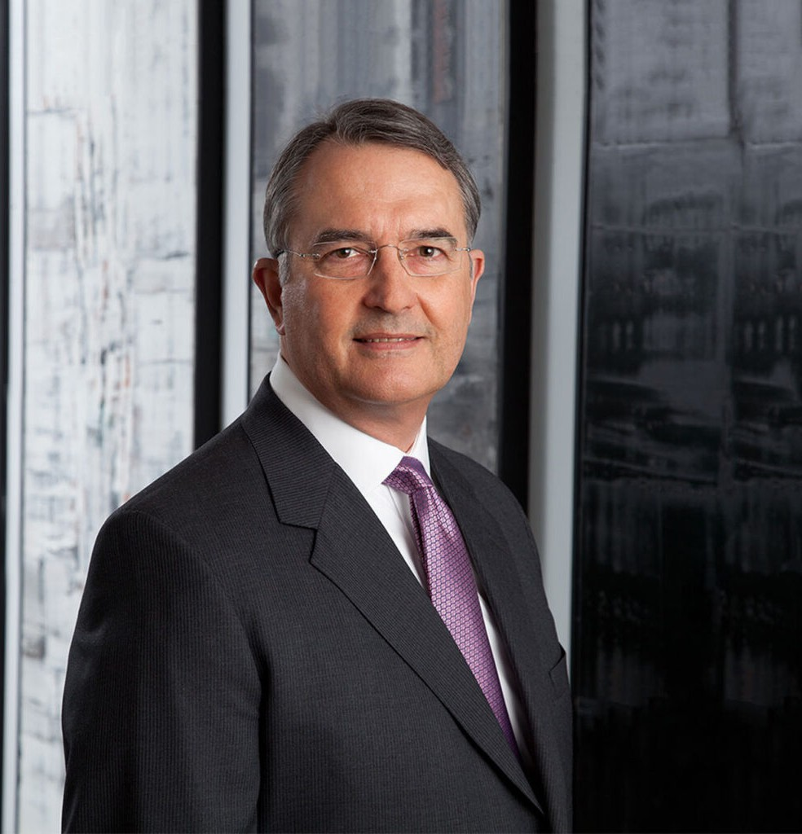

LAUREN J. CASTER

Director

[Natural Resources](https://www.fennemorelaw.com/services/natural-resources-energy-and-environmental/)

[Phoenix](https://www.fennemorelaw.com/contact-us/phoenix/)

P: 602.916.5367 F: 602.916.5567

[lcaster@fennemorelaw.com](mailto:lcaster@fennemorelaw.com)

**LAUREN J. CASTER**

Larry practices in the areas of water and environmental law as it relates to the exercise of water rights. He represents clients in both the [Gila River Adjudication](http://www.superiorcourt.maricopa.gov/SuperiorCourt/GeneralStreamAdjudication/gila.asp) and the [Little Colorado River](http://www.superiorcourt.maricopa.gov/SuperiorCourt/GeneralStreamAdjudication/littleColorado.asp) [Adjudication](http://www.superiorcourt.maricopa.gov/SuperiorCourt/GeneralStreamAdjudication/littleColorado.asp) pending in the state courts. He also represents water users in the Upper Gila River Valley in federal court litigation, and water users in the Agua Fria River Basin in state court.

Larry is a former Chair of the American Bar Association’s Section of Environment, Energy, and Resources, and held numerous other leadership positions in that Section as well.

Natural Resources Agribusiness Advanced Energy

# EDUCATION

J.D., University of Nebraska College of Law, with distinction B.A., University of Nebraska-Lincoln

Order of the Coif

# AREAS OF PRACTICE

OTHER EXPERIENCE

Appeals Water Law

Natural Resources Agribusiness Advanced Energy

# REPRESENTATIVE CASES

Representing a client in litigation over the water right claims of the Hopi Tribe, Superior Court of Arizona, Apache County. The Special Master’s report is awaiting review by the Superior

Court.

Representing clients in litigation over the water right claims of the Navajo Nation in federal and state courts.

Represented client in arguing successfully that a federal consent decree, entered by the United States on behalf of the San Carlos Apache Tribe, precluded additional water right claims by or for that Tribe to the mainstem of the Gila River. *In re General Adjudication of All Rights to Use Water in Gila River Sys. & Source*, 127 P.3d 882 (Ariz.), *reconsideration denied*, 134 P.3d 375 (Ariz. 2006), *cert. denied*, 549 U.S. 1156 (2007).

Represented clients opposing a claim by the Arizona State Land Department in both the Gila River and Little Colorado River Adjudications to a federal reserved water right for millions of acres of state trust lands. The Arizona Supreme Court held that no such reserved right exists. *In re General Adjudication of All Rights to Use Water in Gila River Sys. & Source*, 289 P.3d 936 (Ariz. 2012).

Advised clients in disputes over the Missouri River and the Apalachicola-Chattahoochee-Flint River System.

Represented the Town of Payson, Arizona, in negotiating an historic agreement with the Salt River Valley Water Users’ Association and the Salt River Project Agricultural Improvement and Power District. Under the agreement, which was approved by the parties in 2008, the Town acquired the right to an average of 3,000 acre feet per year of water from C.C. Cragin Reservoir. That quantity of water, combined with groundwater pumping the agreement allows the Town to conduct and the Town’s effective water conservation program, should provide a supply sufficient to meet the Town’s demand at anticipated build-out. The contract is the

result of more than a decade of effort by the Town staff and Larry to obtain access to water from this reservoir.

Advises clients on water resource planning, and the interplay between utilization of water resources and the impact of various environmental laws.

# AWARDS AND HONORS

*Chambers USA,* Leading Lawyers for Business, 2005-2024

*Best Lawyers in America®,* Litigation – Environmental, Natural Resources Law, Water Law, 1999- 2025

*Best Lawyers in America®,* Lawyer of the Year, Water Law, 2011, 2020

*Southwest Super Lawyers®,* Energy and Natural Resources, 2007; 2010-2013 and 2016-2020 *Best Lawyers in America®,* Lawyer of the Year, Litigation – Environmental, 2012, 2016, 2018 *Best Lawyers in America®,* Lawyer of the Year, Natural Resources Law, 2015

AV® Preeminent™ Peer Review Rated (the highest rating available), by Martindale-Hubbell

# ARTICLES AND PRESENTATIONS

Speaker, “CA Water: Building for the Future,” 2018 Association of California Water Agencies Spring Conference and Exhibition, May 2018

Panelist, “Beyond D-1641: How the Water Quality Control Planning Process Works,” 2017 Association of California Water Agencies Spring Conference & Exhibition, May 2017

Speaker, “Update on the Navajo Nation’s Challenge to Federal Management Decisions Relating to the Colorado River,” CLE International Arizona Water Law Conference, Aug. 2015

Speaker, “Watershed Management and Cumulative Effects – American Style,” Canadian Bar Association’s 2011 Annual National Environment, Energy and Resource Law Summit, April 2011

Author, “General Stream Adjudications and Eastern River Systems,” Vol. 133, Journal of Contemporary Water Research & Education, 2006

Speaker, “The Year in Review – Recent Environmental and Resource Developments That May Be of Interest to Canadian Environmental Law Practitioners,” Canadian Bar Association’s First Annual National Environment, Energy and Resources Law Summit, May 2005

Speaker, “Cross-Border Water Issues (Quantity and Quality) – Perspective of Practitioner in U.S.A.,” Mexican Bar Association program, Aug. 2004

Speaker, “Lessons Learned from the Complex Federal/State Relationship in Water

Management,” American Bar Association, Section of Environmental, Energy, and Resources’ program entitled Eastern Water Resources: Law, Policy and Technology, May 2004

Co-author and co-presenter, “Negotiating a Water Right Settlement: Bringing Claimants Who Are Not at the Table into the Process,” 47 Rocky Mtn. Mineral L. Institute 19-1, 2001

# PROFESSIONAL AND COMMUNITY ACTIVITIES

Member, American Bar Association

Past Chair, Section of Environment, Energy, and Resources, American Bar Association

Past Member of Council and Strategic Planning Committee Chair, Section of Environment, Energy, and Resources, American Bar Association

Past Chair, Water Resources Committee, Section of Environment, Energy, and Resources, American Bar Association

Past Program Chair, Annual Water Law Conference, Section of Environment, Energy, and Resources, American Bar Association

# ADMISSIONS

Arizona California Montana Nebraska Oregon

U.S. District Court, District of Arizona

U.S. District Court, Eastern District of California

U.S. District Court, Northern District of California

U.S. District Court, District of Nebraska

U.S. Court of Appeals, Ninth Circuit

U.S. Court of Appeals, Eleventh Circuit

U.S. Court of Appeals, District of Columbia Circuit

U.S. Supreme Court