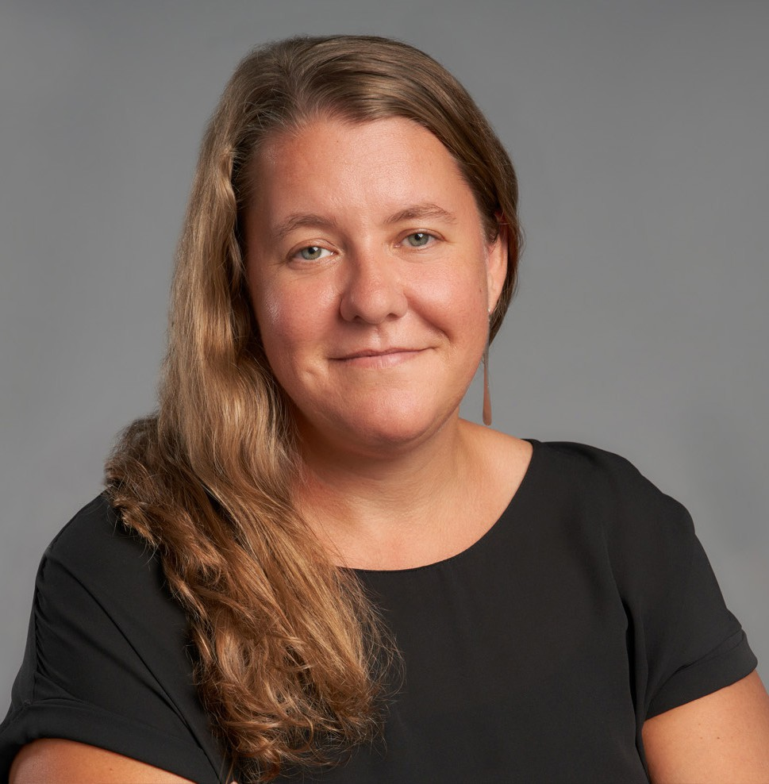

LISA LENHERR

Pronouns: she/her

Director

[Financial Restructuring](https://www.fennemorelaw.com/services/financial-restructuring-bankruptcy-creditors-rights/)

[Oakland](https://www.fennemorelaw.com/contact-us/oakland/)

P: 510.834.6600 F: 510.834.1928

[llenherr@fennemorelaw.com](mailto:llenherr@fennemorelaw.com)

“

Where all think alike there is little danger of innovation.

- Edward Abbey, Desert Solitaire

**LISA LENHERR**

”

A dedicated advocate, Lisa is recognized for her efficient, effective, and innovative work to solve clients’ complex challenges. She focuses her practice on creditors’ rights, business insolvency and restructuring issues, including Chapter 7 and 11 bankruptcy, out-of-court

workouts, debtor-creditor law, assignments for the benefit of creditors, bankruptcy appeals, and distressed business and financing transactions.

Lisa has extensive experience representing all constituents in the insolvency context, including Chapter 7 and 11 bankruptcy trustees, debtors, creditors, landlords, lenders, title companies,

equipment lessors, asset purchasers, and debtors and creditors as parties to non-dischargeability litigation.

Lisa is an active member of the Bay Area insolvency community. She is currently the president of the Bay Area Bankruptcy Forum and formerly served as Chair of the Bar Association of San Francisco’s Commercial Law & Bankruptcy Section, Co-Chair of the Bench Bar Liaison Committee of the Bankruptcy Court for the Northern District of California, and as treasurer for the International Women’s Insolvency & Restructuring Confederation. During law school Lisa externed for the Honorable Robert E. Jones of the U.S. District Court for the District of Oregon and clerked for the Oregon Department of Justice in the antitrust unit.

# EDUCATION

J.D., Lewis & Clark Law School, c*um laude*

B.A., Lewis & Clark College

# AREAS OF PRACTICE

**OTHER EXPERIENCE**

Bankruptcy

Insolvency and Restructuring Financial Restructuring Business & Finance

Business Litigation Real Estate

# ARTICLES AND PRESENTATIONS

[Featuring, “Every case reads like its own unique story and can present a variety of complex](https://www.fennemorelaw.com/every-case-reads-like-its-own-unique-story-and-can-present-a-variety-of-complex-and-intertwining-legal-questions/) [and intertwining legal questions,” Fennemore Blog, July 20, 2023](https://www.fennemorelaw.com/every-case-reads-like-its-own-unique-story-and-can-present-a-variety-of-complex-and-intertwining-legal-questions/)

# AWARDS AND HONORS

*Northern California Super Lawyers*®, 2022 & 2023 Rising Star, *Northern California Super Lawyers*®, 2019

# PROFESSIONAL AND COMMUNITY ACTIVITIES

Bay Area Bankruptcy Forum: current President, former Vice President, Secretary, and Treasurer Alameda County Bar Association: Member

Commercial Law & Bankruptcy Section, The Bar Association of San Francisco: Member, former Chair, Vice-Chair, and Treasurer

International Women’s Insolvency & Restructuring Confederation (IWIRC): Member, former Treasurer

Bench-Bar Liaison Committee, Bankruptcy Court for the Northern District of California: former Member and Co-Chair

Local Rules Subcommittee, Bench-Bar Liaison Committee, Bankruptcy Court for the Northern District of California: former Chair

30th Annual Insolvency Conference, California Bankruptcy Forum (CBF): Education Co-Chair 29th Annual Insolvency Conference, CBF: YIP Co-Chair

28th Annual Insolvency Conference, CBF: Producer 26th Annual Insolvency Conference, CBF: Producer California Bankruptcy Journal: Editor 2012-2018

90th and 91st National Conference of Bankruptcy Judges Next Generation Program: Committee Member

89th Annual National Conference of Bankruptcy Judges Next Generation Program: Participant

# ADMISSIONS

California

U.S. District and Bankruptcy Courts, Northern, Eastern, and Central Districts of California

U.S. Court of Appeals, Ninth Circuit