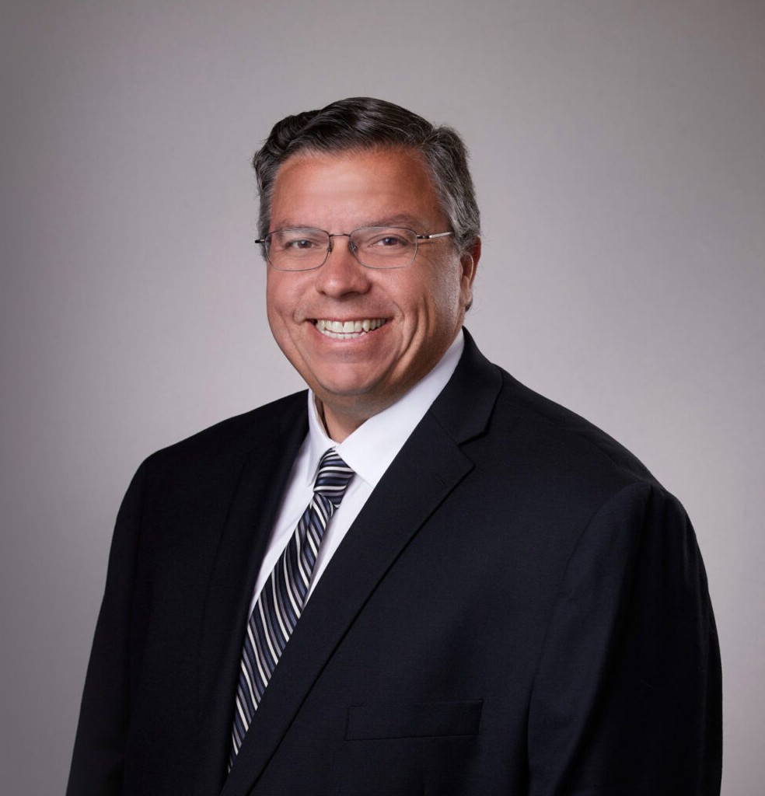

MACK ANDERSON

Director

[Real Estate](https://www.fennemorelaw.com/services/real-estate/)

[San Bernardino](https://www.fennemorelaw.com/contact-us/san-bernardino/)

P: 909.723.1838 F: 909.890.9877

[manderson@fennemorelaw.com](mailto:manderson@fennemorelaw.com)

# MACK ANDERSON

Mack Anderson is a director who works in our Real Estate practice group out of the firm’s San Bernardino office. His practice involves all aspects of real estate transactions, including the

acquisition, development, construction, leasing, ownership, financing, management and disposition of industrial, commercial, retail and office properties. Mack has extensive experience representing real estate developers and corporate tenants in complex industrial projects. Mack has assisted his clients to develop more than 10 million square feet of industrial space. In

addition, Mack has extensive commercial experience, representing national retail and corporate tenants with the acquisition of their properties and the negotiation of their leases.

A seasoned veteran, Mack’s lease materials are in use for commercial and retail properties throughout California and the west coast. Mack is adept at negotiating, drafting and successfully closing purchase and sale agreements, leases, development and construction agreements, reciprocal easement agreements declarations of covenants, conditions and restrictions, and loan and finance agreements.

Mack often coordinates and manages real estate development teams on behalf of his clients, including brokers, architects, engineers, consultants and contractors. Mack’s experience enables him to routinely advise clients regarding business entity formation, operations, title

matters, environmental due diligence and entitlements matters.

Real Estate

# EDUCATION

J.D., University of Southern California Gould School of Law B.S., Occidental College, Biochemistry

# AREAS OF PRACTICE

Real Estate

# PROFESSIONAL AND COMMUNITY ACTIVITIES

Member, State Bar of California

Member, San Bernardino County Bar Association

# ADMISSIONS

California

U.S. Court of Appeals, Ninth Circuit

U.S. District Court, Central District of California