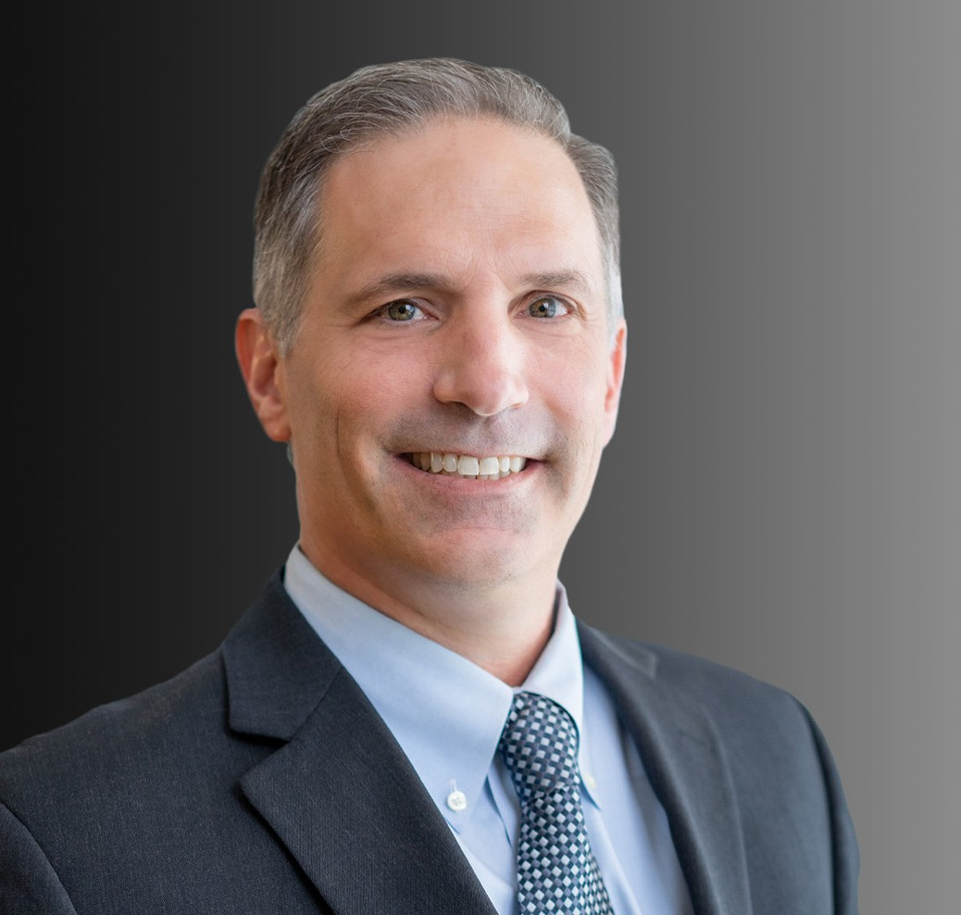

MARK D. EPSTEIN

Director

[Business Litigation](https://www.fennemorelaw.com/services/business-litigation/)

[Oakland](https://www.fennemorelaw.com/contact-us/oakland/)

P: 510.834.6600 F: 510.834.1928

[mepstein@fennemorelaw.com](mailto:mepstein@fennemorelaw.com)

# MARK D. EPSTEIN

Mark has more than 24 years of experience in real estate, business, lending and title insurance coverage litigation. He has a solid track record of successful client representations in resolving disputes that entail real property, title insurance, escrow, commercial landlord-tenant, mortgage lending, easement, boundary line, encroachment and lien priority claims. Mark represents property owners, developers, fractional interest investors, title insurers, banks, and other financial institutions, as well as real estate professionals. He also negotiates and drafts loan documents, leases and purchase and sale agreements.

Mark has been an adjunct professor at the University of California, Berkeley School of Law where he co-taught a course on real estate transactions and litigation during the fall 2015 and 2016 semesters.

Business Litigation Business & Finance Real Estate

# EDUCATION

J.D., University of San Francisco School of Law B.A., University of California, Davis

# AREAS OF PRACTICE

OTHER EXPERIENCE

Real Estate Litigation Title Insurance Business Litigation Business & Finance Real Estate

# AWARDS AND HONORS

AV® Preeminent™ Peer Review Rated by Martindale Hubbell

# ARTICLES AND PRESENTATIONS

Speaker, “Recovering Possession of Abandoned Leased Premises,” Oakland / Berkeley Association of Realtors, December 9, 2019

Speaker, “The Responsible Salesperson: Guidelines to Reduce Your Liability Risks,” Colliers International, May 30, 2019

Author, “Filling the Holes in a “Swiss Cheese Parcel” Correcting Flawed Metes & Bounds

Description,” *California Land Title Association Claims Awareness Committee*, March 8, 2018

Author, “The Swiss Cheese Property Conundrum: Correcting CA’s Flawed Metes and Bounds Descriptions,” *Western Real Estate Business*, October 2017

Speaker, “The Devilish Details: Keeping an Eye Out for Mortgage Lien Irregularities That You May Not Have Bargained For,” Wendel Rosen Client Seminar, February 13, 2017

Speaker, “Title to Real Property – Strange But True Examples of What Can Go Wrong With Title, and How to Fix Them” Wendel Rosen Client Seminar, December 12, 2017

Speaker, “Unraveling Real Estate Co-Owner Disputes,” Oakland Association of Realtors, December 14, 2015

Speaker, “Easy In, Not Always So Easy Out,” Wendel Rosen Client Seminar, November 10, 2015

Co-Speaker, “Law 257 – Real Estate Transactions & Litigation,” U.C. Berkeley School of Law, Fall Semester 2015

Speaker, “This Land is … Whose Land?” Wendel Rosen Client Seminar, April 14, 2015

Speaker, “Default Remedies: Traps for the Unwary … Weapons for the Wise,” Wendel Rosen Client Seminar, June 10, 2014

Speaker, “Understanding Title Insurance: What it Typically Covers and Excludes, and What Additional Coverage May Be Available,” Wendel Rosen Speaker Series, March 11, 2014

Author, “New Law Regarding Short Sales Goes Into Immediate Effect: No Deficiency Judgments,” *Wendel Rosen Client Update,* July 2011

Author, “Reclaiming Lien Priority: The Doctrine of Equitable Subrogation Explained,” *Wendel Rosen Client Update*, June 2013

Speaker, “Insured Closing Letters: What Attorneys Need to Know,” tele-presentation, National Business Institute, May 2011

Presenter, “Opportunity Knocks: Investing in Residential Income Property,” April 2011

Author, “Ensure That You’ve Insured The Right Property,” *California Land Title Association (CLTA) Claims Awareness Hot Sheet*, October, 2010

Author, “New Case Holds That Title Company Has No Liability When It Gratuitously Provides Erroneous Title Information,” *California Land Title Association (CLTA) Claims Awareness Hot Sheet*, September, 2010

Presenter, “Important Provisions to Include in Real Estate Related Loan Documents,” National Business Institute, May 2010

Presenter, “Borrower vs. Lender: Negotiating the Workout Agreement,” National Business Institute, May 2010

Co-Author, “RESPA Update: Enforcement Delay a Call to Action,” *Wendel Rosen Client Update*, December 16, 2009

Panelist, “Real Property Foreclosure: A Step-by-Step Workshop,” National Business Institute, November 2009

Panelist, “In-Depth Title Insurance Principles,” National Business Institute, December 2007 Panelist, “Meeting the Challenges of California Real Estate Titles and Title Insurance,” National Business Institute, February 2005

Author, “Escrow 101: Follow the Instructions,” *California Land Title Association (CLTA) Claims Awareness Hot Sheet*, February, 2005

Panelist, “California Real Estate Law: Problems and Solutions,” National Business Institute, May 2004

# PROFESSIONAL AND COMMUNITY ACTIVITIES

Member, California Land Title Association

Member, S.F. Bay Area Chapter, NAIOP – Commercial Real Estate Development Association

Member, Bench Bar Liaison Committee, Federal Courts

Member, Legal Affairs Forum, California Association of REALTORS® Member, Tort and Insurance Claim Sections, American Bar Association Member, Alameda County Bar Association

Member, Oakland Rotary, No. 3

# ADMISSIONS

California

U.S. District Court, Central District of California

U.S. District Court, Eastern District of California

U.S. District Court, Northern District of California

U.S. District Court, Southern District of California

U.S. Court of Appeals, Ninth Circuit