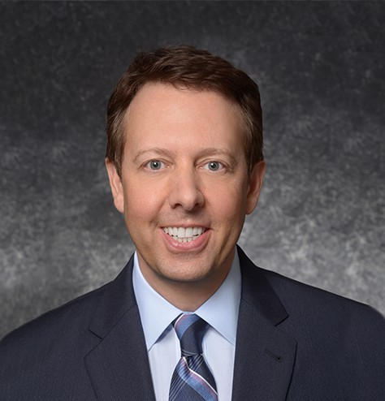

MATTHEW WILCOX

Director

[Real Estate](https://www.fennemorelaw.com/services/real-estate/)

[San Diego](https://www.fennemorelaw.com/contact-us/san-diego/)

P: 619.344.2980 F: 619.231.4372

[mwilcox@fennemorelaw.com](mailto:mwilcox@fennemorelaw.com)

# MATTHEW WILCOX

Matt Wilcox is the managing director in our San Diego office, where his practice focuses primarily on commercial, industrial and retail real estate transactional work, as well as general business,

corporate, and financing matters. He is known as a practical, pragmatic, efficient problem solver who places a high value on client service, personal integrity, hard work and achieving our client’s business objectives.

His practice includes:

**Real Estate.** All aspects of commercial real estate transactions, including acquisitions,

dispositions, leasing, construction and financing of retail, residential (development), commercial and industrial properties.

**Financing.** Secured and unsecured lending transactions; tax exempt bond financing; construction and permanent financing.

**Business**. Business transactions, including entity formation, operational transactions, acquisitions, sales and mergers.

Matt has served as lead counsel for Fortune 500 companies in the successful acquisition and development of several hundred real estate projects throughout California. He also represents private universities, affordable housing developers, local businesses, regional real estate

developers, and construction companies. Many of Matt’s clients have worked with him for his entire career.

# EDUCATION

J.D., University of San Diego School of Law B.S., California Baptist University

# AREAS OF PRACTICE

Real Estate

# REPRESENTATIVE MATTERS

Represented several multi-million dollar real estate purchase and sale transactions, as well as lease transactions for clients ranging from regional developers to Fortune 500 companies.

Represented private universities in numerous multi-million dollar tax-exempt bond transactions.

# ARTICLES AND PRESENTATIONS

Program Co-Chair, Law Seminars International Conference, “Commercial Real Estate Leases,” 2012

# PROFESSIONAL AND COMMUNITY ACTIVITIES

Member, State Bar of California

Board of Visitors, California Baptist University

Member, International Council of Shopping Centers (ICSC) Past Board Member, Rotary Club of Riverside

Past Board Member, Kamali’i Foster Family Agency, Inc.,

Board Member, Secretary, Chair of Board Development Committee, Mary S. Roberts Pet Adoption Center

Past President and Board Member, Inland Caregiver Resource Center Leadership Riverside

Past Board Member, Arrowhead United Way

# ADMISSIONS

California Washington

U.S. District Court, Central District of California