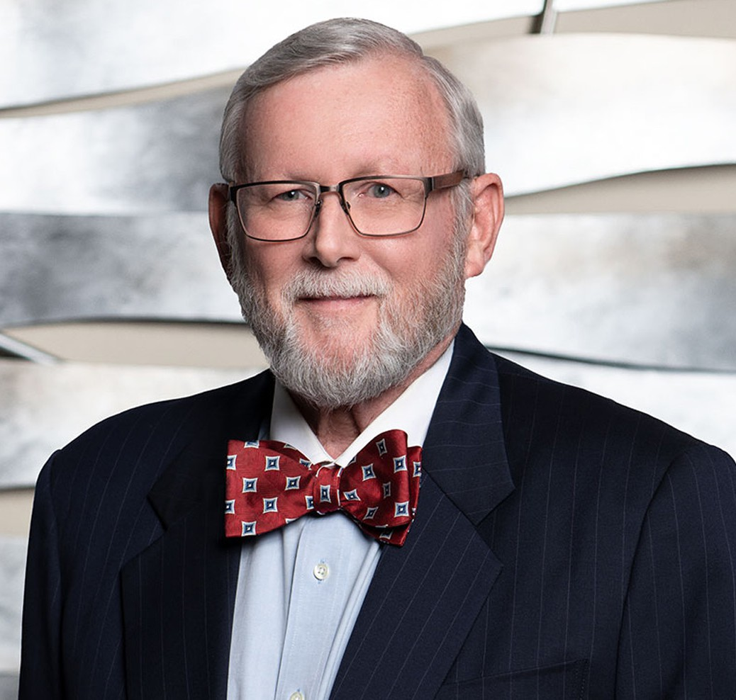

MELVIN K. RUBE

Of Counsel

[Trusts & Estates](https://www.fennemorelaw.com/services/trusts-estates/)

[Fennemore Forward](https://www.fennemorelaw.com/contact-us/fennemore-forward/)

P: 916.782.8555 F: 916.791.4550

[mrube@fennemorelaw.com](mailto:mrube@fennemorelaw.com)

Due process consists of those rights which are so rooted in the traditions and

“-(Palkoconscv.ienCtheonnBillecofticRightsutce of thecon(193as7):theceptpeople aoJusdefinitionticers tschemCardoofzoDue'seo be deeofmordereejProcessectionr ded neceberty.ooffil ssary an"iLaw.)ncorporation"d implicit in anyof

”

# MELVIN K. RUBE

Mel Rube works out of our Fresno and Sacramento offices. His trust and estate litigation practice involves representing fiduciaries and beneficiaries in all types of matters such as will and trust

contests, breach of trust and breach of fiduciary duty actions, actions to compel accountings, actions to remove a trustee or fiduciary, actions to interpret a trust, will, codicil or trust

amendment, determination of heirship proceedings, financial or physical elder abuse and actions brought to recover assets claimed to belong to a trust or estate. Mel’s estate planning, trust administration and probate practice includes drafting of simple and complex wills, revocable and irrevocable trusts, first party and third party special needs trusts, inherited IRA

trusts, durable powers of attorney for financial management and personal care decisions and health care directives; representing and counseling fiduciaries and beneficiaries regarding the administration of a trust or estate; counseling fiduciaries regarding the preparation of trust and estate accountings and representing fiduciaries and beneficiaries in contested and uncontested testate and intestate probate matters.

Mel firmly and unequivocally believes in our Constitutional Democracy and the rule of law that has been established in the United States of America over the course of our history. He wanted to be a part of that tradition, and he wanted a life in the practice of law. To this day, he takes great satisfaction in knowing that he has met the legal needs of his clients.

Away from work, Mel enjoys gardening, camping, walking, traveling, photography (nature), and reading. Prior to joining Dowling Aaron, Mel was a Senior Defense Attorney with the Fresno County Public Defender’s Office where he tried over 50 jury trials and appeared in hundreds of

evidentiary hearings. After leaving the Fresno County Public Defender’s Office, Mel joined the state wide insurance defense firm of Ericksen Arbuthnot, first as a partner and then as the managing partner of the firm’s Fresno office where tried several jury and bench trials defending civil litigants in catastrophic personal injury cases involving medical malpractice, product liability and motor vehicle negligence. After leaving Ericksen Arbuthnot, Mel practiced as a solo practitioner for 20 years, primarily in the areas of estate planning, trust and estate administration and trust and estate litigation.

# EDUCATION

J.D., Humphreys College, School of Law

M.A., with distinction, International Relations, California State University, Fresno B.A., Political Science, University of California, Santa Barbara

# AREAS OF PRACTICE

Trusts & Estates Estate Planning Estate Litigation

# PROFESSIONAL AND COMMUNITY ACTIVITIES

Member, State Bar of California

Member, Fresno County Bar Association, Probate Section Member, American Bar Association

# ADMISSIONS

California