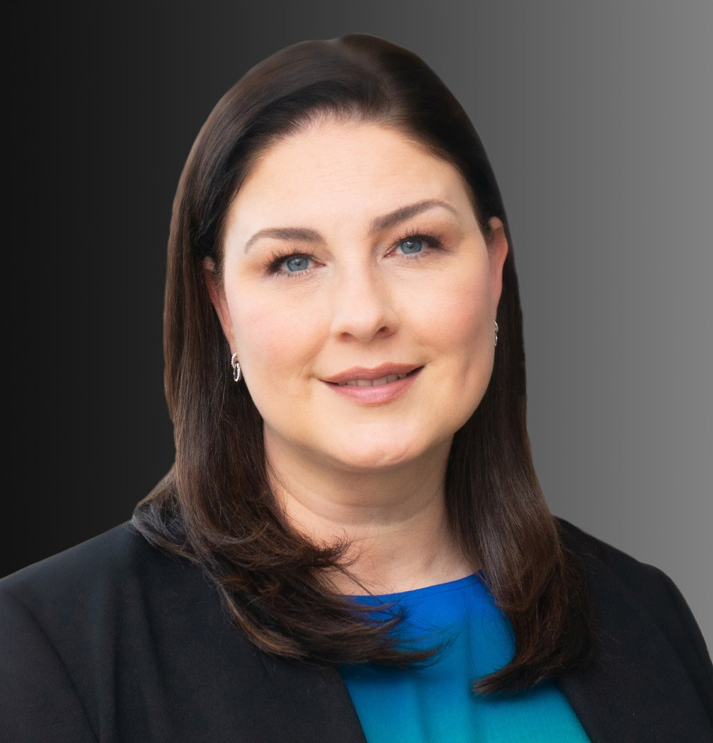

MICHELE C. KIRRANE

Director

[Business Litigation](https://www.fennemorelaw.com/services/business-litigation/)

[Oakland](https://www.fennemorelaw.com/contact-us/oakland/)

P: 510.834.6600 F: 510.834.1928

[mkirrane@fennemorelaw.com](mailto:mkirrane@fennemorelaw.com)

“

An intellectual solves a problem. A genius avoids it.

Einstein

**MICHELE C. KIRRANE**

”

Michele Kirrane is an experienced litigator who handles a wide variety of business litigation

matters, including commercial disputes, claims of breach of contract, misappropriation, fraud and breach of fiduciary responsibility for clients ranging from individuals to large, multinational companies. She has been representing employers in matters involving discrimination,

harassment, retaliation, whistleblower and wrongful termination. She’s also well-versed in real estate property issues such as premises liability, nuisance, conversion, and commercial lease disputes.

Michele’s background with handling large exposure insurance defense matters in both state and federal courts, from intake to trial also makes her a trusted personal and monitoring counsel where she helps navigate complex litigation matters, including commercial, products liability, premises liability and catastrophic loss actions. She is trusted by a wide range of clients who include product manufacturers and suppliers, business owners, municipalities, schools,

individuals, community organizations, and retailers.

Michele understands the high stakes of litigation and takes a tailored approach to each matter she handles. She is tenacious in her investigation and development of strategies carefully designed to protect her clients’ interests. She enjoys a challenge, and thoroughly relishes investigations that utilize her innate problem-solving skills. A born multitasker who you want on your side, Michele allows her clients to “take a deep breath,” especially in high-stakes, high- pressure situations.

Married with twin boys, Michele recharges her batteries with intriguing hobbies including pottery, gardening and home renovation.

Business Litigation Real Estate

Employment & Labor

# EDUCATION

J.D., West Virginia University College of Law B.A., Syracuse University

# AREAS OF PRACTICE

Business Litigation Real Estate

Employment & Labor

# ARTICLES AND PRESENTATIONS

[Interview, “A Conversation On Lessons Learned & Life In The Law With Attorney Michele](https://www.fennemorelaw.com/i-try-to-achieve-as-much-of-a-true-balance-as-possible/) [Kirrane,” Fennemore Blog, May 4, 2023](https://www.fennemorelaw.com/i-try-to-achieve-as-much-of-a-true-balance-as-possible/)

# PROFESSIONAL AND COMMUNITY ACTIVITIES

Member, Alameda County Bar Association

Former Member, Women in the Law and Products Liability Committees, Defense Research Institute

Former Member and Chair, Board of Directors, Business Litigation Committee, Association of Defense Counsel of Northern California

Former Member, American Bar Association

# ADMISSIONS

California