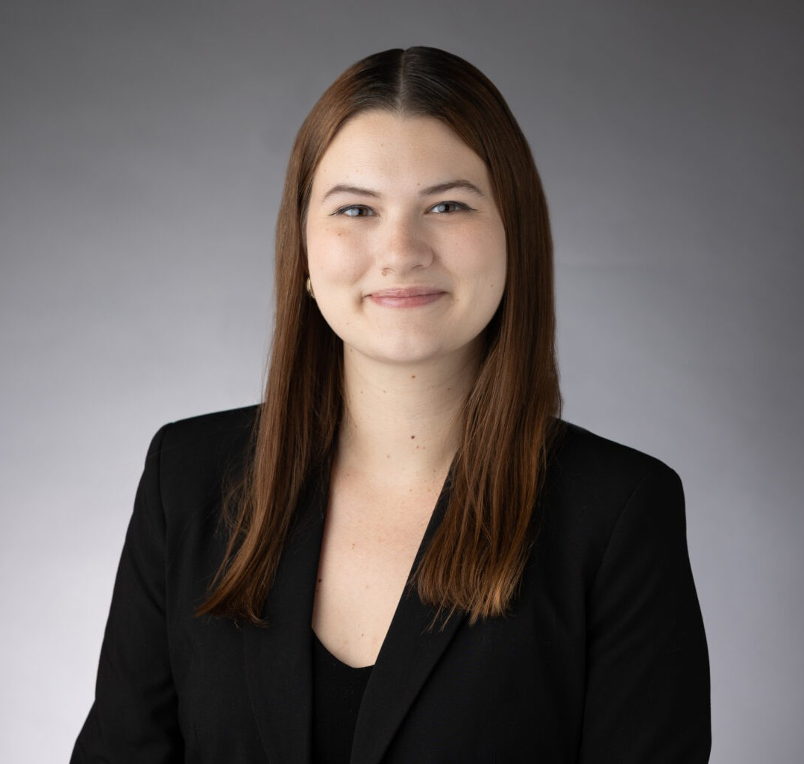

NATALIE KOBE

Associate

[Trusts & Estates](https://www.fennemorelaw.com/services/trusts-estates/)

[Oakland](https://www.fennemorelaw.com/contact-us/oakland/)

P: 510.622.7527 F: 510.622.7571

[nkobe@fennemorelaw.com](mailto:nkobe@fennemorelaw.com)

“

All that you touch, you change. All that you change, changes you. The only lasting truth is change

Octavia E. Butler

”

# NATALIE KOBE

Natalie Kobe is an Associate Attorney who works in our [trust and estates](https://www.fennemorelaw.com/services/trusts-estates/) practice group from our Oakland office. Natalie’s practice is centered on helping individuals and families with all of their estate planning needs. Natalie is passionate about helping clients to understand the options available to them, proactively protect their assets, and wisely plan for the future.

Originally from Zionsville, Indiana, Natalie has taken an unconventional path to practicing law. Natalie holds two undergraduate degrees in French and English from the University of Southern Indiana, and was a high school French teacher for several years before pursuing law school.

Natalie graduated with her law degree from the Washington University School of Law, where she was a senior staff editor of the Jurisprudence Review and a member of several student

organizations. Natalie also participated in the pro bono Intellectual Property Clinic at Washington University School of Law, where she had the opportunity to advise clients on

copyright, patent, trademark, and trade secret matters. Prior to joining Fennemore, Natalie also held an externship at the Equal Employment Opportunity Commission, where she gained valuable insight regarding employment discrimination issues.

Outside of work, Natalie enjoys spending time with her close-knit family and pets. She is also an avid reader, home cook, and world traveler.

# EDUCATION

J.D., Washington University School of Law

B.A., University of Southern Indiana, *magna cum laude*

# AREAS OF PRACTICE

Trusts & Estates

# AWARDS AND HONORS

Washington University Scholar in Law Scholarship

Bob & Carol Rust Foreign Language Scholarship, University of Southern Indiana

USI Global Engagement Scholarship Rabat, Morocco, University of Southern Indiana

# PROFESSIONAL AND COMMUNITY AFFILIATIONS

Legal Extern, Equal Employment Opportunity Commission, 2022 Senior Staff Editor, Jurisprudence Review, 2022 – 2024

Vice President, Alpha Mu Gamma, 2017 Vice President, Sigma Tau Delta, 2017

# ADMISSIONS

California

# LANGUAGE

French, Fluent