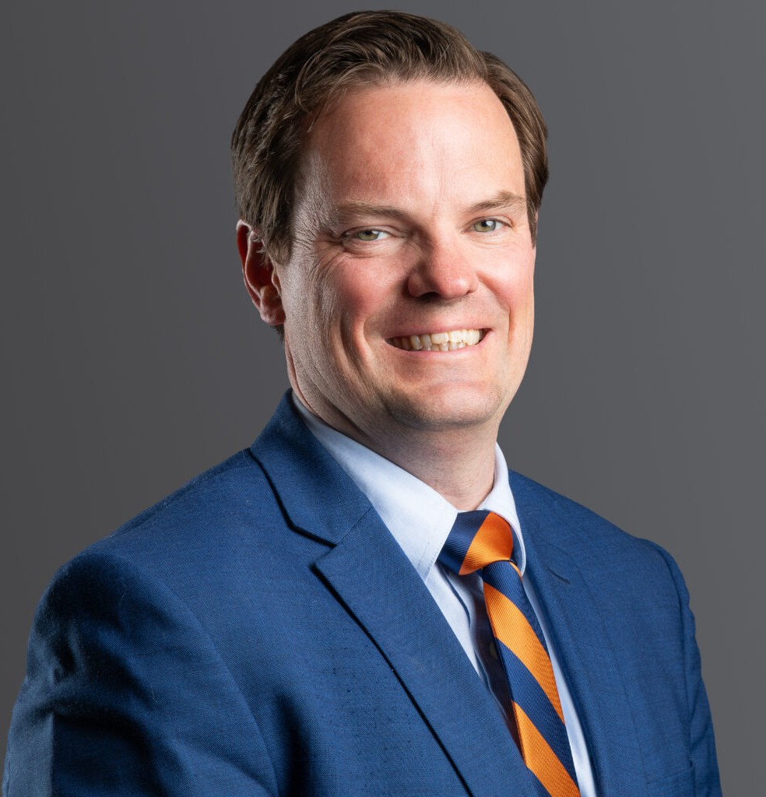

PATRICK J. HICKEY

Director

[Business Litigation](https://www.fennemorelaw.com/services/business-litigation/)

[Denver](https://www.fennemorelaw.com/contact-us/denver-2/)

P: 303.813.3830 F: 303.291.3201

[phickey@fennemorelaw.com](mailto:phickey@fennemorelaw.com)

# PATRICK J. HICKEY

As a former accountant, Patrick focuses on achieving results for his clients that are beneficial from a business as well as from a legal perspective. Patrick is a commercial and real estate litigator representing clients in a variety of industries including advanced energy, real estate, employment, construction, and private equity.

He has successfully tried cases to judges and juries and has experience representing clients throughout the country. He also defends clients in administrative proceedings and arbitrations. Patrick has a depth of experience with both commercial and real estate disputes, including landlord/tenant disputes, lease disputes, evictions, boundary disputes, and breach of contract.

A Wyoming native and a member of the Wyoming State Bar, Patrick regularly represents clients throughout Wyoming where he has litigated cases involving mountain real estate developments, business disputes, and oil and gas agreements. Patrick is licensed in all Wyoming state and federal courts.

Before private practice, Patrick clerked for Judge Daniel J. Kaup in Colorado’s Eighth Judicial District Court in Fort Collins, Colorado. Before law school, Patrick worked for Deloitte & Touche,

LLP in Philadelphia and Denver where he audited public utility, insurance, and oil and gas companies.

# EDUCATION

J.D., The University of Denver Sturm College of Law Business Editor, Water Law Review

Scholastic Excellence Awards in Advanced Trial Practice and Sustainable Development and Trade

Phi Delta Phi International Legal Honors Fraternity Member B.S., Villanova University

Summer Program Attendee, London School of Economics and Political Science

# AREAS OF PRACTICE

Business Litigation

# PROFESSIONAL AND COMMUNITY AFFILIATIONS

American Bar Association Litigation and Construction

Arts Student League of Denver, Former Board and Executive Committee Member Colorado Bar Association

Denver Bar Association Wyoming State Bar

# AWARDS AND HONORS

Benchmark Litigation: Local Litigation Star – General Commercial Litigation and Real Estate Litigation, 2020 – 2024

Best Lawyers®: Litigation – Labor and Employment, 2023 – 2025

Colorado Super Lawyer: Business Litigation, 2024; Rising Star: Business Litigation, 2020-2021

# ARTICLES AND PRESENTATIONS

Author, “Do Videoconferences Establish Jurisdiction with Defendants?” Law360, April 2023

# ADMISSIONS

Colorado

U.S. Supreme Court

U.S. Court of Appeals for the Tenth Circuit Wyoming