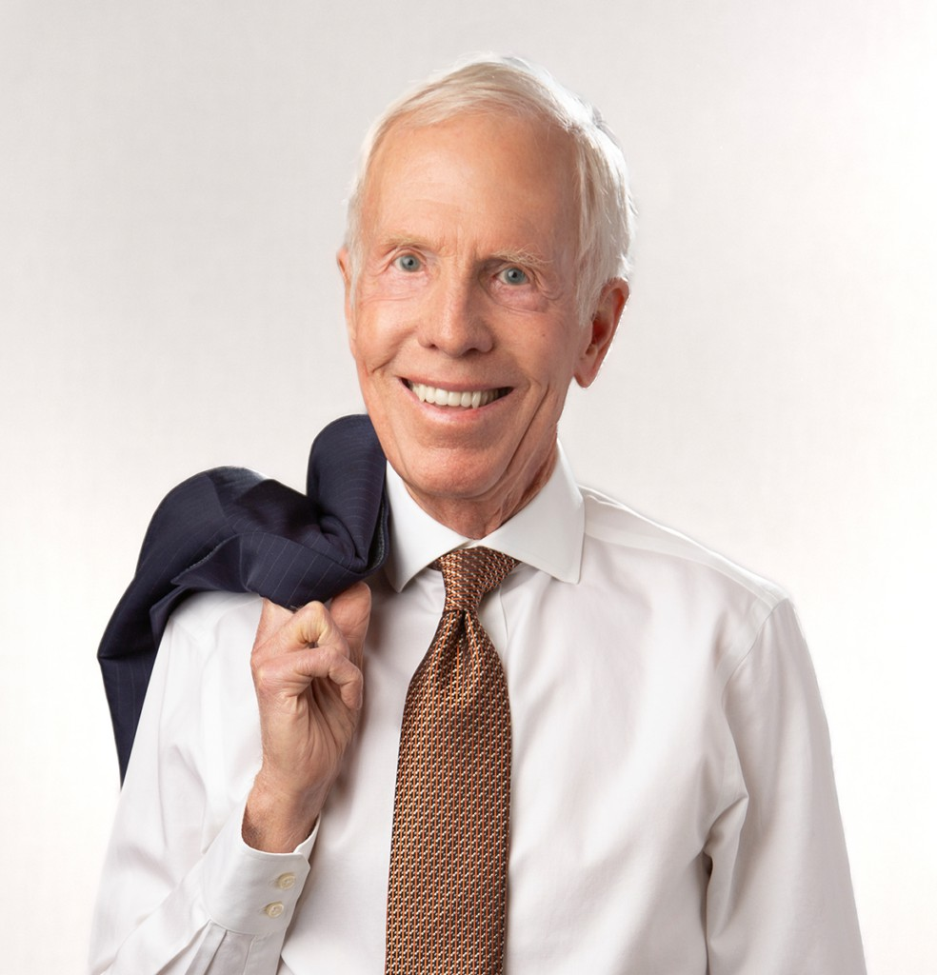

ROBERT L.

SULLIVAN, JR.

Of Counsel

[Trusts & Estates](https://www.fennemorelaw.com/services/trusts-estates/)

[Fresno](https://www.fennemorelaw.com/contact-us/fresno/)

P: 559.753.2801 F: 559.753.2800

[rsullivan@fennemorelaw.com](mailto:rsullivan@fennemorelaw.com)

**ROBERT L. SULLIVAN, JR.**

Robert L. Sullivan, Jr. is an Of Counsel attorney in our Fresno office where his practice focuses on estate planning, trust and estate administration, taxation, and litigation support in trust and estate matters. He has guided clients through an array of estate planning, trust administration, business planning, succession planning, and related tax matters throughout a distinguished career spanning over 50 years.

A leader in the field, Bob has held the position of Chair of the California State Bar’s Estate

Planning, Trust, and Probate Law Section, an influential group comprising over 4,000 esteemed estate planning attorneys and probate judges. He is a long-standing fellow of the American College of Trust and Estate Counsel and has also been an academician of the International Academy of Estate and Trust Law.

His dedication to advancing the profession is evident through his collaborative efforts with lawmakers and academia to enhance legislative procedures for informal administration of

decedents’ estates. Bob has received dual certifications from The State Bar of California Board of Legal Specialization as a specialist in Estate Planning, Trust and Probate Law, and as a

specialist in Taxation Law.

# EDUCATION

J.D., University of San Francisco School of Law B.S., University of California, Berkeley

# AREAS OF PRACTICE

OTHER EXPERIENCE

Litigation Support in Trusts and Estates Matters Trusts & Estates

Tax Law

Estate Planning

# REPORTED CASES

*Dorothy Schwartz Rojas and Estate of Charles R. Schwartz, deceased v. Commissioner of Internal Revenue Service,* 901 F.2d 810 (9th Cir. 1990)

*Edmond of Fresno v. MacDonald Group Ltd,* 171 Cal. App. 3d 598 (1985)

# AWARDS AND HONORS

Member of the McAuliffe Honor Society at the University of San Francisco School of Law AV® Preeminent™ Peer Review Rated with Martindale-Hubbell

Northern California Super Lawyer in the field of Estate Planning & Probate, 2006-2024

# ARTICLES AND PRESENTATIONS

The Southern California Tax and Estate Planning Forum The University of Southern California Tax Institute Annual programs of the Estate Planning

Probate Trust Law Section of the California State Bar

Education Institutes Section of the State Bar of California Continuing Education Program

Drafted a Proposal for the Enactment of Informal Administration of Decedent’s Estate in California on behalf of The State Bar of California

Course Outline, CEB Impact of California’s Probate Code Reform

Course Outline, CEB Recent Developments in Estate Planning and Administration Course Outline, Programs on The Tax Reform Act of 1986

Course Outline, CEB Recent Developments in Estate Planning and Administration, 1/88 Course Outline, CEB Recent Developments in Estate Planning and Administration, 1/89 Course Outline, CEB Recent Developments in Estate Planning and Administration, 1/90 Course Outline, CEB Recent Developments in Estate Planning and Administration, 1/91 Course Materials, “Planning the Small Estate”, California CEB, 3/92

Recent Developments in Taxation, California CEB, 1/93

Course Materials, “Effective Client Communication in Estate Planning,” 10/94 Analysis, “Informal Decedent Estate Administration in California,” 10/95

Course Materials, “New § 2033A, A Senator’s Dream or An Attorney’s Nightmare?”, USC Institute on Federal Taxation, 1/98

Course Outline, “The Qualified Family Owned Business Exclusion: New §2033A”, The Southern California Tax & Estate Planning Forum, 5/98

# PROFESSIONAL AND COMMUNITY AFFILIATIONS

Editor-in-Chief of the University of San Francisco Law Review Fellow, American College of Trust and Estate Counsel

Member, State Bar of California

Member, Bar of the US Supreme Court, 1974

Past Member, Executive Committee of the State Bar of California Trust and Estate Section, 1985-1995; Chair 1994-1995

Past Member, California Taxation Law Advisory Commission of California Board of Legal Specialization, 1988-1989

Past President of the Fresno Estate Planning Council, 1982-1983 Former Director, Fresno Art Museum and Fresno Metropolitan Museum Former Director, Carmel Bach Festival

# ADMISSIONS

California

United State Supreme Court

United States Court of Appeals for the 9th District United States Tax Court