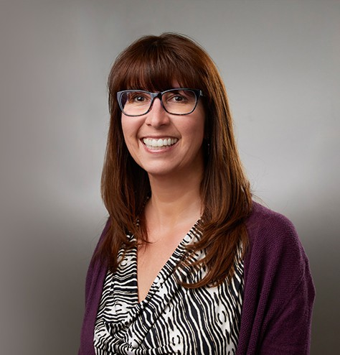

SANDRA D. WALSH

Paralegal

[Trusts & Estates](https://www.fennemorelaw.com/services/trusts-estates/)

[San Bernardino](https://www.fennemorelaw.com/contact-us/san-bernardino/)

P: 909.723.1737 F: 909.890.9877

[swalsh@fennemorelaw.com](mailto:swalsh@fennemorelaw.com)

**OVERVIE**“**W**

Don’t sweat the small stuff.

”

Sandra Walsh is a paralegal who works out of our firm’s San Bernardino office. Her work focuses primarily in the areas of business/transactional matters, entity formation and maintenance, estate planning, probate, third-party liens, health insurance billing, and some litigation.

Sandy originally joined the firm and worked with attorney Ken Stream, and his group with a different plan in mind, but found that she enjoyed the team aspect of working in a legal office. To this day, Sandy enjoys working through analytical tasks and assisting others.

Outside of work, Sandy recharges her batteries by exercising, listening to music, reading and spending time with loved ones.

Trusts & Estates Estate Planning Estate Litigation Business & Finance

# EDUCATION

Currently attending Riverside City College

# AREAS OF PRACTICE

Trusts & Estates Estate Planning

Estate Litigation Business & Finance

# ADMISSIONS

*\*Not licensed to the practice of law*

Trusts & Estates Estate Planning Estate Litigation Business & Finance